NDRS – NICE Partnership Report ID975

Background
This report was produced in partnership by the National Disease and Registration Service (NDRS) and National Institute for Health and Care Excellence (NICE). NDRS and NICE have established a partnership focused on routinely collected data to support NICE decision making on the appraisals of cancer treatments. The partnership uses NDRS datasets, including the information submitted by trusts to the Systemic Anti-Cancer Therapy (SACT) dataset, to provide an understanding of current practice.
To determine a severity modifier, NICE considers factors such as the age, gender, and overall survival of the patient cohort affected by the disease. Additionally, knowing the time-on-treatment for each therapy is useful, as it validates assumptions made in technology appraisal evaluations about the duration of treatment use.
Generally, this partnership is focused on producing demographic and survival information using NDRS data, alongside supplementary information tailored to each technology appraisal. In this specific instance, similar information was derived to enable a post-approval re-evaluation as part of an academic study independently conducted by NICE. This specific information was not presented to NICE committees nor used in any NICE technology appraisal or process.
The focus of this report is the indication: Tisagenlecleucel for treating relapsed or refractory B-cell acute lymphoblastic leukaemia in people 25 years and under (ID975)
Two cohorts were assessed for this indication:
Cohort 1: Patients receiving tisagenlecleucel for acute lymphoblastic leaukaemia aged 25 years and under
Cohort 2: Patients receiving blinatumumab for acute lymphoblastic leaukaemia aged 25 years and under

Age, Gender and Overall Survival for Tisagenlecleucel

Introduction
This report was produced in partnership by the National Disease Registration Service (NDRS) and the National Institute for Health and Care Excellence (NICE). It presents patient demographic characteristics and overall survival among patients who have received a treatment of tisagenlecleucel for refractory or relapsed B-cell acute lymphoblastic leukaemia (B-ALL).
Data extracted as part of this project was used to provide demographic and overall survival information for those treated with tisagenlecleucel or blinatumumab for B-ALL, for the purposes of comparing real-world data to that used in NICE Technology Appraisal 975. Data presented in this report will be combined with data for blinatumomab, in cohort 2 below (page 14).

Method
A snapshot of Systemic AntiCancer Therapy (SACT) data was taken on 8th June 2025 and made available for analysis on 26th June 2025. SACT data is only considered complete when 90% of trusts have submitted data. As a result, SACT data is considered complete up to 31st October 2024. Patients were traced for their vital status on 5th April 2025.
Descriptive statistics of age and gender were computed, as well as overall survival (OS) Kaplan-Meier graphs and parametric fits.

Cohort inclusions / exclusions
Patients were included in this cohort where:
- Country code was ‘England’
- Age at start of treatment (using first drug administration date) was under 25
- Gender field was known (male or female)
- ICD-10 diagnosis code was C910 (consistent with the restriction on blinatumomab)
- Treatment included a drug administration of tisagenlecleucel, defined in the drug detail table of SACT. Drug tables were used to define the cohort rather than regimen level information, these regimens include a period of induction prior to the immunotherapy being given. Some patients may have a record of starting a relevant regimen but not actually receiving the immunotherapy if the regimen is discontinued before immunotherapy administration

Patient Acknowledgement
This work uses data that has been provided by patients and collected by the NHS as part of their care and support. The data is collated, maintained and quality assured by the National Cancer Registration and Analysis Service, which is part of NHS England.

Results

Age at start of treatment
The table below sets out the mean age, standard (std.) deviation, median age and interquartile range (IQR) of patients who have received tisagenlecleucel. Age is measured at the commencement of the administration date of tisagenlecleucel.
Cohort 1 Table 1: Mean age, standard deviation, median age and IQR of patients who have received tisangelecleucel
Characteristic | Female N = 61 | Male N = 91
Age at administration | 12, (6) : 12 (7, 16) | 12, (7) : 13 (7, 17)

Overall Survival

Base K-M plot
The Kaplan-Meier plot below shows overall survival over time for those receiving tisagenlecleucel.
Cohort 1 Figure 1: Kaplan-Meier plot of overall survival amongst patients who have received tisagenlecleucel
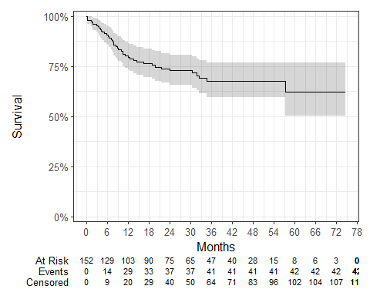

Median survival was not reached and restricted mean survival (over the whole curve) was 53.64 months. The minimum follow-up time was 0.2 months, median 23.6 months, and maximum follow-up time of 74.6 months.

Exponential
Cohort 1 Figure 2: Kaplan-Meier plot with Exponential fit of overall survival amongst patients who have received tisagenlecleucel

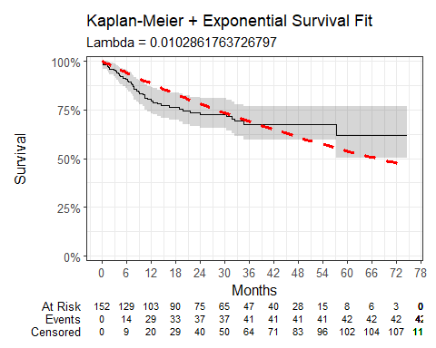

Cohort 1 Table 2: Parameter estimates for Exponential survival model
Variable | Estimate | Std. Error | z | p-value
(Intercept) | 4.577 | 0.1543 | 29.6621 | 0
Model diagnostics: Log-likelihood = -234.23; AIC = 470.46; BIC = 473.49
AIC: Akaike Information Criterion
BIC: Bayesian Information Criterion

Weibull
Cohort 1 Figure 3: Kaplan-Meier plot with Weibull fit of overall survival amongst patients who have received tisagenlecleucel
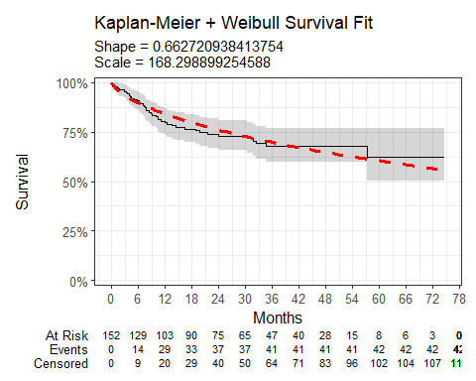

Cohort 1 Table 3: Parameter estimates for Weibull survival model
Variable | Estimate | Std. Error | z | p-value
(Intercept) | 5.1257 | 0.3323 | 15.4232 | 0.0000
Log(scale) | 0.4114 | 0.1389 | 2.9618 | 0.0031
Model diagnostics: Log-likelihood = -229; AIC = 462; BIC = 468.05

Log-Normal
Cohort 1 Figure 4: Kaplan-Meier plot with Log-Normal fit of overall survival amongst patients who have received tisagenlecleucel
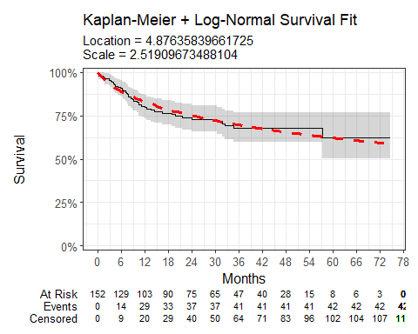

Cohort 1 Table 4: Parameter estimates for Log-Normal survival model
Variable | Estimate | Std. Error | z | p-value
(Intercept) | 4.8764 | 0.3722 | 13.1024 | 0
Log(scale) | 0.9239 | 0.1238 | 7.4607 | 0
Model diagnostics: Log-likelihood = -227.57; AIC = 459.14; BIC = 465.19

Log-Logistic
Cohort 1 Figure 5: Kaplan-Meier plot with Log-Logistic fit of overall survival amongst patients who have received tisagenlecleucel
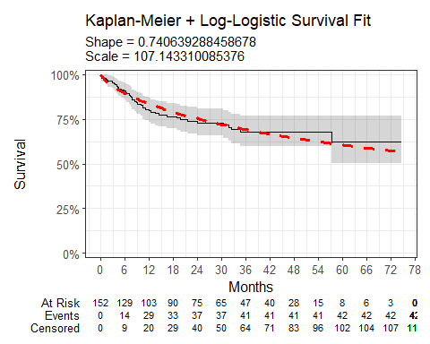

Cohort 1 Table 5: Parameter estimates for Log-Logistic survival model
Variable | Estimate | Std. Error | z | p-value
(Intercept) | 4.6742 | 0.3207 | 14.5762 | 0.0000
Log(scale) | 0.3002 | 0.1362 | 2.2052 | 0.0274
Model diagnostics: Log-likelihood = -228.21; AIC = 460.42; BIC = 466.47

Gaussian
Cohort 1 Figure 6: Kaplan-Meier plot with Gaussian fit of overall survival amongst patients who have received tisagenlecleucel
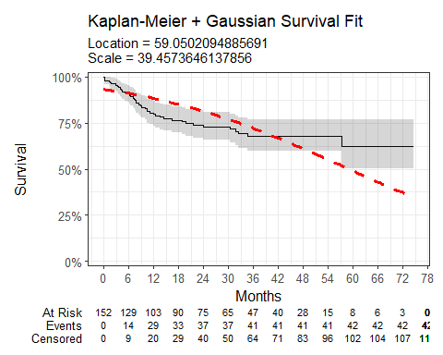

Cohort 1 Table 6: Parameter estimates for Gaussian survival model
Variable | Estimate | Std. Error | z | p-value
(Intercept) | 59.0502 | 5.7576 | 10.2561 | 0
Log(scale) | 3.6752 | 0.1224 | 30.0162 | 0
Model diagnostics: Log-likelihood = -262.63; AIC = 529.26; BIC = 535.3

Gamma
Cohort 1 Figure 7: Kaplan-Meier plot with Gamma fit of overall survival amongst patients who have received tisagenlecleucel
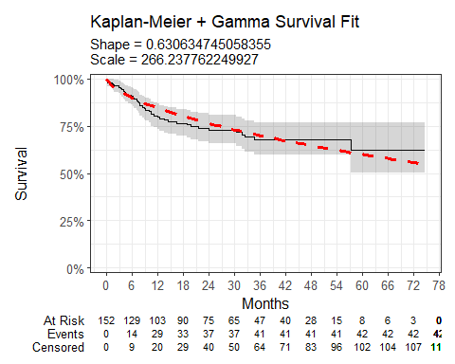

Cohort 1 Table 7: Parameter estimates for Gamma survival model
Variable | Estimate | L95% | U95% | Std. Error | p-value
shape | 0.6306 | 0.4623 | 0.8602 | 0.0999 | 0.0000
rate | 0.0038 | 0.0015 | 0.0091 | 0.0017 | 0.0268
Model diagnostics: Log-likelihood = -229.47; AIC = 462.93; BIC = 468.98

Generalised Gamma
Cohort 1 Figure 8: Kaplan-Meier plot with Generalised-Gamma fit of overall survival amongst patients who have received tisagenlecleucel
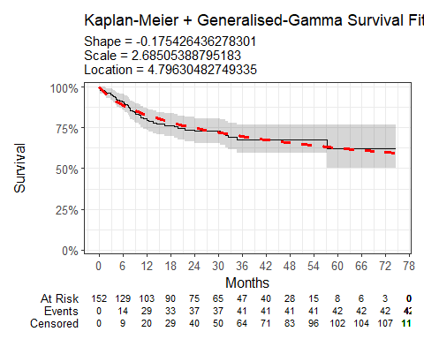

Cohort 1 Table 8: Parameter estimates for Generalised Gamma survival model
Variable | Estimate | L95% | U95% | Std. Error | p-value
mu | 4.7963 | 3.7677 | 5.8249 | 0.5248 | 0.0000
sigma | 2.6851 | 1.5523 | 4.6443 | 0.7506 | 0.0003
Q | -0.1754 | -1.6211 | 1.2703 | 0.7376 | 0.8120
Model diagnostics: Log-likelihood = -227.54; AIC = 461.08; BIC = 470.15

Gompertz
Cohort 1 Figure 9: Kaplan-Meier plot with Gompertz fit of overall survival amongst patients who have received tisagenlecleucel
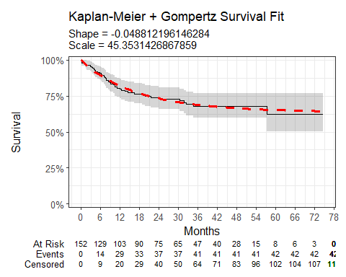

Cohort 1 Table 9: Parameter estimates for Gompertz survival model
Variable | Estimate | L95% | U95% | Std. Error | p-value
shape | -0.0488 | -0.0765 | -0.0211 | 0.0141 | 6e-04
rate | 0.0220 | 0.0141 | 0.0344 | 0.0050 | 0e+00
Model diagnostics: Log-likelihood = -226.41; AIC = 456.81; BIC = 462.86

Age, Gender and Overall Survival for Blinatumomab

Introduction
This report was produced in partnership by the National Disease Registration Service (NDRS) and the National Institute for Health and Care Excellence (NICE). It presents patient demographic characteristics and overall survival among patients who have received a treatment of blinatumomab for refractory or relapsed B-cell acute lymphoblastic leukaemia (B-ALL).
Data extracted as part of this project was used to provide demographic and overall survival information for those treated with tisagenlecleucel or blinatumumab for B-ALL, for the purposes of comparing real-world data to that used in NICE Technology Appraisal 975. Data presented in this report will be combined with data for tisagenlecleucel, available in cohort 1 above..

Method
A snapshot of SACT data was taken on 8th June 2025 and made available for analysis on 26th June 2025. SACT data is only considered complete when 90% of trusts have submitted data. As a result, SACT data is considered complete up to 31st October 2024. Patients were traced for their vital status on 5th April 2025.
Descriptive statistics of age and gender were computed, as well as overall survival (OS) Kaplan-Meier graphs and parametric fits. Counts of those receiving a stem cell transplant after the start date of the blinatumomab regimen were calculated using linkage to HES. Time-on-treatment was also derived, defined as the time between the earliest and latest blinatumomab administration date (defined in SACT) plus one day (to remove zero length time-on-treatment).

Cohort inclusions / exclusions
Patients were included in this cohort where:
- Age at treatment date (using first administration date) was 25 and under
- Gender field was known (male or female)
- ICD-10 diagnosis code was C910 (blinatumomab has more than one indication)
- Treatment included a drug administration of blinatumomab, defined in the drug detail table of SACT. Drug tables were used to define the cohort rather than regimen level information, these regimens include a period of induction prior to the immunotherapy being given. Some patients may have a record of starting a relevant regimen but not actually receiving the immunotherapy if the regimen is discontinued before immunotherapy administration
- The treatment regimen containing blinatumomab was started before 1st November 2019. After this date blinatumomab was made available as a treatment for minimal residual disease acute lymphoblastic leukaemia (ALL), which is not part of our cohort
- The patient was primary refractory ALL, defined as having a regimen containing dexamethasone, vincristine, mercaptopurine or asparaginase between 29 and 50 days prior to their blinatumomab infusion, or second relapse / chemo refractory ALL, defined as having mixotantrone more than 29 days before the blinatumomab infusion or a stem cell transplant prior to the blinatumomab infusion. These dates were selected as the best means of distinguishing between refractory/second relapsed ALL rather than non-refractory/relapsed. Patients are defined as primary refractory if they fail a full chemotherapy induction regimen. According to the UKALL 2019 guidelines, induction regimens could be one of three regimens taken for 29 days. Therefore, patients receiving blinatumomab 29 days after a chemotherapy induction regimen are assumed primary refractory. This criterion was expanded from 29 to 50 days to account for reasonable gaps between the treatments. For chemo-refractory and second relapse, first-line chemotherapy consists of a regimen of either 3 drugs (dexamethasone, vincristine and asparaginase) or 4 drugs (dexamethasone, vincristine, asparaginase and daunorubicin). After first relapse, a patient could receive either blinatumomab, inotuzumab ozogamicin or UK ALLR3, a 4-drug chemotherapy regimen of dexamethasone, vincristine, asparaginase and mitoxantrone, going on to receive an allo-SCT or UK ALLR3 maintenance. If patients had received blinatumomab at first relapse they should not have received prior mitoxantrone as this is only a component of UK ALLR3 and not the first-line treatments. With the assumption that patients are unlikely to be treated with blinatumomab twice, those who receive mitoxantrone or an allo-SCT, then subsequent blinatumomab, are likely in second relapse or chemo-refractory.

Patient Acknowledgement
This work uses data that has been provided by patients and collected by the NHS as part of their care and support. The data is collated, maintained and quality assured by the National Disease Registration Service, which is part of NHS England.

Results

Age at start of treatment
The table below sets out the mean age, standard (std.) deviation, median age and interquartile range (IQR) of patients who have received blinatumomab. Age is measured at the commencement of the administration date of blinatumomab.
Cohort 2 Table 1: Mean age, standard deviation, median age and IQR of patients who have received blinatumomab
Characteristic | Female N = 26¹ | Male N = 30¹
Age at administration | 12, (7) : 12 (6, 18) | 12, (7) : 12 (7, 19)
¹Mean, (SD) : Median (Q1, Q3)

Overall Survival (excluding clinical trials)

Base K-M plot
The Kaplan-Meier plot below shows overall survival over time for those receiving blinatumomab.
Cohort 2 Figure 1: Kaplan-Meier plot of overall survival amongst patients who have received blinatumomab
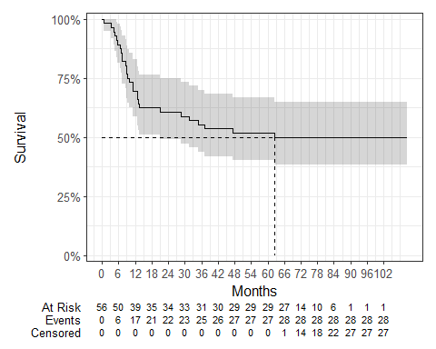

Median survival was 62.52 and restricted mean survival (over the whole curve) was 62.99 months. The minimum follow-up time was 0.7 months, median 64.1 months, and maximum follow-up time of 110.5 months.

Exponential
Cohort 2 Figure 2: Kaplan-Meier plot with Exponential fit of overall survival amongst patients who have received blinatumomab
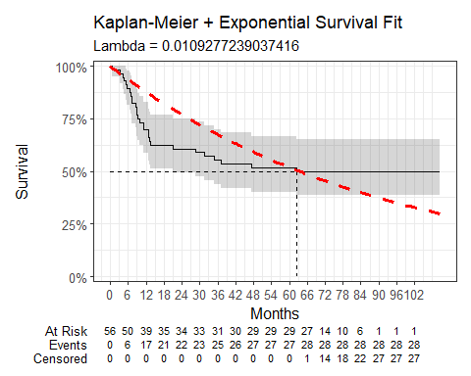

Cohort 2 Table 2: Parameter estimates for Exponential survival model
Variable | Estimate | Std. Error | z | p-value
(Intercept) | 4.5165 | 0.189 | 23.8988 | 0
Model diagnostics: Log-likelihood = -154.46; AIC = 310.92; BIC = 312.95

Weibull
Cohort 2 Figure 3: Kaplan-Meier plot with Weibull fit of overall survival amongst patients who have received blinatumomab
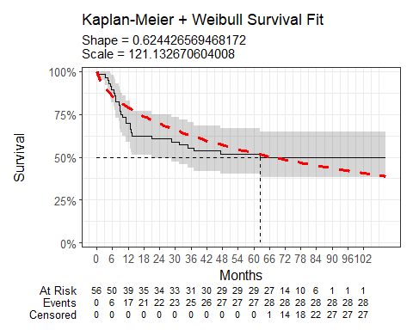

Cohort 2 Table 3: Parameter estimates for Weibull survival model
Variable | Estimate | Std. Error | z | p-value
(Intercept) | 4.7969 | 0.3347 | 14.3306 | 0.0000
Log(scale) | 0.4709 | 0.1696 | 2.7769 | 0.0055
Model diagnostics: Log-likelihood = -149.79; AIC = 303.58; BIC = 307.63

Log-Normal
Cohort 2 Figure 4: Kaplan-Meier plot with Log-Normal fit of overall survival amongst patients who have received blinatumomab
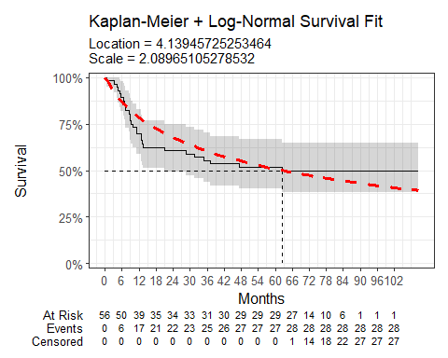

Cohort 2 Table 4: Parameter estimates for Log-Normal survival model
Variable | Estimate | Std. Error | z | p-value
(Intercept) | 4.1395 | 0.3429 | 12.0716 | 0
Log(scale) | 0.7370 | 0.1520 | 4.8493 | 0
Model diagnostics: Log-likelihood = -146.62; AIC = 297.24; BIC = 301.3

Log-Logistic
Cohort 2 Figure 5: Kaplan-Meier plot with Log-Logistic fit of overall survival amongst patients who have received blinatumomab
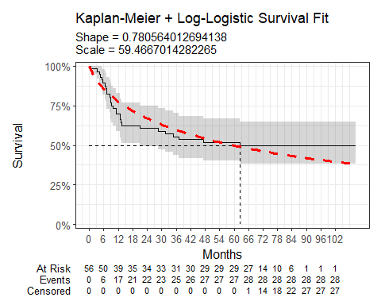

Cohort 2 Table 5: Parameter estimates for Log-Logistic survival model
Variable | Estimate | Std. Error | z | p-value
(Intercept) | 4.0854 | 0.3401 | 12.0118 | 0.0000
Log(scale) | 0.2477 | 0.1612 | 1.5364 | 0.1244
Model diagnostics: Log-likelihood = -147.95; AIC = 299.9; BIC = 303.95

Gaussian
Cohort 2 Figure 6: Kaplan-Meier plot with Gaussian fit of overall survival amongst patients who have received blinatumomab
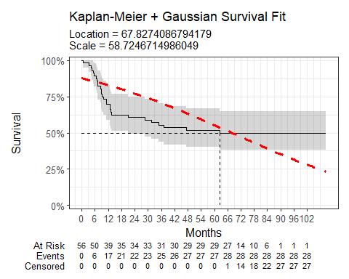

Cohort 2 Table 6: Parameter estimates for Gaussian survival model
Variable | Estimate | Std. Error | z | p-value
(Intercept) | 67.8274 | 9.6184 | 7.0519 | 0
Log(scale) | 4.0729 | 0.1537 | 26.4992 | 0
Model diagnostics: Log-likelihood = -174.73; AIC = 353.46; BIC = 357.52

Gamma
Cohort 2 Figure 7: Kaplan-Meier plot with Gamma fit of overall survival amongst patients who have received blinatumomab
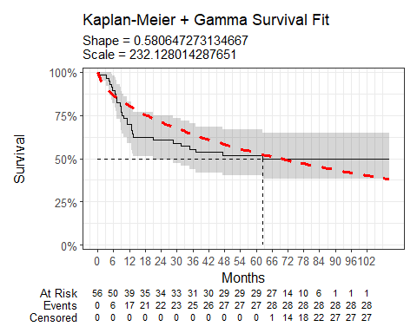

Cohort 2 Table 7: Parameter estimates for Gamma survival model
Variable | Estimate | L95% | U95% | Std. Error | p-value
shape | 0.5806 | 0.3828 | 0.8808 | 0.1234 | 0.0000
rate | 0.0043 | 0.0016 | 0.0113 | 0.0021 | 0.0413
Model diagnostics: Log-likelihood = -150.74; AIC = 305.48; BIC = 309.53

Generalised Gamma
Cohort 2 Figure 8: Kaplan-Meier plot with Generalised-Gamma fit of overall survival amongst patients who have received blinatumomab
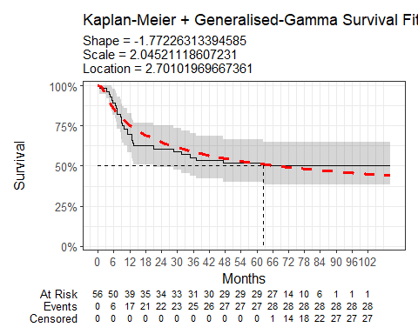

Cohort 2 Table 8: Parameter estimates for Generalised Gamma survival model
Variable | Estimate | L95% | U95% | Std. Error | p-value
mu | 2.7010 | 1.6001 | 3.8019 | 0.5617 | 0.0000
sigma | 2.0452 | 1.5232 | 2.7462 | 0.3075 | 0.0000
Q | -1.7723 | -3.0322 | -0.5123 | 0.6428 | 0.0058
Model diagnostics: Log-likelihood = -143.78; AIC = 293.57; BIC = 299.64

Gompertz
Cohort 2 Figure 9: Kaplan-Meier plot with Gompertz fit of overall survival amongst patients who have received blinatumomab
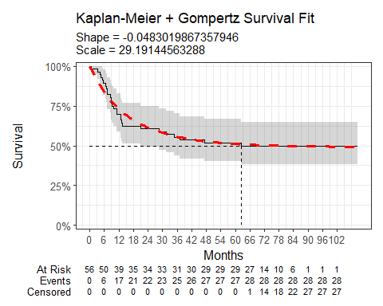

Cohort 2 Table 9: Parameter estimates for Gompertz survival model
Variable | Estimate | L95% | U95% | Std. Error | p-value
shape | -0.0483 | -0.0725 | -0.0241 | 0.0123 | 1e-04
rate | 0.0343 | 0.0202 | 0.0580 | 0.0092 | 2e-04
Model diagnostics: Log-likelihood = -143.39; AIC = 290.77; BIC = 294.82

Stem Cell Transplants
30 of the 56 cases in this cohort had a stem cell transplant following the first administration of blinatumomab

Time-on-Treatment
Cohort 2 Figure 10: Kaplan-Meier plot of time-on-treatment amongst patients who have received Blinatumumab
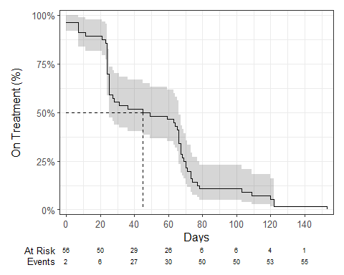

The median time-on-treatment was 47 days.

Data Resource Profile: The Systemic Anti-Cancer Therapy (SACT) dataset | International Journal of Epidemiology | Oxford Academic
Overview | Tisagenlecleucel for treating relapsed or refractory B-cell acute lymphoblastic leukaemia in people 25 years and under | Guidance | NICE
Overview | Tisagenlecleucel for treating relapsed or refractory B-cell acute lymphoblastic leukaemia in people 25 years and under | Guidance | NICE
von Stackelberg A, Locatelli F, Zugmaier G, Handgretinger R, Trippett TM, Rizzari C, et al. Phase I/Phase II Study of Blinatumomab in Pediatric Patients With Relapsed/Refractory Acute Lymphoblastic Leukemia. Journal of Clinical Oncology: Official Journal of the American Society of Clinical Oncology. 2016 Dec;34(36):4381–9.
Overview | Blinatumomab for treating acute lymphoblastic leukaemia in remission with minimal residual disease activity | Guidance | NICE
Parker C, Waters R, Leighton C, Hancock J, Sutton R, Moorman AV, et al. Effect of mitoxantrone on outcome of children with first relapse of acute lymphoblastic leukaemia (ALL R3): An open-label randomised trial. Lancet (London, England). 2010 Dec;376(9757):2009–17
Overview | Tisagenlecleucel for treating relapsed or refractory B-cell acute lymphoblastic leukaemia in people 25 years and under | Guidance | NICE

