NDRS-NICE partnership report

Background
This report was produced in partnership by the National Disease and Registration Service (NDRS) and National Institute for Health and Care Excellence (NICE). NDRS and NICE have established a partnership focused on routinely collected data to support NICE decision making on the appraisals of cancer treatments. The partnership uses NDRS datasets, including the information submitted by trusts to the Systemic Anti-Cancer Therapy (SACT) dataset, to provide an understanding of current practice.
To determine a severity modifier, NICE considers factors such as the age, gender, and overall survival of the patient cohort affected by the disease. Additionally, knowing the time-on-treatment for each therapy is useful, as it validates assumptions made in technology appraisal evaluations about the duration of treatment use.
This partnership is focused on producing demographic and survival information using NDRS data, alongside supplementary information tailored to each technology appraisal. These may include, for example, the time patients spend on particular treatments, genetic data where this is available, or other information on real-world care pathways. Interpretation of the data is not included in this report, it is the information as provided to the NICE technology appraisal committees. Detail on how NICE health technology appraisals use this data can be found in the NICE health technology evaluations manual, with specific information relating to the survival analysis modelling available in Technical Support Document (TSD).
The focus of this report is the indication ID6442: Mirvetuximab soravtansine for treating folate receptor alpha-positive platinum-resistant advanced epithelial ovarian, fallopian tube or primary peritoneal cancer
A single cohort was assessed for this indication:
- Adults with platinum-resistant advanced epithelial ovarian, fallopian tube or primary peritoneal cancer treated with pegylated liposomal doxorubicin (PLD) or paclitaxel monotherapies (pooled chemotherapy cohort)

Age and overall survival for adults with platinum-resistant advanced epithelial ovarian, fallopian tube or primary peritoneal cancer

Introduction
This report was produced in partnership by the National Disease and Registration Service (NDRS) and National Institute for Health and Care Excellence (NICE). It presents overall survival and age distributions among patients aged 18 or over with platinum-resistant advanced epithelial ovarian, fallopian tube or primary peritoneal cancer treated with pegylated liposomal doxorubicin (PLD) or paclitaxel monotherapies (pooled chemotherapy).

Method
A snapshot of SACT data was taken on 7th December 2025 and made available for analysis on 19th December 2025. SACT data is only considered complete when 90% of trusts have submitted data, which at the time of analysis was 31st March 2025. This date is used as the upper limit when selecting regimens of interest. Patients were traced for their vital status on 5th October 2025, which is the censoring date for the overall survival analysis.
Descriptive statistics of age were computed, along with Kaplan-Meier estimates and parametric fits for overall survival. Patients were censored at the date of the most recent trace (5th October 2025), representing the last date on which vital status was confirmed.

Cohort inclusions / exclusions
Patients were included if they met all of the following:
- Diagnosed between 1st January 2010 and 31st December 2023
- Gender recorded as female
- Country code was England, based on postcode of residence at diagnosis
- Age at diagnosis date was 18 or over
- ICD-10 diagnosis code was one of the following:
  - ‘C56’ - Malignant neoplasm of ovary
  - ‘C570’ - Malignant neoplasm of other and unspecified female genital organs: fallopian tube
  - ‘C481’ - Malignant neoplasm of retroperitoneum and peritoneum: specified parts of peritoneum
  - ‘C482’ - Malignant neoplasm of retroperitoneum and peritoneum: peritoneum, unspecified
- Only one tumour was recorded during the study period
- No registration for another malignant neoplasm within the 36 months preceding diagnosis
- PLD or paclitaxel monotherapy was initiated on or after 27th April 2016 (NICE TA389 publication date). Usage before this point would be through the Cancer Drugs Fund or compassionate use schemes
- PLD or paclitaxel monotherapy was initiated on or before the point at which SACT is considered complete (31st March 2025)
- PLD or paclitaxel monotherapy was not recorded as being administered in an adjuvant/neoadjuvant or curative setting
- Individuals had received treatment with a platinum-based therapy (cisplatin, carboplatin, oxaliplatin) prior to initiating PLD or paclitaxel monotherapy
Note: Folate receptor-α genetic status was not considered due to low data completeness.

Identification of platinum resistant cases
PLD and paclitaxel monotherapies are recommended as treatments for individuals with platinum-resistant disease, defined as disease progression occurring within 6 months of the last platinum-based chemotherapy regimen. Platinum-resistance may arise following 1st line platinum-based therapy or after subsequent lines of treatment. As PLD or paclitaxel monotherapy is recommended only for platinum-resistant disease, initiation of either monotherapy was used as a proxy indicator for platinum-resistance.
Owing to variation in SACT recording practices and the structure of SACT tables, it can be challenging to algorithmically distinguish PLD and paclitaxel monotherapies from other lines of therapy, where these agents are given in combination with a platinum-based therapy (e.g. paclitaxel plus carboplatin). These combinations may be grouped at the regimen level in SACT or recorded as contemporaneous but separate (‘split’) regimens.
To reduce misclassification of PLD or paclitaxel monotherapies, we: (i) count only regimens where the NDRS‑categorised description (“benchmark group”) specifies PLD or paclitaxel alone; (ii) exclude regimens where a platinum-based therapy appears in the drug-level tables for a PLD or paclitaxel monotherapy regimen (iii) exclude regimens where a drug-level record of a platinum-based therapy occurs within ±7 days of the PLD or paclitaxel monotherapy regimen start date. When given in combination PLD or paclitaxel is usually administered on the same day as a platinum agent. This ±7-day window was chosen as a pragmatic buffer to allow for a degree of real-world variation in clinical practice.

Sensitivity analyses
To assess the robustness of the study findings, a series of sensitivity analyses were conducted. These analyses examined the impact of varying the inclusion and exclusion criteria used to define the study population, and how these variations influenced both the size of the study population and the estimated overall survival.
The table below summarises the sensitivity analyses undertaken and their corresponding effects on population size and overall survival estimates.
Assumption | Population | N | Median survival | Restricted mean survival (Whole curve)
- | Base population: OFP diagnosis, any stage at diagnosis, PLD/paclitaxel monotherapy initiated, prior platinum-based therapy | 7,083 | 8.54 months | 13.57 months
Morphology | Base population, but only individuals with an epithelial morphology code (stricter population) | 7,004 | 8.51 months | 13.54 months
Staging at diagnosis | Base population, but only individuals with stage 3/4 at diagnosis (stricter population) | 5,798 | 8.51 months | 13.19 months
Intent of treatment | Base population, but including PLD or paclitaxel regimens given with adjuvant, neoadjuvant or curative intent (relaxed population) | 7,331 | 8.54 months | 13.62 months
Prior platinum-based therapy | Base population, but removing need for a prior platinum-based therapy (relaxed population) | 7,596 | 8.61 months | 13.82 months
Table 1: Sensitivity analyses

Flow chart
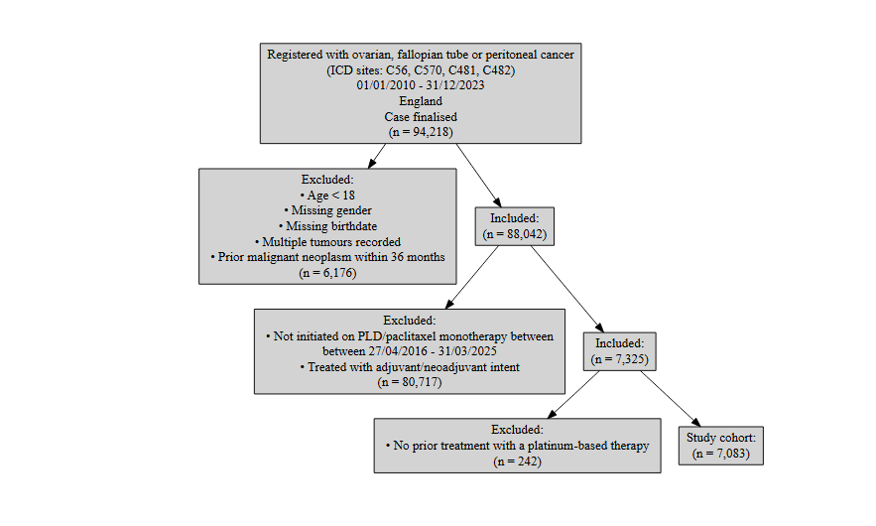
Figure 1: Inclusion / Exclusion Flow Chart

Patient acknowledgement
This work uses data that has been provided by patients and collected by the NHS as part of their care and support. The data is collated, maintained and quality assured by the National Cancer Registration and Analysis Service, which is part of NHS England.

Results

Age at start of treatment
The table below sets out the mean age, standard deviation, median age and interquartile range (IQR) of patients who have received PLD or paclitaxel for platinum-resistant advanced epithelial ovarian, fallopian tube or primary peritoneal cancer. Age is measured at the commencement of the first treatment regimen of PLD or paclitaxel monotherapy.
Characteristic | N = 7,083¹
Age at start of regimen | 67, (10) : 68 (60, 75)
¹Mean, (SD) : Median (Q1, Q3)
Table 2: Mean age, standard deviation, median age and IQR of patients who have received PLD or paclitaxel monotherapy

Figure 2: Age distribution of patients who have received PLD or paclitaxel monotherapy
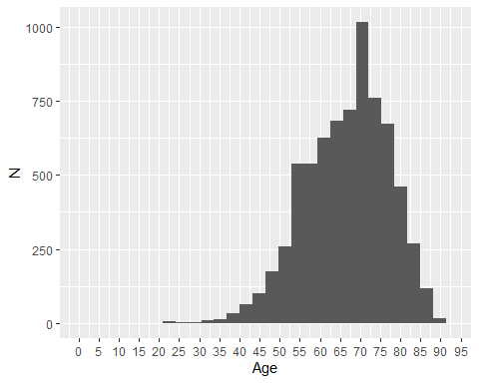

Overall survival

Base K-M plot
The Kaplan-Meier plot below shows survival over time for those receiving a treatment regimen of PLD or paclitaxel monotherapy.
Median survival was 8.54 months. Restricted mean survival (over the whole curve) was 13.57 months. The minimum follow-up time was 0.1 months, median 8.3 months, and maximum follow-up time of 113 months.
Figure 3: Overall survival amongst patients who have received PLD or paclitaxel monotherapy
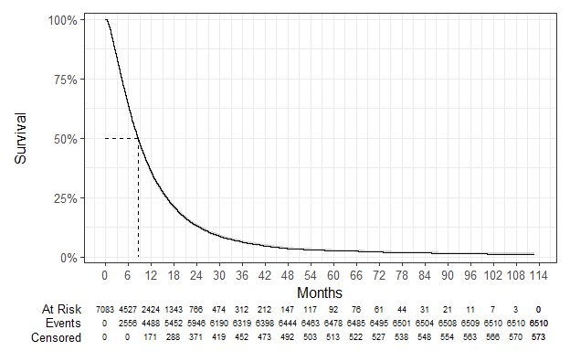

Exponential
Figure 4: Overall survival against exponential survival function
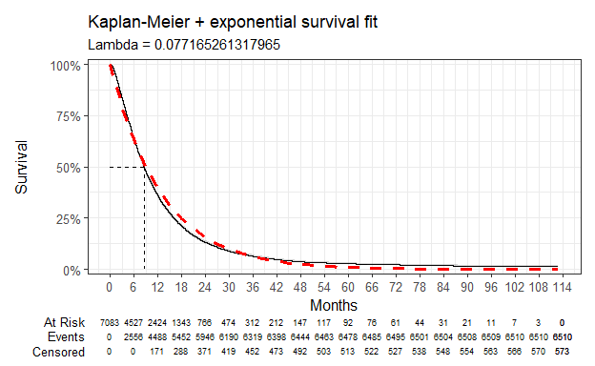

Parameter | Estimate | Std. Error | z | p-value
(Intercept) | 2.562 | 0.012 | 206.6982 | 0
log-likelihood = -23187.3564491549
AIC = 46376.7128983098
BIC = 46383.5783511355
Table 3: Survival model fit summary (exponential distribution)

Weibull
Figure 5: Overall survival against Weibull survival function
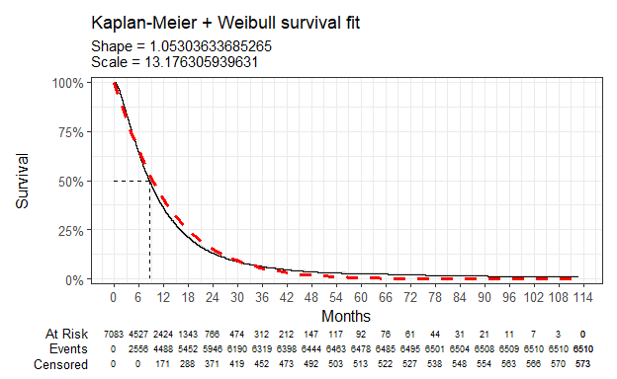

Parameter | Estimate | Std. Error | z | p-value
(Intercept) | 2.578 | 0.012 | 211.980246 | 0.000000e+00
Log(scale) | -0.052 | 0.009 | -5.597361 | 2.176394e-08
log-likelihood = -23172.1665303428
AIC = 46348.3330606855
BIC = 46362.063966337
Table 4: Survival model fit summary (Weibull distribution)

Log-normal
Figure 6: Overall survival against log-normal survival function
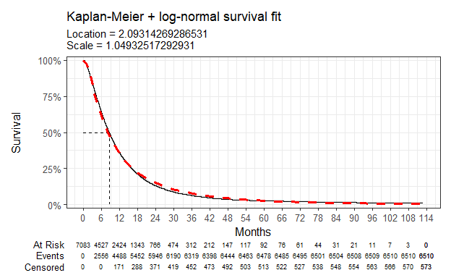

Parameter | Estimate | Std. Error | z | p-value
(Intercept) | 2.093 | 0.013 | 166.078903 | 0.000000e+00
Log(scale) | 0.048 | 0.009 | 5.420214 | 5.952776e-08
log-likelihood = -22894.935132085
AIC = 45793.8702641699
BIC = 45807.6011698215
Table 5: Survival model fit summary (log-normal distribution)

Log-logistic
Figure 7: Overall survival against log-logistic survival function
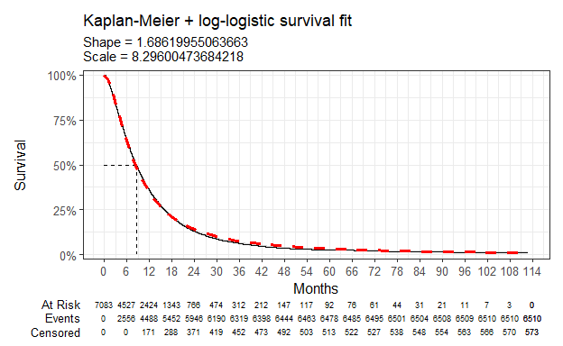

Parameter | Estimate | Std. Error | z | p-value
(Intercept) | 2.116 | 0.012 | 172.33498 | 0
Log(scale) | -0.522 | 0.010 | -50.63594 | 0
log-likelihood = -22857.4831851504
AIC = 45718.9663703008
BIC = 45732.6972759523
Table 6: Survival model fit summary (log-logistic distribution)

Gaussian
Figure 8: Overall survival against Gaussian survival function
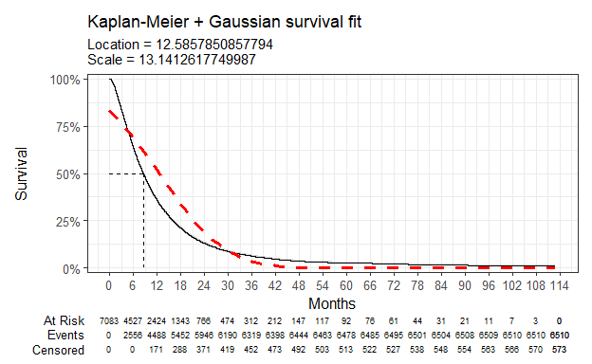

Parameter | Estimate | Std. Error | z | p-value
(Intercept) | 12.586 | 0.158 | 79.64473 | 0
Log(scale) | 2.576 | 0.009 | 290.53888 | 0
log-likelihood = -26588.8001426688
AIC = 53181.6002853376
BIC = 53195.3311909891
Table 7: Survival model fit summary (Gaussian distribution)

Gamma
Figure 9: Overall survival against gamma survival function
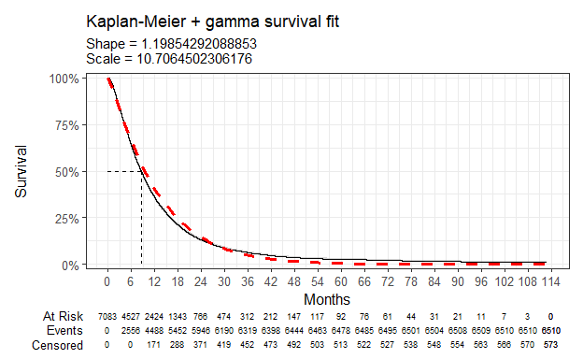

Parameter | Estimate | Std. Error | L95. | U95.
shape | 1.199 | 0.019 | 1.16255090 | 1.23564924
rate | 0.093 | 0.002 | 0.08983505 | 0.09710983
log-likelihood = -23122.7203191803
AIC = 46249.4406383606
BIC = 46263.1715440121
Table 8: Survival model fit summary (gamma distribution)

Generalised gamma
Figure 10: Overall survival against generalised gamma survival function
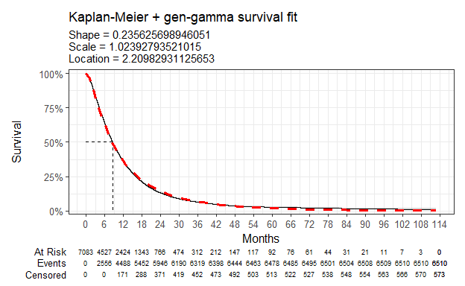

Parameter | Estimate | Std. Error | L95. | U95.
mu | 2.210 | 0.019 | 2.1720048 | 2.2476539
sigma | 1.024 | 0.010 | 1.0050202 | 1.0431913
Q | 0.236 | 0.030 | 0.1765289 | 0.2947225
log-likelihood = -22864.4557531161
AIC = 45734.9115062322
BIC = 45755.5078647095
Table 9: Survival model fit summary (generalised gamma distribution)

Gompertz
Figure 11: Overall survival against Gompertz survival function
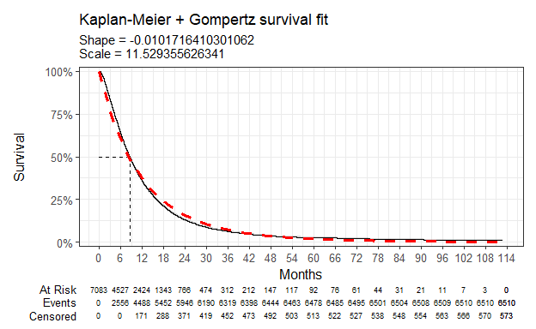

Parameter | Estimate | Std. Error | L95. | U95.
shape | -0.010 | 0.001 | -0.01216473 | -0.008178554
rate | 0.087 | 0.001 | 0.08398222 | 0.089578256
log-likelihood = -23131.2241491928
AIC = 46266.4482983856
BIC = 46280.1792040371
Table 10: Survival model fit summary (Gompertz distribution)

Chloe J. Bright et al., “Data Resource Profile: The Systemic Anti-Cancer Therapy (SACT) dataset,” International Journal of Epidemiology 49, no. 1 (February 2020): 15–15l, https://dx.doi.org/10.1093/ije/dyz137.
NICE health technology evaluations: the manual (2025) NICE process and methods PMG36. Last updated 23 October 2025, n.d., https://www.nice.org.uk/process/pmg36.
Latimer Nicholas, NICE DSU Technical Support Document 14: Undertaking survival analysis for economic evaluations alongside clinical trials - extrapolation with patient-level data, 2011, http://www.nicedsu.org.uk/.

