NDRS – NICE Partnership Report ID6332

Background
This report was produced in partnership by the National Disease and Registration Service (NDRS) and National Institute for Health and Care Excellence (NICE). NDRS and NICE have established a partnership focused on routinely collected data to support NICE decision making on the appraisals of cancer treatments. The partnership uses NDRS datasets, including the information submitted by trusts to the Systemic Anti-Cancer Therapy (SACT) dataset, to provide an understanding of current practice.
To determine a severity modifier, NICE considers factors such as the age, gender, and overall survival of the patient cohort affected by the disease. Additionally, knowing the time-on-treatment for each therapy is useful, as it validates assumptions made in technology appraisal evaluations about the duration of treatment use.
This partnership is focused on producing demographic and survival information using NDRS data, alongside supplementary information tailored to each technology appraisal. These may include, for example, the time patients spend on particular treatments, genetic data where this is available, or other information on real-world care pathways. Interpretation of the data isn’t included in this report, it is the information as provided to the NICE technology appraisal committees. Detail on how NICE health technology appraisals use this data can be found in the NICE health technology evaluations manual , with specific information relating to the survival analysis modelling available in Technical Support Document (TSD) 14.
The focus of this report is the indication ID6332: Enfortumab vedotin with pembrolizumab for first-line treatment of unresectable or metastatic urothelial cancer who are eligible for platinum-containing chemotherapy
Three cohorts were assessed for this indication:
Cohort 1: Patients receiving platinum-based chemotherapy with gemcitabine with unresectable or metastatic urothelial cancer
Cohort 2: Patients receiving platinum-based chemotherapy with gemcitabine AND avelumab maintenance (NB: avelumab has only been available since 2022 for routine commissioning)
Cohort 3: Patients receiving platinum-based chemotherapy with gemcitabine irrespective of subsequent avelumab maintenance

Age, Gender and Overall Survival for Gemcitabine + Platinum Chemo (no Avelumab)

Introduction
This report was produced in partnership by the National Disease Registration Service (NDRS) and National Institute for Health and Care Excellence (NICE). It presents overall survival and patient characteristics among patients who have received platinum-based chemotherapy with gemcitabine for the treatment of metastatic urothelial cancer with no record of avelumab maintenance.

Method
A snapshot of SACT data was taken on 4th January 2025 and made available for analysis on 20th January 2025. SACT data is only considered complete when 90% of trusts have submitted data. As a result, SACT data is considered complete up to 31st March 2024. Patients were traced for their vital status on 5th October 2024.
Descriptive statistics of age and gender were computed, as well as overall survival (OS) Kaplan-Meier graphs and parametric fits.

Cohort inclusions / exclusions
Patients were included in this cohort where:
- tumour site was consistent with the NDRS site groups ‘Bladder’, ‘Renal pelvis and ureter’, or ‘Urethra’
- country code was ‘England’
- age was 18 or over
- gender field was known (male or female)
- diagnosis occurred between 2020 and 2022
- stage of 4 (4, 4A or 4B) at diagnosis
- M of 1 (distant metastases) or unknown
- first systemic treatment was gemcitabine plus platinum chemotherapy (first regimen following diagnosis, identified using start date of regimen)
and excluded where:
- multiple tumours of interest (bladder, renal pelvis and ureter) were diagnosed between 2020 and 2022
- subsequent treatment (up to 31st March 2024) included avelumab

Patient Acknowledgement
This work uses data that has been provided by patients and collected by the NHS as part of their care and support. The data is collated, maintained and quality assured by the National Cancer Registration and Analysis Service, which is part of NHS England.

Results

Age at start of treatment
The table below sets out the mean age, standard (std.) deviation, median age and inter-quartile range (IQR) of patients who have received platinum-based chemotherapy with gemcitabine (no subsequent avelumab maintenance). Age is measured at the commencement of the first treatment regimen.

Cohort 1 Table 1: Mean age, standard deviation, median age and IQR of patients who have received platinum-based chemotherapy with gemcitabine (no subsequent avelumab maintenance)
Characteristic | Female N = 210¹ | Male N = 432¹
Age at start of regimen | 67, (10) : 68 (61, 75) | 69, (10) : 71 (64, 76)
¹Mean, (SD) : Median (Q1, Q3)

Cohort 1 Figure 1: Age distribution of patients who have received platinum-based chemotherapy with gemcitabine (no subsequent avelumab maintenance)
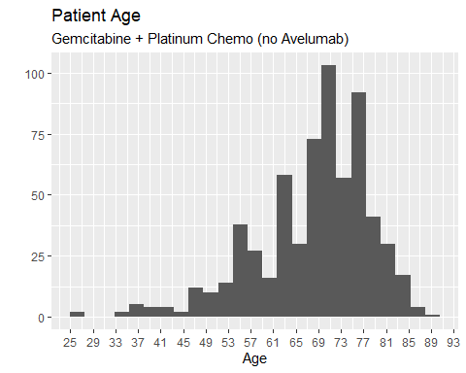
Cohort 1 Figure 2: Age distribution of patients who have received platinum-based chemotherapy with gemcitabine (no subsequent avelumab maintenance), by gender
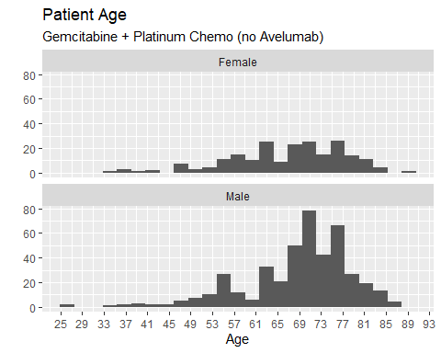

Overall Survival

Base K-M plot
The Kaplan-Meier plot below shows survival over time for those receiving a treatment regimen of platinum-based chemotherapy with gemcitabine (no subsequent avelumab maintenance). The median overall survival (OS) was 8.4 months, confidence interval (CI) (7.7 months, 9.3 months).
Cohort 1 Figure 3: Overall survival amongst patients who have received platinum-based chemotherapy with gemcitabine (no subsequent avelumab maintenance)
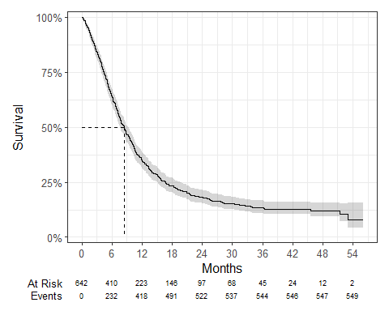

Exponential
Cohort 1 Figure 4: Overall survival against exponential survival function
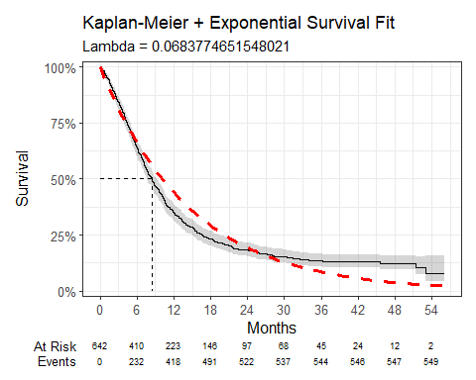
Cohort 1 Table 2: Survival Model Fit Summary (Exponential distribution)
Parameter | Estimate | Std. Error | z | p-value
(Intercept) | 2.683 | 0.043 | 62.85795 | 0
log-likelihood = -2021.80886904916
AIC = 4045.617738
BIC = 4050.082326

Weibull
Cohort 1 Figure 5: Overall survival against Weibull survival function
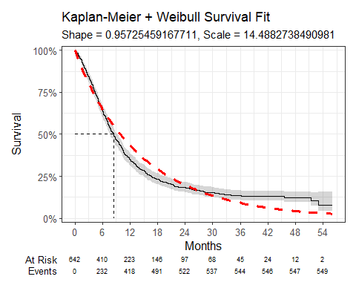
Cohort 1 Table 3: Survival Model Fit Summary (Weibull distribution)
Parameter | Estimate | Std. Error | z | p-value
(Intercept) | 2.673 | 0.045 | 59.241789 | 0.0000000
Log(scale) | 0.044 | 0.034 | 1.289564 | 0.1972022
log-likelihood = -2020.95852877918
AIC = 4045.917058
BIC = 4054.846234

Log-Normal
Cohort 1 Figure 6: Overall survival against Log-Normal survival function
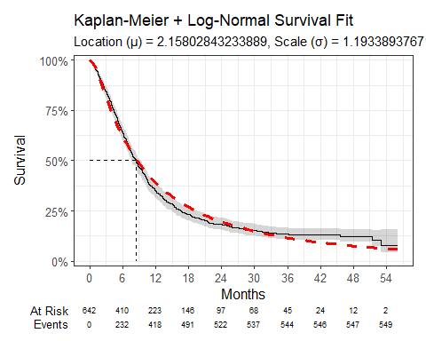
Cohort 1 Table 4: Survival Model Fit Summary (Log-Normal distribution)
Parameter | Estimate | Std. Error | z | p-value
(Intercept) | 2.158 | 0.048 | 45.020112 | 0.00000e+00
Log(scale) | 0.177 | 0.031 | 5.646022 | 1.64203e-08
log-likelihood = -1986.11899735246
AIC = 3976.237995
BIC = 3985.167171

Log-Logistic
Cohort 1 Figure 7: Overall survival against Log-Logistic survival function
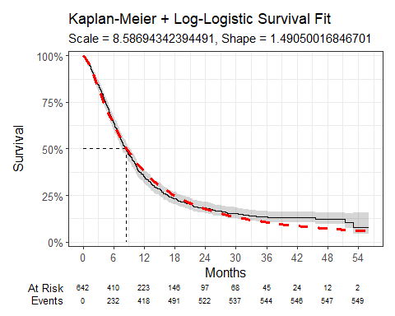
Cohort 1 Table 5: Survival Model Fit Summary (Log-Logistic distribution)
Parameter | Estimate | Std. Error | z | p-value
(Intercept) | 2.150 | 0.046 | 47.09556 | 0.000000e+00
Log(scale) | -0.399 | 0.036 | -11.10994 | 1.122319e-28
log-likelihood = -1977.03051896372
AIC = 3958.061038
BIC = 3966.990215

Gaussian
Cohort 1 Figure 8: Overall survival against Gaussian survival function
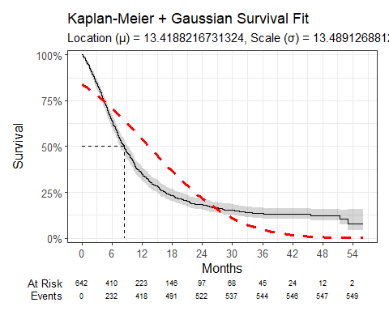
Cohort 1 Table 6: Survival Model Fit Summary (Gaussian distribution)
Parameter | Estimate | Std. Error | z | p-value
(Intercept) | 13.419 | 0.541 | 24.82184 | 5.210194e-136
Log(scale) | 2.602 | 0.032 | 82.54919 | 0.000000e+00
log-likelihood = -2321.95966636666
AIC = 4647.919333
BIC = 4656.848509

Age, Gender and Overall Survival for Gemcitabine + Platinum Chemo (with Avelumab maintenance)

Introduction
This report was produced in partnership by the National Disease Registration Service (NDRS) and National Institute for Health and Care Excellence (NICE). It presents overall survival and patient characteristics among patients who have received platinum-based chemotherapy with gemcitabine and avelumab maintenance for the treatment of metastatic urothelial cancer.

Method
A snapshot of SACT data was taken on 4th January 2025 and made available for analysis on 20th January 2025. SACT data is only considered complete when 90% of trusts have submitted data. As a result, SACT data is considered complete up to 31st March 2024. Patients were traced for their vital status on 5th October 2024.
Descriptive statistics of age and gender were computed, as well as overall survival (OS) Kaplan-Meier graphs and parametric fits. Time on Treatment was measured by the difference between a patient’s first and last avelumab administration date, plus a prescription length of fourteen days. If the patient had an administration date after 15 March 2024, the patient is assumed to still be on treatment and censored.

Cohort inclusions / exclusions
Patients were included in this cohort where :
- tumour site was consistent with the NDRS site groups ‘Bladder’, ‘Renal pelvis and ureter’, or ‘Urethra’
- country code was ‘England’
- age was 18 or over
- gender field was known (male or female)
- diagnosis occurred between 2020 and 2022
- stage of 4 (4, 4A or 4B) at diagnosis
- M of 1 (distant metastases) or unknown
- first systemic treatment was Gemcitabine plus platinum chemotherapy (first regimen following diagnosis, identified using start date of regimen)
- subsequent treatment (up to 31st March 2024) included Avelumab
and excluded where:
- multiple tumours of interest (bladder, renal pelvis and ureter) were diagnosed between 2020 and 2022

Patient Acknowledgement
This work uses data that has been provided by patients and collected by the NHS as part of their care and support. The data is collated, maintained and quality assured by the National Cancer Registration and Analysis Service, which is part of NHS England.

Results

Age at start of treatment
The table below sets out the mean age, std. deviation, median age and IQR of patients who have received Gemcitabine + Platinum Chemo (with Avelumab maintenance). Age is measured at the commencement of the first treatment regimen.
Cohort 2 Table 1: Mean age, standard deviation, median age and IQR of patients who have received platinum-based chemotherapy with gemcitabine and avelumab maintenance
Characteristic | Female N = 44¹ | Male N = 107¹
Age at start of regimen | 66, (11) : 70 (60, 73) | 68, (10) : 69 (62, 75)
¹Mean, (SD) : Median (Q1, Q3)

Cohort 2 Figure 1: Age distribution of patients who have received platinum-based chemotherapy with gemcitabine and avelumab maintenance
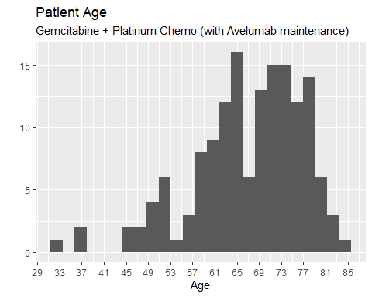
Cohort 2 Figure 2: Age distribution of patients who have received platinum-based chemotherapy with gemcitabine and avelumab maintenance, by gender
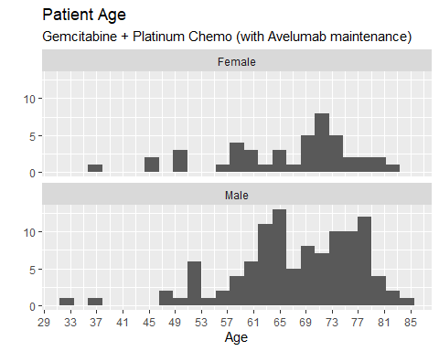

Overall Survival

Base K-M plot
The Kaplan-Meier plot below shows survival over time for those receiving a treatment regimen of platinum-based chemotherapy with gemcitabine and avelumab maintenance. The median OS was 16.7 months, CI (14.7 months, 19.4 months).

Cohort 2 Figure 3: Overall survival amongst patients who have received platinum-based chemotherapy with gemcitabine and avelumab maintenance
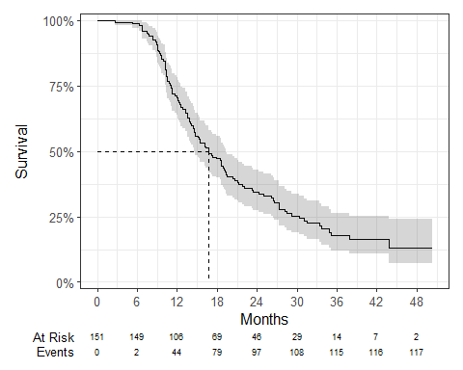

Exponential
Cohort 2 Figure 4: Overall survival against Exponential survival function
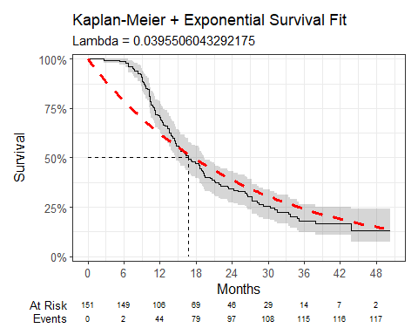
Cohort 2 Table 2: Survival Model Fit Summary (Exponential distribution)
Parameter | Estimate | Std. Error | z | p-value
(Intercept) | 3.230 | 0.092 | 34.93968 | 1.857933e-267
log-likelihood = -494.930393656135
AIC = 991.8607873
BIC = 994.8780671

Weibull
Cohort 2 Figure 5: Overall survival against Weibull survival function
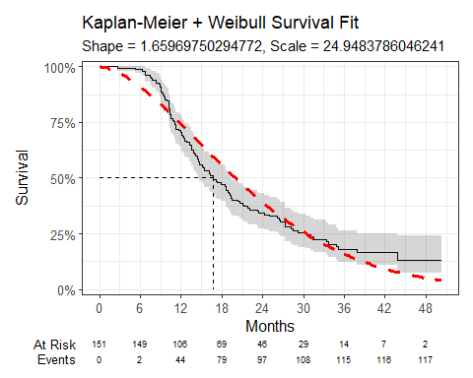
Cohort 2 Table 3: Survival Model Fit Summary (Weibull distribution)
Parameter | Estimate | Std. Error | z | p-value
(Intercept) | 3.217 | 0.056 | 57.590691 | 0.000000e+00
Log(scale) | -0.507 | 0.073 | -6.925757 | 4.336495e-12
log-likelihood = -476.229805857177
AIC = 956.4596117
BIC = 962.4941714

Log-Normal
Cohort 2 Figure 6: Overall survival against Log-Normal survival function
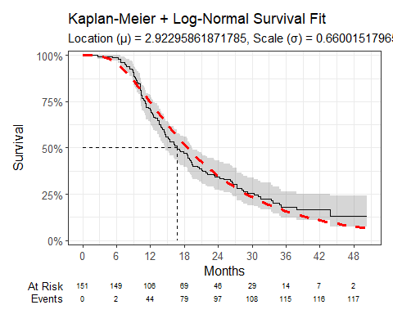
Cohort 2 Table 4: Survival Model Fit Summary (Log-Normal distribution)
Parameter | Estimate | Std. Error | z | p-value
(Intercept) | 2.923 | 0.056 | 52.278668 | 0.000000e+00
Log(scale) | -0.415 | 0.069 | -6.057438 | 1.383068e-09
log-likelihood = -462.448013222687
AIC = 928.8960264
BIC = 934.9305861

Log-Logistic
Cohort 2 Figure 7: Overall survival against Log-Logistic survival function
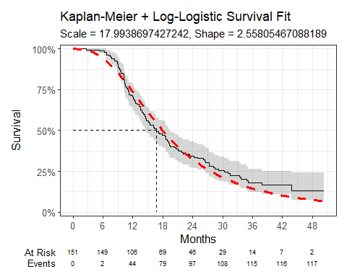
Cohort 2 Table 5: Survival Model Fit Summary (Log-Logistic distribution)
Parameter | Estimate | Std. Error | z | p-value
(Intercept) | 2.890 | 0.057 | 50.98547 | 0.000000e+00
Log(scale) | -0.939 | 0.076 | -12.33164 | 6.118534e-35
log-likelihood = -463.80042341938
AIC = 931.6008468
BIC = 937.6354065

Gaussian
Cohort 2 Figure 8: Overall survival against Gaussian survival function
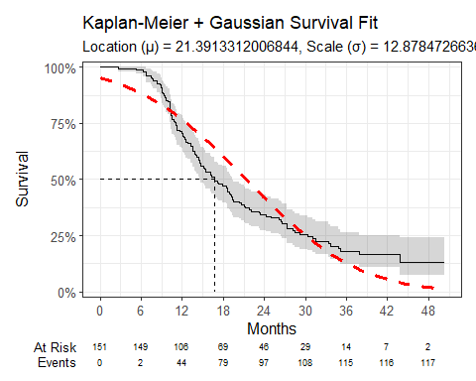
Cohort 2 Table 6: Survival Model Fit Summary (Gaussian distribution)
Parameter | Estimate | Std. Error | z | p-value
(Intercept) | 21.391 | 1.090 | 19.61993 | 1.044982e-85
Log(scale) | 2.556 | 0.069 | 37.21418 | 4.025581e-303
log-likelihood = -498.470041748085
AIC = 1000.940083
BIC = 937.635406

Time on Treatment - Avelumab maintenance only
The Kaplan-Meier plot below shows Time on Treatment (ToT) for patients receiving avelumab maintenance. The median ToT was 4.7 months, CI (3.3 months, 5.99 months).

Cohort 2 Figure 9: Time on Treatment (ToT) for patients receiving avelumab maintenance
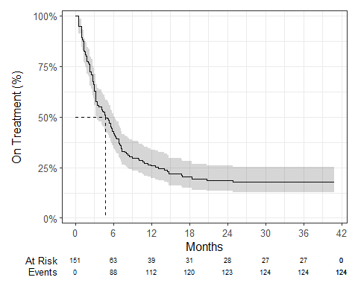

Age, Gender and Overall Survival for Gemcitabine + Platinum Chemo (irrespective of subsequent Avelumab maintenance)

Introduction
This report was produced in partnership by the National Disease Registration Service (NDRS) and National Institute for Health and Care Excellence (NICE). It presents overall survival and patient characteristics among patients who have received platinum-based chemotherapy with gemcitabine for the treatment of metastatic urothelial cancer.

Method
A snapshot of SACT data was taken on 4th January 2025 and made available for analysis on 20th January 2025. SACT data is only considered complete when 90% of trusts have submitted data. As a result, SACT data is considered complete up to 31st March 2024. Patients were traced for their vital status on 5th October 2024.
Descriptive statistics of age and gender were computed, as well as overall survival (OS) Kaplan-Meier graphs and parametric fits.

Cohort inclusions / exclusions
Patients were included in this cohort where :
- tumour site was consistent with the NDRS site groups ‘Bladder’, ‘Renal pelvis and ureter’, or ‘Urethra’
- country code was ‘England’
- age was 18 or over
- gender field was known (male or female)
- diagnosis occurred between 2020 and 2022
- stage of 4 (4, 4A or 4B) at diagnosis
- M of 1 (distant metastases) or unknown
- first systemic treatment was Gemcitabine plus platinum chemotherapy (first regimen following diagnosis, identified using start date of regimen)
and excluded where:
- multiple tumours of interest (bladder, renal pelvis and ureter) were diagnosed between 2020 and 2022

Patient Acknowledgement
This work uses data that has been provided by patients and collected by the NHS as part of their care and support. The data is collated, maintained and quality assured by the National Cancer Registration and Analysis Service, which is part of NHS England.

Results

Age at start of treatment
The table below sets out the mean age, std. deviation, median age and IQR of patients who have received Gemcitabine + Platinum Chemo. Age is measured at the commencement of the first treatment regimen.
Cohort 3 Table 1: Mean age, standard deviation, median age and IQR of patients who have received platinum-based chemotherapy with gemcitabine
Characteristic | Female N = 254¹ | Male N = 539¹
Age at start of regimen | 67, (10) : 68 (60, 74) | 69, (10) : 71 (63, 75)
¹Mean, (SD) : Median (Q1, Q3)

Cohort 3 Figure 1: Age distribution of patients who have received platinum-based chemotherapy with gemcitabine
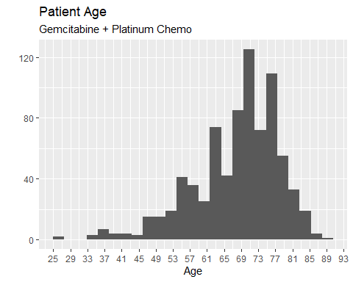

Cohort 3 Figure 2: Age distribution of patients who have received platinum-based chemotherapy with gemcitabine, by gender
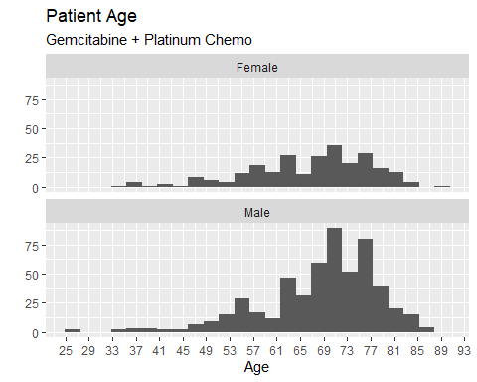

Overall Survival

Base K-M plot
The Kaplan-Meier plot below shows survival over time for those receiving a treatment regimen of platinum-based chemotherapy with gemcitabine. The median OS was 10.1 months, CI (9.4 months, 10.5 months).

Cohort 3 Figure 3: Overall survival amongst patients who have received platinum-based chemotherapy with gemcitabine
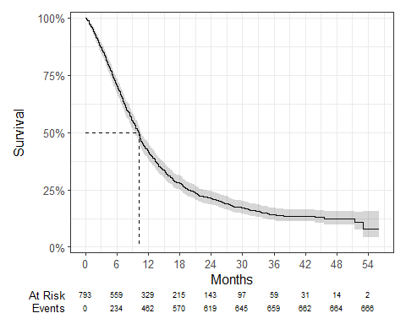

Exponential
Cohort 3 Figure 4: Overall survival against Exponential survival function
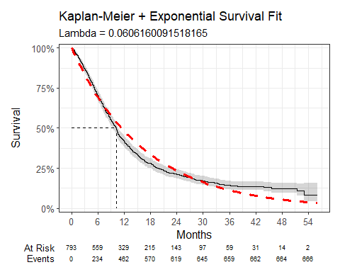
Cohort 3 Table 2: Survival Model Fit Summary (Exponential distribution)
Parameter | Estimate | Std. Error | z | p-value
(Intercept) | 2.803 | 0.039 | 72.34202 | 0
log-likelihood = -2532.9286980943
AIC = 5067.857396
BIC = 5072.533219

Weibull
Cohort 3 Figure 5: Overall survival against Weibull survival function
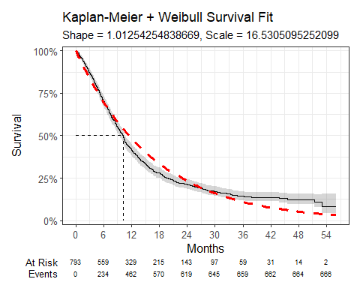
Cohort 3 Table 3: Survival Model Fit Summary (Weibull distribution)
Parameter | Estimate | Std. Error | z | p-value
(Intercept) | 2.805 | 0.039 | 72.6587610 | 0.0000000
Log(scale) | -0.012 | 0.031 | -0.3998801 | 0.6892448
log-likelihood = -2532.84923799132
AIC = 5069.698476
BIC = 5079.050122

Log-Normal
Cohort 3 Figure 6: Overall survival against Log-Normal survival function
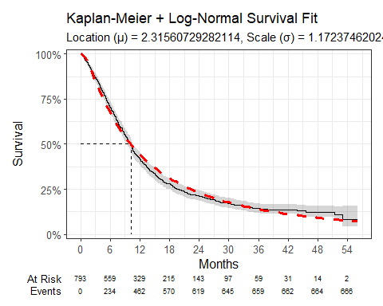
Cohort 3 Table 4: Survival Model Fit Summary (Log-Normal distribution)
Parameter | Estimate | Std. Error | z | p-value
(Intercept) | 2.316 | 0.043 | 54.437483 | 0.000000e+00
Log(scale) | 0.159 | 0.028 | 5.586773 | 2.313279e-08
log-likelihood = -2504.98961058149
AIC = 5013.979221
BIC = 5023.330868

Log-Logistic
Cohort 3 Figure 7: Overall survival against Log-Logistic survival function
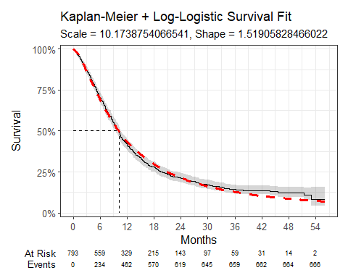
Cohort 3 Table 5: Survival Model Fit Summary (Log-Logistic distribution)
Parameter | Estimate | Std. Error | z | p-value
(Intercept) | 2.320 | 0.040 | 57.42644 | 0.000000e+00
Log(scale) | -0.418 | 0.033 | -12.81816 | 1.297507e-37
log-likelihood = -2493.60581656425
AIC = 4991.211633
BIC = 5000.56328

Gaussian
Cohort 3 Figure 8: Overall survival against Gaussian survival function
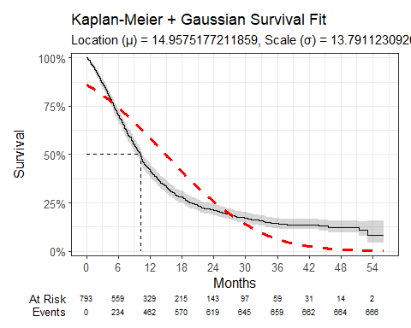
Cohort 3 Table 6: Survival Model Fit Summary (Gaussian distribution)
Parameter | Estimate | Std. Error | z | p-value
(Intercept) | 14.958 | 0.499 | 29.96304 | 2.975834e-197
Log(scale) | 2.624 | 0.029 | 91.55298 | 0.000000e+00
log-likelihood = -2841.21153862864
AIC = 5686.423077
BIC = 5695.774724

Data Resource Profile: The Systemic Anti-Cancer Therapy (SACT) dataset | International Journal of Epidemiology | Oxford Academic
Introduction to health technology evaluation | NICE health technology evaluations: the manual | Guidance | NICE
Survival analysis TSD | NICE Decision Support Unit | The University of Sheffield

