NDRS-NICE partnership report

Background
This report was produced in partnership by the National Disease Registration Service (NDRS) and National Institute for Health and Care Excellence (NICE). NDRS and NICE have established a partnership focused on routinely collected data to support NICE decision making on the appraisals of cancer treatments. The partnership uses NDRS datasets, including the information submitted by trusts to the Systemic Anti-Cancer Therapy (SACT) dataset, to provide an understanding of current practice.
This partnership is focused on producing demographic and survival information using NDRS data, alongside supplementary information tailored to each technology appraisal. These may include, for example, the time patients spend on particular treatments, genetic data where this is available, or other information on real-world care pathways. An important part of the partnership is to provide information for the severity modifiers that NICE uses for appraisals of cancer drugs. To determine severity modifiers, NICE considers factors such as the age, gender, and overall survival of the patient cohort affected by the disease.
Interpretation of the data is not included in this report, it is the information as provided to the NICE technology appraisal committees.
Detail on how NICE health technology appraisals use this data can be found in the NICE health technology evaluations manual, with specific information relating to the survival analysis modelling available in Technical Support Document (TSD).
The focus of this report is the indication ID6249 Daratumumab with bortezomib, lenalidomide and dexamethasone for untreated multiple myeloma when a stem cell transplant is suitable.
Two cohorts were assessed for this indication:

- Those receiving first line lenalidomide maintenance therapy after autologous stem cell transplant
- Those receiving first line lenalidomide maintenance therapy after autologous stem cell transplant where the induction / consolidation regimen included daratumumab (a subset containing 94% of the first cohort)

The latter cohort was picked in order to differentiate between induction/consolidation regimens approved under NICE TA763 that contain daratumumab in addition to bortezomib, thalidomide and dexamethasone, and other induction/consolidation regimens, for example bortezomib, dexamethasone and thalidomide approved under NICE TA311.

Age, gender, overall survival and time on treatment for those receiving lenalidomide maintenance therapy following an autologous stem cell transplant (cohort 1)

Introduction
This report was produced in partnership by the National Disease Registration Service (NDRS) and National Institute for Health and Care Excellence (NICE). It presents overall survival, gender split, age distribution and time on treatment among patients with multiple myeloma who have received lenalidomide maintenance at first line following an autologous stem cell transplant.

Method
A snapshot of SACT data was taken on 7th December 2025 and made available for analysis on 19th December 2025. SACT treatment data is only considered complete when 90% of trusts have submitted data, which at the time of analysis was 31st March 2025. This date is used for censoring of time on treatment. Patients were traced for their vital status on 5th October 2025, which is the censoring date for the overall survival analysis.
Overall survival is measured from commencement of first lenalidomide maintenance treatment to death (if date recorded) or censoring date (if death date not present). Time-on-treatment was measured by the difference between a patient’s first and last recorded lenalidomide maintenance treatment, plus 28 days (standard gap between administrations). If a patient died before the nominal cycle end, the end date was revised to the date of death. If the treatment end date extends beyond the treatment censoring date (31st March 25), the patient was censored.

Cohort inclusions / exclusions
Patients were included if they met all of the following conditions:
- Diagnosed between 1st Feb 2022 and 31st December 2023 (inclusive). Diagnoses and treatment pathways prior to this point would be before publication of NICE Technology Appraisal TA763 — “Daratumumab in combination for untreated multiple myeloma” and would not reflect subsequent changes to the expected pathway resulting from commissioners being required to fund the approved treatment
- Gender recorded as male or female
- Country code was ‘England’, based on postcode of residence at diagnosis
- NDRS cancer group definition of ‘Myeloma’
- An autologous stem cell transplant was carried out as part of treatment after diagnosis
- Lenalidomide was initiated within 6 months after the stem cell transplant (based on both regimen and drug administration descriptions), and the lenalidomide regimen did not include dexamethasone.
and were excluded if
- Any SACT treatments after diagnosis (not only lenalidomide) were recorded as being given as part of a trial

Identification of autologous stem cell transplant
The presence of an autologous stem cell transplant (ASCT) in the treatment pathway was determined by linkage of the registration record to HES, specifically where the post-diagnosis HES inpatient record contained an OPCS code of ‘X33.4 - autologous peripheral blood stem cell transplant’. A sensitivity analysis explored how many additional records would be added by including other related codes in case significant numbers were recorded under related codes. All other restrictions were kept in place whilst codes were varied. Varying the codelist gave the following results: No additional cases were identified by including bone marrow graft codes (W34*). One additional record was found recorded as an allogenic stem cell transplant (X33.6), and no further cases were associated with the code for a syngeneic stem cell transplant (X33.5). Sixteen cases would be added if the definition was expanded to include X33.8 ‘Other specified blood transfusion’ and X33.9 ‘Unspecified other blood transfusion’. Given the risk of including non‑ASCT cases and minimal gain in sample size, X33.4 was selected as the sole ASCT defining code.
Observed ASCT rates (c. 16%) were lower than expected (25-30%), based on previous modelling work for NICE TA680. The identified cases therefore likely understate the true number of applicable procedures, reflecting under‑recording or miscoding. We assume that ASCTs that are unrecorded or coded under alternative OPCS codes are not systematically associated with the outcomes analysed below (e.g., overall survival or time on treatment), given that coding missingness is likely a function of hospital administration and documentation rather than anything associated with clinical treatment. On this basis, any bias from missing ASCT data is expected to be minimal.

Identification of lenalidomide maintenance
Lenalidomide monotherapy is recommended as first‑line maintenance following stem cell transplant. Owing to variation in SACT recording practices and the structure of SACT tables, it can be challenging to algorithmically distinguish first‑line lenalidomide from second and subsequent lines, where lenalidomide may be used in combination (for example, carfilzomib + dexamethasone + lenalidomide [KRd], lenalidomide + dexamethasone [Rd], or ixazomib + lenalidomide + dexamethasone [Ixa‑Rd]). These combinations may be grouped at the regimen level in SACT or recorded as contemporaneous but separate (‘split’) regimens.
To reduce misclassification of second‑line uses, we: (i) count only regimens where the NDRS‑categorised description (“benchmark group”) mentions lenalidomide only; (ii) include only cases where the earliest lenalidomide use occurs within six months of the ASCT date; and (iii) exclude cases where dexamethasone appears in the drug‑level tables for lenalidomide monotherapy regimens. Dexamethasone was selected as the common element for combination therapies that are given at second line (and subsequently). Therefore, excluding based on dexamethasone should remove second line therapies not of interest.
Where split regimens occur, time‑on‑treatment may be overstated if the lenalidomide end date is taken from a combination containing lenalidomide. However, the observed time‑on‑treatment pattern would not imply a median survival exceeding the 53‑month progression‑free survival reported in a published meta‑analysis. We therefore consider potential overstatement of time on treatment from the incidental inclusion of combination regimens to be limited.

Flow chart
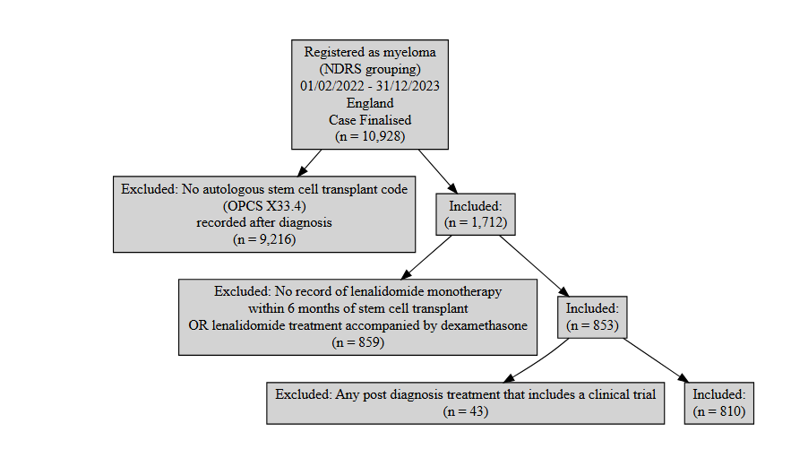
Figure 1: Inclusion / Exclusion Flow Chart

Patient acknowledgement
This work uses data that has been provided by patients and collected by the NHS as part of their care and support. The data is collated, maintained and quality assured by the National Cancer Registration and Analysis Service, which is part of NHS England.

Results

Age at start of treatment
The table below sets out the mean age, standard deviation, median age and interquartile range (IQR) of patients who have received lenalidomide monotherapy maintenance treatment for multiple myeloma following an ASCT. Age is measured at the commencement of lenalidomide.
Characteristic | Female N = 326¹ | Male N = 484¹
Age at start of treatment | 62, (8) : 63 (56, 68) | 62, (8) : 63 (56, 68)
¹Mean, (SD) : Median (Q1, Q3)
Table 1: Mean age, standard deviation, median age and IQR of patients who have received lenalidomide maintenance

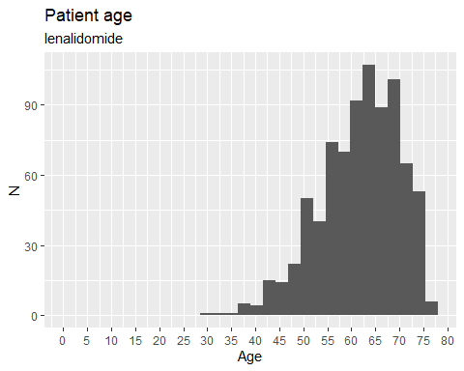
Figure 2: Age distribution of patients who have received lenalidomide maintenance
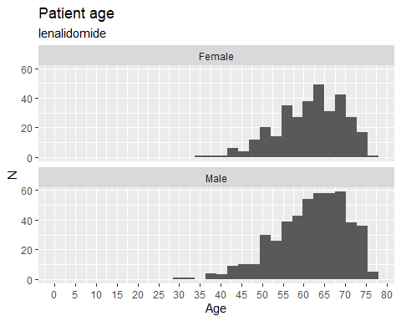
Figure 3: Age distribution of patients who have received lenalidomide maintenance

Overall survival

Base K-M plot
The Kaplan-Meier plot below shows survival over time for those receiving first line maintenance lenalidomide monotherapy after ASCT.
Median survival was not reached, restricted mean survival (over the whole curve) was 32.71 months. The minimum follow-up time was 1.6 months, median 22.8 months, and maximum follow-up time of 34 months. Subsequent graphs with fitted parametric survival curves have an extended X axis to allow differentiation of longer-term projections.
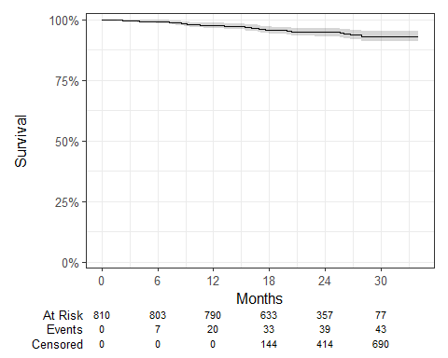
Figure 4: Overall survival amongst patients who have received lenalidomide maintenance therapy for multiple myeloma

Exponential
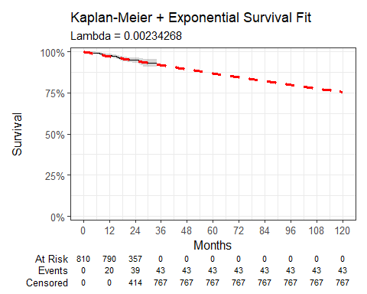
Figure 5: Overall survival against exponential survival function
Parameter | Estimate | Std. Error | z | p-value
(Intercept) | 6.056 | 0.152 | 39.71487 | 0
log-likelihood = -303.427843150141
AIC = 608.855686300282
BIC = 613.552720547948
Table 2: Survival Model Fit Summary (Exponential distribution)

Weibull
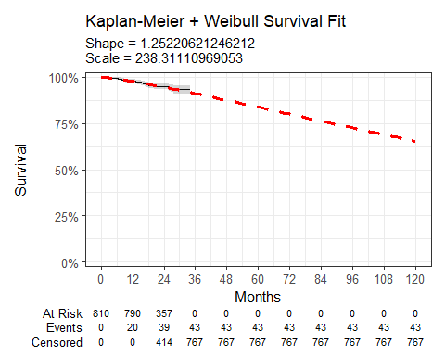
Figure 6: Overall survival against Weibull survival function
Parameter | Estimate | Std. Error | z | p-value
(Intercept) | 5.474 | 0.359 | 15.265119 | 1.305899e-52
Log(scale) | -0.225 | 0.146 | -1.536548 | 1.244040e-01
log-likelihood = -302.340927614068
AIC = 608.681855228136
BIC = 618.075923723469
Table 3: Survival Model Fit Summary (Weibull distribution)

Log-normal
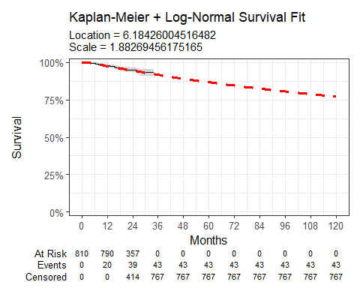
Figure 7: Overall survival against Log-normal survival function
Parameter | Estimate | Std. Error | z | p-value
(Intercept) | 6.184 | 0.445 | 13.887904 | 7.499799e-44
Log(scale) | 0.633 | 0.132 | 4.780935 | 1.744815e-06
log-likelihood = -301.821107391555
AIC = 607.642214783109
BIC = 617.036283278442
Table 4: Survival Model Fit Summary (Log-normal distribution)

Log-logistic
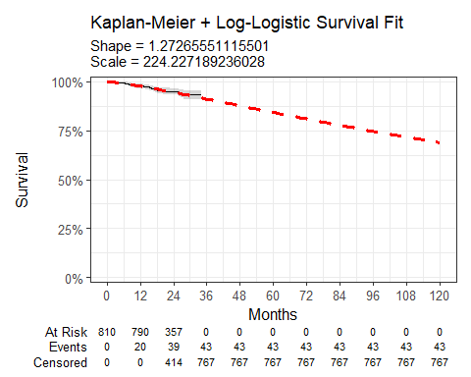
Figure 8: Overall survival against Log-Logistic survival function
Parameter | Estimate | Std. Error | z | p-value
(Intercept) | 5.413 | 0.351 | 15.406888 | 1.471294e-53
Log(scale) | -0.241 | 0.146 | -1.656183 | 9.768480e-02
log-likelihood = -302.285597379016
AIC = 608.571194758032
BIC = 617.965263253365
Table 5: Survival Model Fit Summary (Log-Logistic distribution)

Gaussian
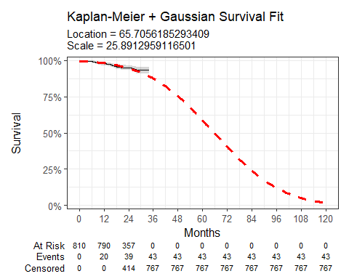
Figure 9: Overall survival against Gaussian survival function
Parameter | Estimate | Std. Error | z | p-value
(Intercept) | 65.706 | 6.042 | 10.87425 | 1.529163e-27
Log(scale) | 3.254 | 0.131 | 24.79834 | 9.341610e-136
log-likelihood = -312.245643068761
AIC = 628.491286137522
BIC = 637.885354632855
Table 6: Survival Model Fit Summary (Gaussian distribution)

Gamma
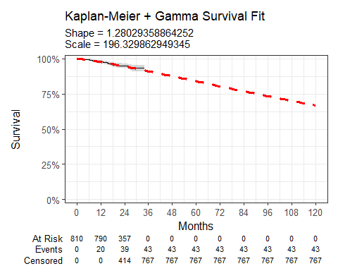
Figure 10: Overall survival against gamma survival function
Parameter | Estimate | Std. Error | L95. | U95.
shape | 1.280 | 0.205 | 0.935949559 | 1.75132480
rate | 0.005 | 0.002 | 0.001998373 | 0.01298227
log-likelihood = -302.297351750161
AIC = 608.594703500322
BIC = 617.988771995655
Table 7: Survival Model Fit Summary (Gamma distribution)

Generalised gamma
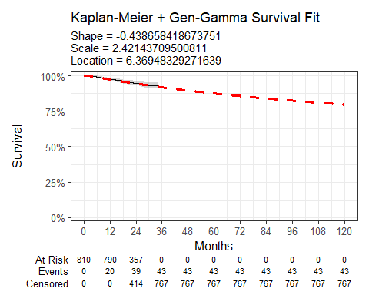
Figure 11: Overall survival against Generalised Gamma survival function
Parameter | Estimate | Std. Error | L95. | U95.
mu | 6.369 | 0.608 | 5.1770214 | 7.561945
sigma | 2.421 | 1.841 | 0.5458601 | 10.741503
Q | -0.439 | 1.542 | -3.4615035 | 2.584187
log-likelihood = -301.775227921522
AIC = 609.550455843044
BIC = 623.641558586043
Table 8: Survival Model Fit Summary (Generalised Gamma distribution)

Gompertz
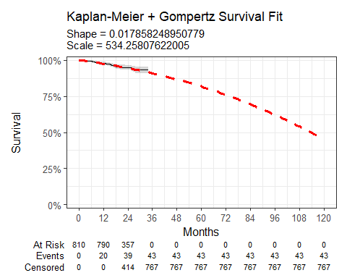
Figure 12: Overall survival against Gompertz survival function
Parameter | Estimate | Std. Error | L95. | U95.
shape | 0.018 | 0.020 | -0.020856093 | 0.056572591
rate | 0.002 | 0.001 | 0.001039182 | 0.003371369
log-likelihood = -303.023738583805
AIC = 610.047477167611
BIC = 619.441545662943
Table 9: Survival Model Fit Summary (Gompertz distribution)

Time on treatment
The Kaplan-Meier plot below shows time-on-treatment (ToT) for patients receiving lenalidomide maintenance after an ASCT and associated induction/consolidation regimen. The median ToT was not reached.
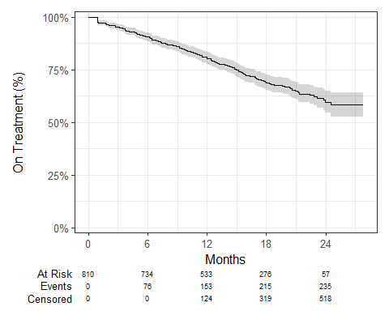
Figure 13: Time-on-treatment for patients receiving lenalidomide maintenance

Age, gender, overall survival and time on treatment for those receiving lenalidomide maintenance therapy following an autologous stem cell transplant and an induction/consolidation regimen containing daratumumab (cohort 2)

Introduction
This report was produced in partnership by the National Disease Registration Service (NDRS) and National Institute for Health and Care Excellence (NICE). It presents overall survival, gender split, age distribution and time on treatment among patients with multiple myeloma who have received lenalidomide maintenance at first line following an autologous stem cell transplant and an induction/consolidation regimen containing daratumumab.

Method
A snapshot of SACT data was taken on 7th December 2025 and made available for analysis on 19th December 2025. SACT treatment data is only considered complete when 90% of trusts have submitted data, which at the time of analysis was 31st March 2025. This date is used for censoring of time on treatment. Patients were traced for their vital status on 5th October 2025, which is the censoring date for the overall survival analysis.
Overall survival is measured from commencement of first lenalidomide maintenance treatment to death (if date recorded) or censoring date (if death date not present). Time-on-treatment was measured by the difference between a patient’s first and last recorded lenalidomide maintenance treatment, plus 28 days (standard gap between administrations). If a patient died before the nominal cycle end, the end date was revised to the date of death. If the treatment end date extends beyond the treatment censoring date (31st March 25), the patient was censored.

Cohort inclusions / exclusions
Patients were included if they met all of the following conditions:
- Diagnosed between 1st Feb 2022 and 31st December 2023 (inclusive). Diagnoses and treatment pathways prior to this point would be before publication of NICE Technology Appraisal TA763 — “Daratumumab in combination for untreated multiple myeloma” and would not reflect subsequent changes to the expected pathway resulting from commissioners being required to fund the approved treatment
- Gender recorded as male or female
- Country code was ‘England’, based on postcode of residence at diagnosis
- NDRS cancer group definition of ‘Myeloma’
- An autologous stem cell transplant was carried out as part of treatment after diagnosis
- Lenalidomide was initiated within 6 months after the stem cell transplant (based on both regimen and drug administration descriptions), and the lenalidomide regimen did not include dexamethasone.
- Daratumumab was recorded as being administered in the window between the diagnosis date and two months after the autologous stem cell transplant date (proxy for induction/consolidation of daratumumab, bortezomib, thalidomide and dexamethasone [‘VTd’])
and were excluded if
- Any SACT treatments after diagnosis (not only lenalidomide) were recorded as being given as part of a trial

Identification of autologous stem cell transplant
The presence of an autologous stem cell transplant (ASCT) in the treatment pathway was determined by linkage of the registration record to HES, specifically where the post-diagnosis HES inpatient record contained an OPCS code of ‘X33.4 - autologous peripheral blood stem cell transplant’. A sensitivity analysis explored how many additional records would be added by including other related codes in case significant numbers were recorded under related codes. All other restrictions were kept in place whilst codes were varied. Varying the codelist gave the following results: No additional cases were identified by including bone marrow graft codes (W34*). One additional record was found recorded as an allogenic stem cell transplant (X33.6), and no further cases were associated with the code for a syngeneic stem cell transplant (X33.5). Sixteen cases would be added if the definition was expanded to include X33.8 ‘Other specified blood transfusion’ and X33.9 ‘Unspecified other blood transfusion’. Given the risk of including non‑ASCT cases and minimal gain in sample size, X33.4 was selected as the sole ASCT defining code.
Observed ASCT rates (c. 16%) were lower than expected (25-30%), based on previous modelling work for NICE TA680. The identified cases therefore likely understate the true number of applicable procedures, reflecting under‑recording or miscoding. We assume that ASCTs that are unrecorded or coded under alternative OPCS codes are not systematically associated with the outcomes analysed below (e.g., overall survival or time on treatment), given that coding missingness is likely a function of hospital administration and documentation rather than anything associated with clinical treatment. On this basis, any bias from missing ASCT data is expected to be minimal.

Identification of lenalidomide maintenance
Lenalidomide monotherapy is recommended as first‑line maintenance following stem cell transplant. Owing to variation in SACT recording practices and the structure of SACT tables, it can be challenging to algorithmically distinguish first‑line lenalidomide from second and subsequent lines, where lenalidomide may be used in combination (for example, carfilzomib + dexamethasone + lenalidomide [KRd], lenalidomide + dexamethasone [Rd], or ixazomib + lenalidomide + dexamethasone [Ixa‑Rd]). These combinations may be grouped at the regimen level in SACT or recorded as contemporaneous but separate (‘split’) regimens.
To reduce misclassification of second‑line uses, we: (i) count only regimens where the NDRS‑categorised description (“benchmark group”) mentions lenalidomide only; (ii) include only cases where the earliest lenalidomide use occurs within six months of the ASCT date; and (iii) exclude cases where dexamethasone appears in the drug‑level tables for lenalidomide monotherapy regimens.
Where split regimens occur, time‑on‑treatment may be overstated if the lenalidomide end date is taken from a combination containing lenalidomide. However, the observed time‑on‑treatment pattern would not imply a median survival exceeding the 53‑month progression‑free survival reported in a published meta‑analysis. We therefore consider potential overstatement of time on treatment from the incidental inclusion of combination regimens to be limited.

Identification of induction/consolidation regimens containing daratumumab
We searched the SACT regimen‑and drug‑level tables for entries indicating daratumumab administered between the diagnosis date and up to two months after the ASCT date. This window, informed by the VTd pathway described in MHRA licensing, was selected to capture the induction/consolidation phase—maximising identification of relevant regimens while minimising inclusion of second‑line and later regimens containing daratumumab.
We conducted a sensitivity analysis by varying the post‑ASCT window and reviewing treatment pathways regimens that fell outside that boundary boundaries, starting with a reduced boundary of 4 months prior and 2 months post ASCT. This returned 75% of patients with a recorded daratumumab administration in the period. Having reviewed a selection of patient pathways in the 25% of remaining diagnosis, we found regimen descriptions indicative of VTd induction outside of that window, chiefly earlier than the recorded ASCT date minus 4 months. Sequentially expanding the initial boundary back to 6 months brought in more of these cases, to the point of including 86% of cases, though induction regimens starting earlier than that were still found in the remaining 14% of the population. Expanding the admissible daratumumab administration window from the diagnosis date to two-months post ASCT date took the proportion of inductions / consolidations containing daratumumab to 94% of ASCT cases. We concluded the diagnosis date to two‑month post‑ASCT boundary was the most appropriate window to capture relevant regimens and was internally consistent with the pathway description, licensing authorisation, and clinical expectations for the proportion receiving VTd induction/consolidation.

Flow chart
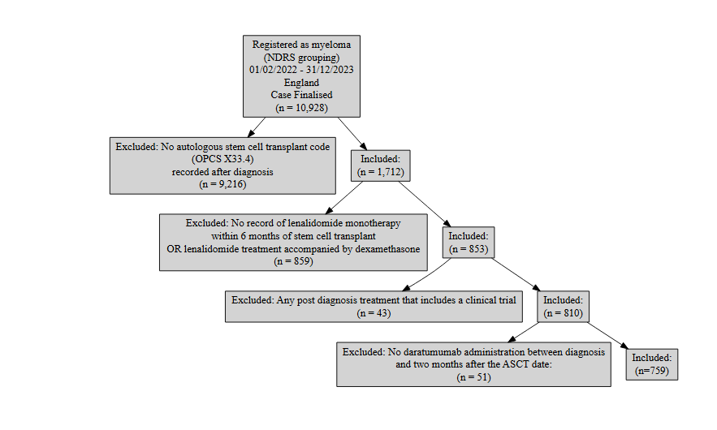
Figure 14: Inclusion / Exclusion Flow Chart

Patient acknowledgement
This work uses data that has been provided by patients and collected by the NHS as part of their care and support. The data is collated, maintained and quality assured by the National Cancer Registration and Analysis Service, which is part of NHS England.

Results

Age at start of treatment
The table below sets out the mean age, standard deviation, median age and interquartile range (IQR) of patients who have received lenalidomide monotherapy maintenance treatment for multiple myeloma following an ASCT. Age is measured at the commencement of lenalidomide.
Characteristic | Female N = 309¹ | Male N = 450¹
Age at start of treatment | 62, (8) : 63 (56, 68) | 62, (8) : 63 (56, 68)
¹Mean, (SD) : Median (Q1, Q3)
Table 10: Mean age, standard deviation, median age and IQR of patients who have received lenalidomide maintenance

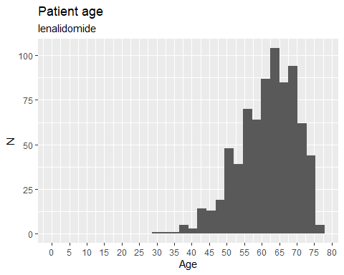
Figure 15: Age distribution of patients who have received lenalidomide maintenance
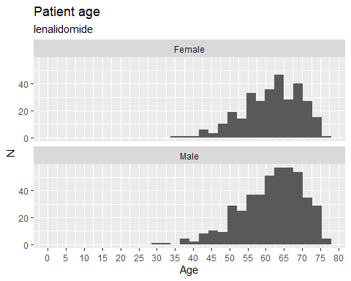
Figure 16: Age distribution of patients who have received lenalidomide maintenance

Overall survival

Base K-M plot
The Kaplan-Meier plot below shows survival over time for those receiving first line maintenance lenalidomide monotherapy after ASCT and induction/consolidation regimen containing daratumumab.
Median survival was not reached, restricted mean survival (over the whole curve) was 32.75 months. The minimum follow-up time was 1.8 months, median 22.7 months, and maximum follow-up time of 34 months. Subsequent graphs with fitted parametric survival curves have an extended X axis to allow differentiation of longer-term projections.
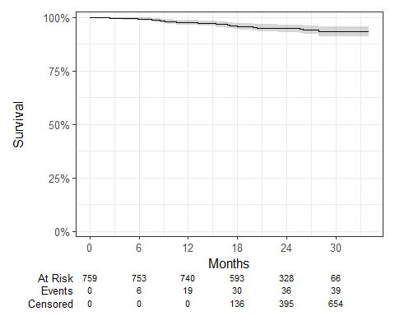
Figure 17: Overall survival amongst patients who have received lenalidomide maintenance therapy for multiple myeloma

Exponential
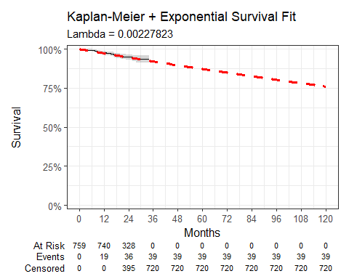
Figure 18: Overall survival against exponential survival function
Parameter | Estimate | Std. Error | z | p-value
(Intercept) | 6.084 | 0.160 | 37.99679 | 6.520145e-316
log-likelihood = -276.289874715598
AIC = 554.579749431196
BIC = 559.211751208591
Table 11: Survival Model Fit Summary (Exponential distribution)

Weibull
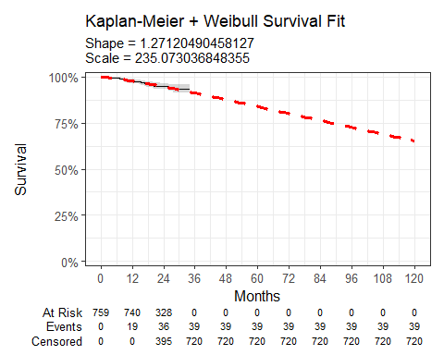
Figure 19: Overall survival against Weibull survival function
Parameter | Estimate | Std. Error | z | p-value
(Intercept) | 5.460 | 0.374 | 14.584478 | 3.526068e-48
Log(scale) | -0.240 | 0.154 | -1.562214 | 1.182377e-01
log-likelihood = -275.172583985309
AIC = 554.345167970618
BIC = 563.609171525409
Table 12: Survival Model Fit Summary (Weibull distribution)

Log-normal
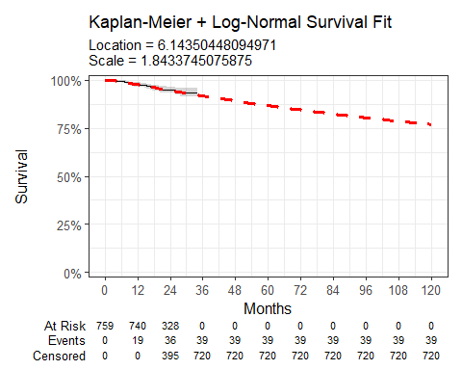
Figure 20: Overall survival against Log-normal survival function
Parameter | Estimate | Std. Error | z | p-value
(Intercept) | 6.144 | 0.462 | 13.287254 | 2.744682e-40
Log(scale) | 0.612 | 0.139 | 4.386989 | 1.149306e-05
log-likelihood = -274.437955449766
AIC = 552.875910899531
BIC = 562.139914454323
Table 13: Survival Model Fit Summary (Log-normal distribution)

Log-logistic
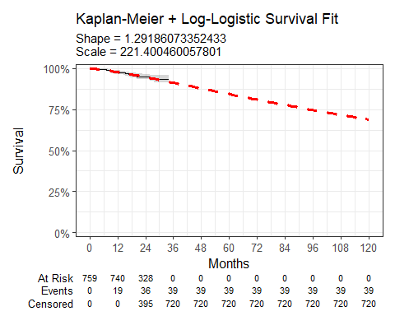
Figure 21: Overall survival against Log-Logistic survival function
Parameter | Estimate | Std. Error | z | p-value
(Intercept) | 5.400 | 0.367 | 14.722989 | 4.589190e-49
Log(scale) | -0.256 | 0.153 | -1.676321 | 9.367543e-02
log-likelihood = -275.103192855218
AIC = 554.206385710436
BIC = 563.470389265228
Table 14: Survival Model Fit Summary (Log-Logistic distribution)

Gaussian
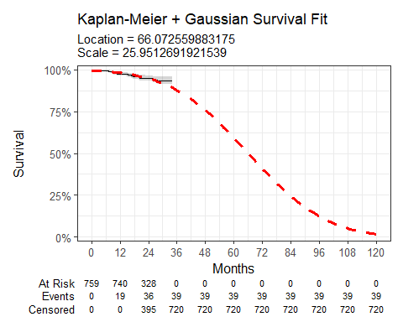
Figure 22: Overall survival against Gaussian survival function
Parameter | Estimate | Std. Error | z | p-value
(Intercept) | 66.073 | 6.419 | 10.29295 | 7.581616e-25
Log(scale) | 3.256 | 0.138 | 23.57783 | 6.508047e-123
log-likelihood = -284.474481857417
AIC = 572.948963714833
BIC = 582.212967269625
Table 15: Survival Model Fit Summary (Gaussian distribution)

Gamma
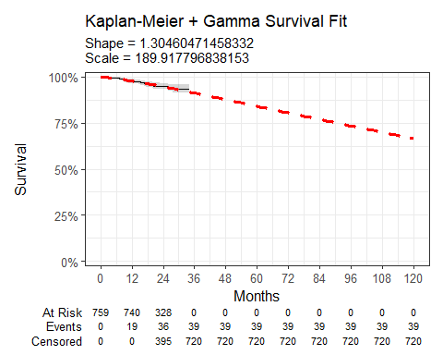
Figure 23: Overall survival against gamma survival function
Parameter | Estimate | Std. Error | L95. | U95.
shape | 1.305 | 0.220 | 0.937993636 | 1.81450427
rate | 0.005 | 0.003 | 0.001975683 | 0.01403303
log-likelihood = -275.113449912085
AIC = 554.226899824171
BIC = 563.490903378962
Table 16: Survival Model Fit Summary (Gamma distribution)

Generalised gamma
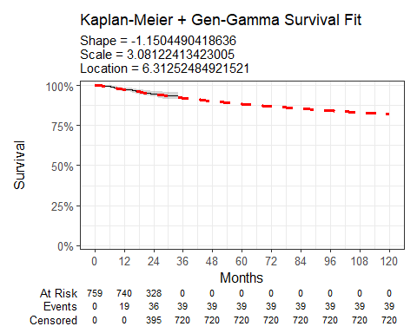
Figure 24: Overall survival against Generalised Gamma survival function
Parameter | Estimate | Std. Error | L95. | U95.
mu | 6.313 | 0.646 | 5.0458694 | 7.579180
sigma | 3.081 | 1.890 | 0.9260419 | 10.252174
Q | -1.150 | 2.114 | -5.2939395 | 2.993041
log-likelihood = -274.213017693144
AIC = 554.426035386289
BIC = 568.322040718476
Table 17: Survival Model Fit Summary (Generalised Gamma distribution)

Gompertz
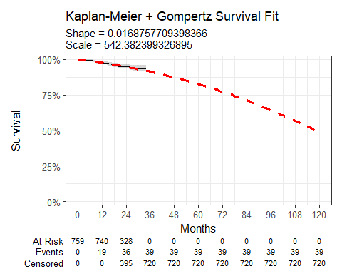
Figure 25: Overall survival against Gompertz survival function
Parameter | Estimate | Std. Error | L95. | U95.
shape | 0.017 | 0.021 | -0.0241042295 | 0.057855771
rate | 0.002 | 0.001 | 0.0009950674 | 0.003416145
log-likelihood = -275.977195637893
AIC = 555.954391275786
BIC = 565.218394830577
Table 18: Survival Model Fit Summary (Gompertz distribution)

Time on treatment
The Kaplan-Meier plot below shows time-on-treatment (ToT) for patients receiving lenalidomide maintenance after ASCT and induction/consolidation regimen containing daratumumab. The median ToT was not reached.
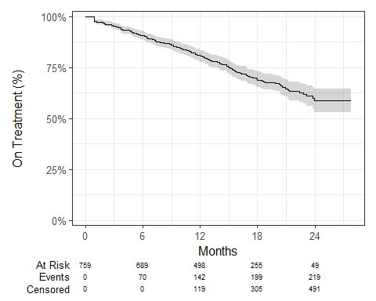
Figure 26: Time-on-treatment for patients receiving lenalidomide maintenance

Chloe J. Bright et al., “Data Resource Profile: The Systemic Anti-Cancer Therapy (SACT) dataset,” International Journal of Epidemiology 49, no. 1 (February 2020): 15–15l, https://dx.doi.org/10.1093/ije/dyz137.
NICE health technology evaluations: the manual (2025) NICE process and methods PMG36. Last updated 23 October 2025, n.d., https://www.nice.org.uk/process/pmg36.
Latimer Nicholas, NICE DSU Technical Support Document 14: Undertaking survival analysis for economic evaluations alongside clinical trials - extrapolation with patient-level data, 2011, http://www.nicedsu.org.uk/.
Philip L. McCarthy et al., “Lenalidomide maintenance after autologous stem-cell transplantation in newly diagnosed multiple myeloma: A meta-analysis,” Journal of Clinical Oncology 35, no. 29 (2017): 3279–3289, https://ascopubs.org/doi/abs/10.1200/JCO.2017.72.6679.
Philip L. McCarthy et al., “Lenalidomide maintenance after autologous stem-cell transplantation in newly diagnosed multiple myeloma: A meta-analysis,” Journal of Clinical Oncology 35, no. 29 (2017): 3279–3289, https://ascopubs.org/doi/abs/10.1200/JCO.2017.72.6679.

