Correction Notice:
A previous version of this report used an inconsistent snapshot of registrations data, such that the death date field did not match the censor date and consequently some deaths that occurred prior to the censor date were not captured. We have republished the corrected report, along with this summary table of the changes:

Population: | Restricted mean survival - whole curve  (months) |  | At risk | Events
Population: | Previous | Corrected |  | Previous | Corrected
chronic lymphocytic leukaemia treated with venetoclax with obinutuzumab (VenO; cohort 1) | 54.38 | 54.09 | 1025 | 68 | 74

No changes were made to cohort definitions, treatment classification or methods, or deaths in cohort 2 (Venl).

NDRS-NICE partnership report

Background
This report was produced in partnership by the National Disease and Registration Service (NDRS) and National Institute for Health and Care Excellence (NICE). NDRS and NICE have established a partnership focused on routinely collected data to support NICE decision making on the appraisals of cancer treatments. The partnership uses NDRS datasets, including the information submitted by trusts to the Systemic Anti-Cancer Therapy (SACT) dataset, to provide an understanding of current practice.
To determine a severity modifier, NICE considers factors such as the age, gender, and overall survival of the patient cohort affected by the disease. Additionally, knowing the time-on-treatment for each therapy is useful, as it validates assumptions made in technology appraisal evaluations about the duration of treatment use.
This partnership is focused on producing demographic and survival information using NDRS data, alongside supplementary information tailored to each technology appraisal. These may include, for example, the time patients spend on particular treatments, genetic data where this is available, or other information on real-world care pathways. Interpretation of the data is not included in this report, it is the information as provided to the NICE technology appraisal committees. Detail on how NICE health technology appraisals use this data can be found in the NICE health technology evaluations manual, with specific information relating to the survival analysis modelling available in Technical Support Document (TSD).
The focus of this report is the indication ID6232: Acalabrutinib and venetoclax (AV) with or without obinutuzumab for untreated chronic lymphocytic leukaemia (CLL)
Two cohorts were assessed for this indication:
- Cohort 1: Adults with untreated chronic lymphocytic leukaemia who have received venetoclax with obinutuzumab (VenO).
- Cohort 2: Adults with untreated chronic lymphocytic leukaemia who have received venetoclax with ibrutinib (VenI).

Age and overall survival for untreated chronic lymphocytic leukaemia treated with venetoclax with obinutuzumab (VenO; cohort 1)

Introduction
This report was produced in partnership by the National Disease and Registration Service (NDRS) and National Institute for Health and Care Excellence (NICE). It presents overall survival and age distributions among patients aged 18 or over with untreated chronic lymphocytic leukemia (CLL) who have received venetoclax with obinutuzumab (VenO; cohort 1).

Method
A snapshot of SACT data was taken on 7th December 2025 and made available for analysis on 19th December 2025. SACT data is only considered complete when 90% of trusts have submitted data. As a result, SACT data is considered complete up to 31st March 2025. Patients were traced for their vital status on 5th October 2025.
Descriptive statistics of age were computed, along with Kaplan-Meier estimates and parametric fits for overall survival (OS). Patients were censored at the date of the most recent trace (5th October 2025), representing the last date on which vital status was confirmed. Given the high survival rate in this population, the fitted curves were extrapolated to cover a 10-year period following treatment initiation.

Cohort inclusions / exclusions
Patients were included if they met all of the following:
- Diagnosed between 1st April 2018 and 31st December 2023
- Gender recorded as male or female
- Country code was ‘England’, based on postcode of residence at diagnosis
- Age at diagnosis date was 18 or over
- Diagnosis of CLL confirmed by an ICD-10 code ‘C91.1’ (Chronic lymphocytic leukaemia of B-cell type) and ICD-O-3 morphology code ‘9823/3’ (Chronic lymphocytic leukaemia/small lymphocytic lymphoma)
- Only one CLL neoplasm recorded during the study period
- No registration for another malignant neoplasm within the 36 months preceding CLL diagnosis
- VenO treatment was initiated on or after 9th December 2020 (NICE TA663 publication date). Usage before this point is assumed to be through compassionate use schemes.
- VenO treatment was initiated on or before the point at which SACT is considered complete (31st March 2025).
- Individuals were untreated, and had received no prior systemic anti-cancer therapy in the period between 1st April 2018 and the date of VenO initiation. Qualifying prior therapies included:
  - Monotherapies: acalabrutinib, zanubrutinib, fludarabine, bendamustine, venetoclax, ibrutinib, chlorambucil, rituximab, idelalisib, or cyclophosphamide
  - Combination therapies: venetoclax + ibrutinib, cyclophosphamide + obinutuzumab, rituximab + venetoclax, rituximab + fludarabine, rituximab + bendamustine, rituximab + chlorambucil, rituximab + idelalisib, or rituximab + cyclophosphamide. Combination therapies may also include other drugs (e.g. rituximab + cyclophosphamide + other) would also be considered a viable treatment.
Note: A potential limitation of this study is that treatments were identified using the ‘regimen’ table. As individual drug administrations in the ‘drug_detail’ table were not reviewed, some individuals who met the inclusion criteria but were only identifiable through drug administration records may have been missed.

Flow chart
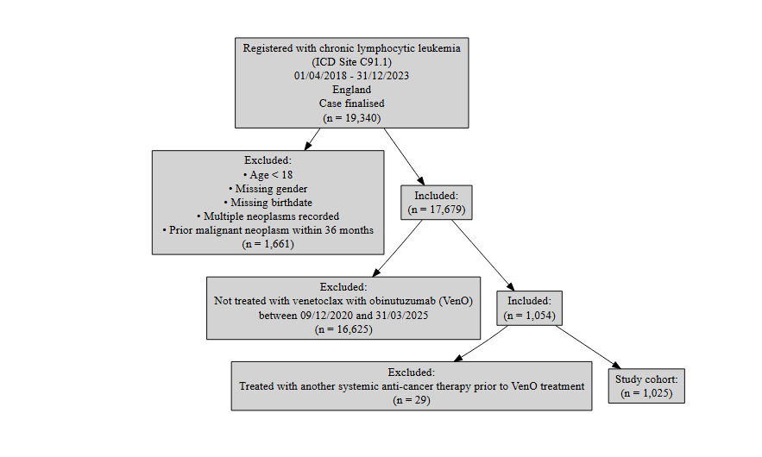
Figure 1: Inclusion / Exclusion Flow Chart

Patient acknowledgement
This work uses data that has been provided by patients and collected by the NHS as part of their care and support. The data is collated, maintained and quality assured by the National Cancer Registration and Analysis Service, which is part of NHS England.

Results

Age at start of treatment
The table below sets out the mean age, standard deviation, median age and interquartile range (IQR) of patients who have received VenO for chronic lymphocytic leukemia, split by gender. Age is measured at the commencement of the first VenO treatment regimen.
Characteristic | Female N = 310¹ | Male N = 715¹
Age at start of regimen | 64, (10) : 65 (57, 73) | 65, (10) : 65 (58, 72)
¹Mean, (SD) : Median (Q1, Q3)
Table 1: Mean age, standard deviation, median age and IQR of patients who have received venetoclax with obinutuzumab, split by gender

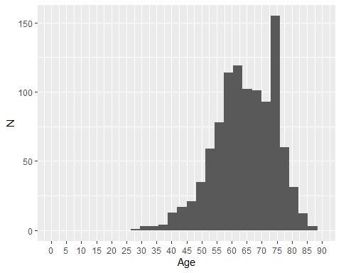
Figure 2: Age distribution of patients who have received venetoclax with obinutuzumab

Overall survival

Base K-M plot
The Kaplan-Meier plot below shows survival over time for those receiving a VenO treatment regimen.
Median survival was not reached. Restricted mean survival (over the whole curve) was 54.09 months. The minimum follow-up time was 0.1 months, median 30.3 months, and maximum follow-up time of 57.8 months.
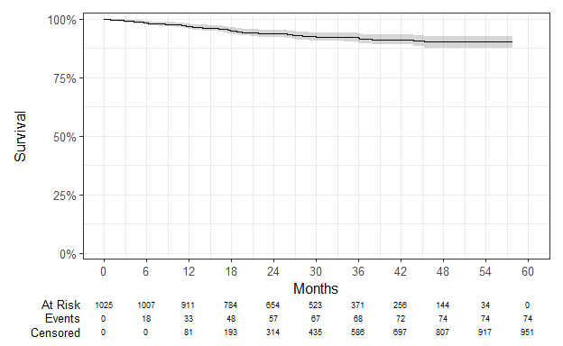
Figure 3: Overall survival amongst patients who have received venetoclax with obinutuzumab

Exponential
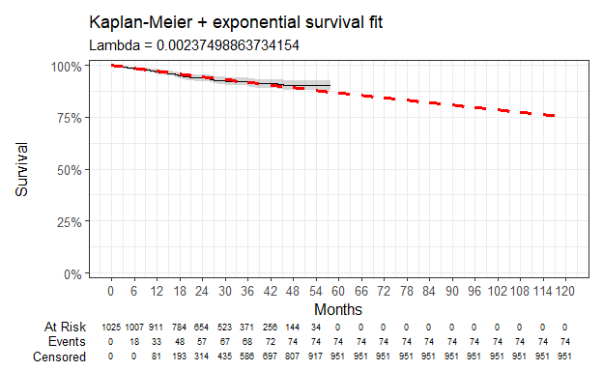
Figure 4: Overall survival against exponential survival function

Parameter | Estimate | Std. Error | z | p-value
(Intercept) | 6.043 | 0.116 | 51.98181 | 0
log-likelihood = -521.164434308152
AIC = 1044.3288686163
BIC = 1049.26131650788
Table 2: Survival model fit summary (exponential distribution)

Weibull
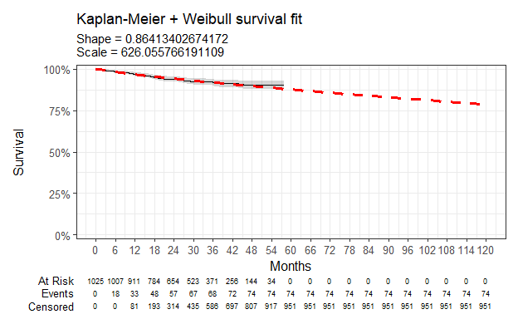
Figure 5: Overall survival against Weibull survival function

Parameter | Estimate | Std. Error | z | p-value
(Intercept) | 6.439 | 0.345 | 18.662779 | 9.942275e-78
Log(scale) | 0.146 | 0.108 | 1.347971 | 1.776676e-01
log-likelihood = -520.200909573653
AIC = 1044.40181914731
BIC = 1054.26671493045
Table 3: Survival model fit summary (Weibull distribution)

Log-normal
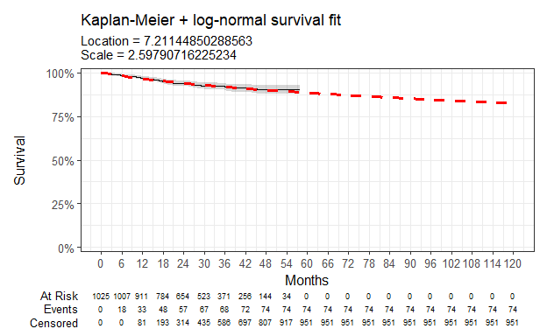
Figure 6: Overall survival against log-normal survival function

Parameter | Estimate | Std. Error | z | p-value
(Intercept) | 7.211 | 0.423 | 17.03997 | 4.149447e-65
Log(scale) | 0.955 | 0.098 | 9.75628 | 1.733997e-22
log-likelihood = -519.654502733426
AIC = 1043.30900546685
BIC = 1053.17390125
Table 4: Survival model fit summary (log-normal distribution)

Log-logistic
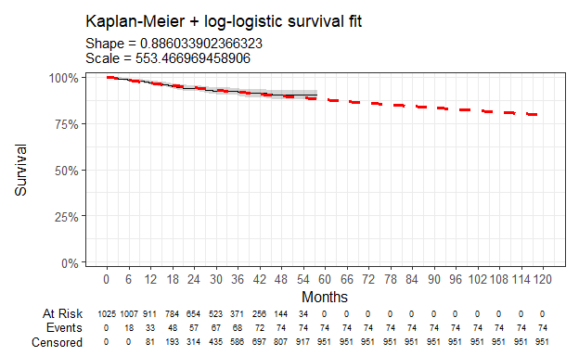
Figure 7: Overall survival against log-logistic survival function

Parameter | Estimate | Std. Error | z | p-value
(Intercept) | 6.316 | 0.336 | 18.801145 | 7.390301e-79
Log(scale) | 0.121 | 0.108 | 1.124104 | 2.609688e-01
log-likelihood = -520.018404844033
AIC = 1044.03680968807
BIC = 1053.90170547121
Table 5: Survival model fit summary (log-logistic distribution)

Gaussian
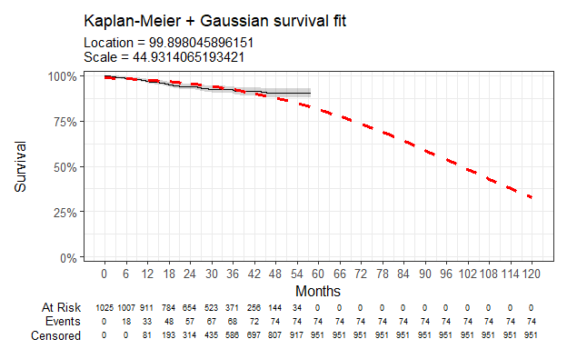
Figure 8: Overall survival against Gaussian survival function

Parameter | Estimate | Std. Error | z | p-value
(Intercept) | 99.898 | 7.124 | 14.02304 | 1.126789e-44
Log(scale) | 3.805 | 0.096 | 39.62632 | 0.000000e+00
log-likelihood = -555.218638113062
AIC = 1114.43727622612
BIC = 1124.30217200927
Table 6: Survival model fit summary (Gaussian distribution)

Gamma
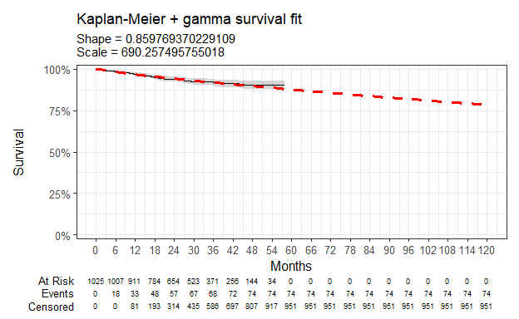
Figure 9: Overall survival against gamma survival function

Parameter | Estimate | Std. Error | L95. | U95.
shape | 0.860 | 0.099 | 0.6867709275 | 1.076346334
rate | 0.001 | 0.001 | 0.0006380542 | 0.003289426
log-likelihood = -520.25863647634
AIC = 1044.51727295268
BIC = 1054.38216873583
Table 7: Survival model fit summary (gamma distribution)

Generalised gamma
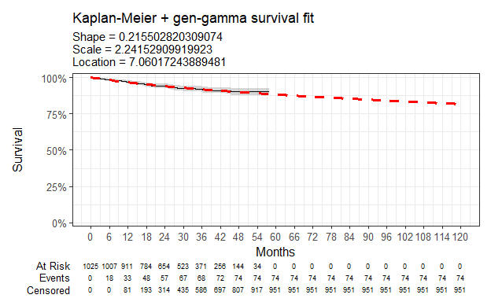
Figure 10: Overall survival against generalised gamma survival function

Parameter | Estimate | Std. Error | L95. | U95.
mu | 7.060 | 0.630 | 5.8245026 | 8.295842
sigma | 2.242 | 1.038 | 0.9046842 | 5.553819
Q | 0.216 | 0.618 | -0.9958792 | 1.426885
log-likelihood = -519.598558868815
AIC = 1045.19711773763
BIC = 1059.99446141235
Table 8: Survival model fit summary (generalised gamma distribution)

Gompertz
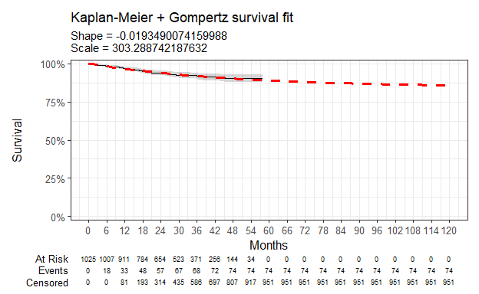
Figure 11: Overall survival against Gompertz survival function

Parameter | Estimate | Std. Error | L95. | U95.
shape | -0.019 | 0.010 | -0.038574904 | -0.0001231108
rate | 0.003 | 0.001 | 0.002265509 | 0.0047986789
log-likelihood = -519.093973662291
AIC = 1042.18794732458
BIC = 1052.05284310773
Table 9: Survival model fit summary (Gompertz distribution)

Age and overall survival for untreated chronic lymphocytic leukaemia treated with venetoclax with ibrutinib (VenI; cohort 2)

Introduction
This report was produced in partnership by the National Disease and Registration Service (NDRS) and National Institute for Health and Care Excellence (NICE). It presents overall survival and age distributions among patients aged 18 or over with untreated chronic lymphocytic leukemia (CLL) who have received venetoclax with ibrutinib (VenI; cohort 2).

Method
A snapshot of SACT data was taken on 7th December 2025 and made available for analysis on 19th December 2025. SACT data is only considered complete when 90% of trusts have submitted data. As a result, SACT data is considered complete up to 31st March 2025. Patients were traced for their vital status on 5th October 2025.
Descriptive statistics of age were computed, along with Kaplan-Meier estimates and parametric fits for overall survival (OS). Patients were censored at the date of the most recent trace (5th October 2025), representing the last date on which vital status was confirmed. Given the high survival rate in this population, the fitted curves were extrapolated to cover a 10-year period following treatment initiation. The generalised gamma model was excluded from the VenI cohort because it produced unreliable results and an implausible survival curve beyond the observed data.

Cohort inclusions / exclusions
Patients were included if they met all of the following:
- Diagnosed between 1st April 2018 and 31st December 2023
- Gender recorded as male or female
- Country code was ‘England’, based on postcode of residence at diagnosis
- Age at diagnosis date was 18 or over
- Diagnosis of CLL confirmed by an ICD-10 code ‘C91.1’ (Chronic lymphocytic leukaemia of B-cell type) and ICD-O-3 morphology code ‘9823/3’ (Chronic lymphocytic leukaemia/small lymphocytic lymphoma)
- Only one CLL neoplasm recorded during the study period
- No registration for another malignant neoplasm within the 36 months preceding CLL diagnosis
- VenI treatment was initiated on or after 31st May 2023 (NICE TA891 publication date). Usage before this point is assumed to be through compassionate use schemes.
- VenI treatment was initiated on or before the point at which SACT is considered complete (31st March 2025).
- Individuals were untreated, and had received no prior systemic anti-cancer therapy in the period between 1st April 2018 and the date of VenI initiation. Qualifying prior therapies included:
  - Monotherapies: acalabrutinib, zanubrutinib, fludarabine, bendamustine, venetoclax, ibrutinib, chlorambucil, rituximab, idelalisib, or cyclophosphamide
  - Combination therapies: venetoclax + obinutuzumab, cyclophosphamide + obinutuzumab, rituximab + venetoclax, rituximab + fludarabine, rituximab + bendamustine, rituximab + chlorambucil, rituximab + idelalisib, or rituximab + cyclophosphamide. Combination therapies may also include other drugs (e.g. rituximab + cyclophosphamide + other) would also be considered a viable treatment.
Note: A potential limitation of this study is that treatments were identified using the ‘regimen’ table. As individual drug administrations in the ‘drug_detail’ table were not reviewed, some individuals who met the inclusion criteria but were only identifiable through drug administration records may have been missed.

Flow chart
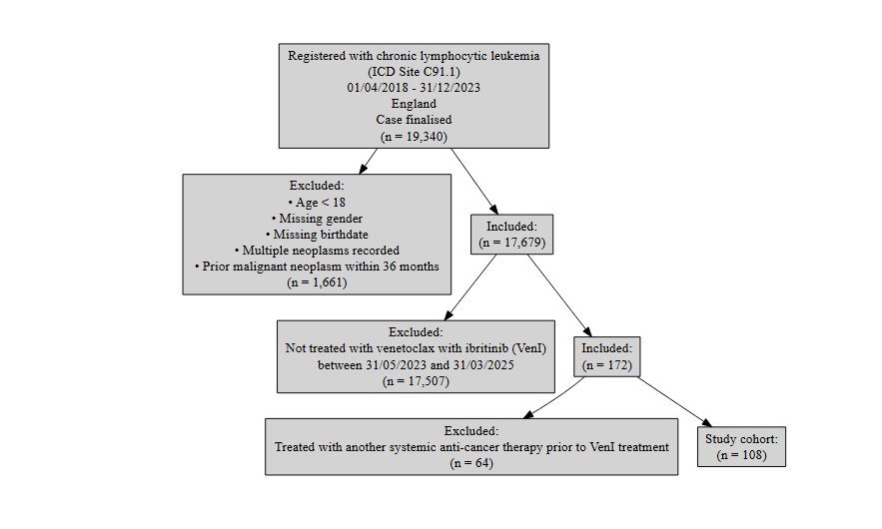
Figure 12: Inclusion / Exclusion Flow Chart

Patient acknowledgement
This work uses data that has been provided by patients and collected by the NHS as part of their care and support. The data is collated, maintained and quality assured by the National Cancer Registration and Analysis Service, which is part of NHS England.

Results

Age at start of treatment
The table below sets out the mean age, standard deviation, median age and interquartile range (IQR) of patients who have received VenI for chronic lymphocytic leukemia, split by gender. Age is measured at the commencement of the first VenI treatment regimen.
Characteristic | Female N = 33¹ | Male N = 75¹
Age at start of regimen | 66, (9) : 67 (59, 71) | 62, (10) : 63 (57, 68)
¹Mean, (SD) : Median (Q1, Q3)
Table 10: Mean age, standard deviation, median age and IQR of patients who have received venetoclax with ibrutinib, split by gender

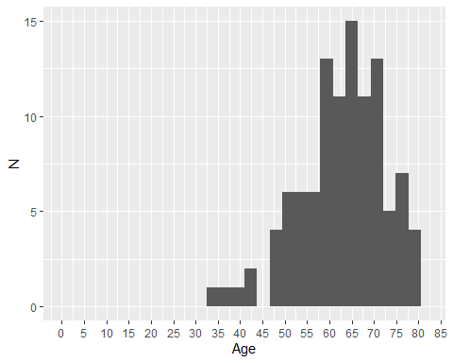
Figure 13: Age distribution of patients who have received venetoclax with ibrutinib

Overall survival

Base K-M plot
The Kaplan-Meier plot below shows survival over time for those receiving a VenI treatment regimen.
Median survival was not reached. Restricted mean survival (over the whole curve) was 27.26 months. The minimum follow-up time was 4.3 months, median 19.4 months, and maximum follow-up time of 28 months.
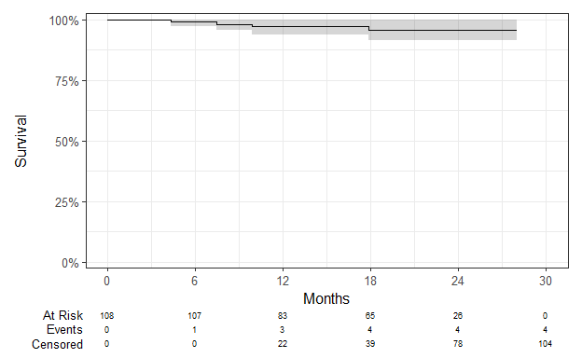
Figure 14: Overall survival amongst patients who have received venetoclax with ibrutinib

Exponential
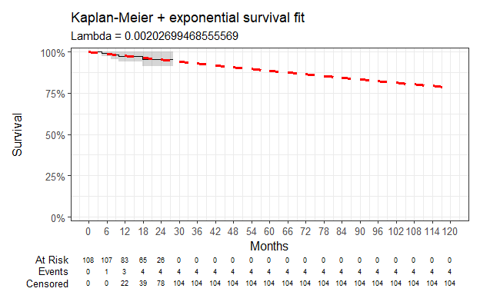
Figure 15: Overall survival against exponential survival function

Parameter | Estimate | Std. Error | z | p-value
(Intercept) | 6.201 | 0.500 | 12.4024 | 2.536054e-35
log-likelihood = -28.8048041333728
AIC = 59.6096082667456
BIC = 62.2917394938698
Table 11: Survival model fit summary (exponential distribution)

Weibull
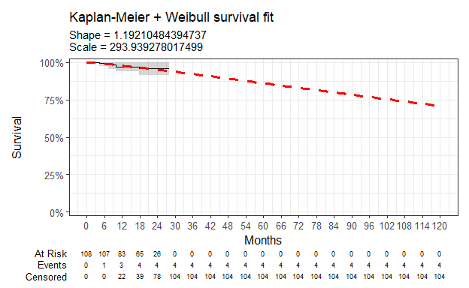
Figure 16: Overall survival against Weibull survival function

Parameter | Estimate | Std. Error | z | p-value
(Intercept) | 5.683 | 1.319 | 4.3091393 | 1.638911e-05
Log(scale) | -0.176 | 0.466 | -0.3772957 | 7.059539e-01
log-likelihood = -28.7383083624217
AIC = 61.4766167248434
BIC = 66.8408791790919
Table 12: Survival model fit summary (Weibull distribution)

Log-normal
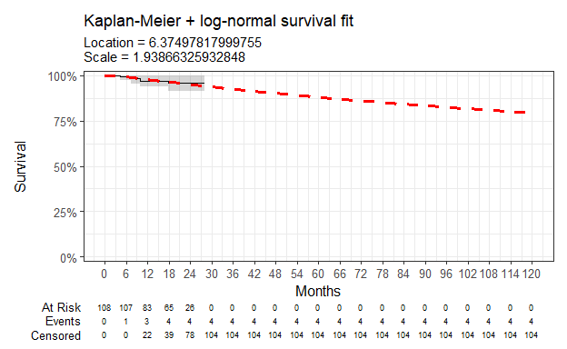
Figure 17: Overall survival against log-normal survival function

Parameter | Estimate | Std. Error | z | p-value
(Intercept) | 6.375 | 1.606 | 3.970512 | 7.171839e-05
Log(scale) | 0.662 | 0.433 | 1.529804 | 1.260653e-01
log-likelihood = -28.5284350897398
AIC = 61.0568701794795
BIC = 66.421132633728
Table 13: Survival model fit summary (log-normal distribution)

Log-logistic
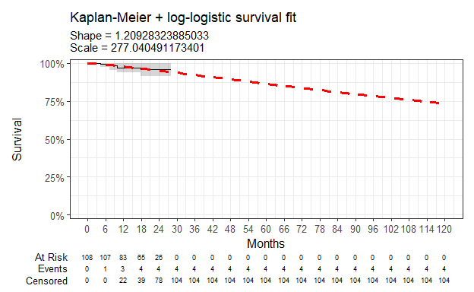
Figure 18: Overall survival against log-logistic survival function

Parameter | Estimate | Std. Error | z | p-value
(Intercept) | 5.624 | 1.295 | 4.3424529 | 1.409007e-05
Log(scale) | -0.190 | 0.463 | -0.4100564 | 6.817646e-01
log-likelihood = -28.7236159283733
AIC = 61.4472318567465
BIC = 66.811494310995
Table 14: Survival model fit summary (log-Logistic distribution)

Gaussian
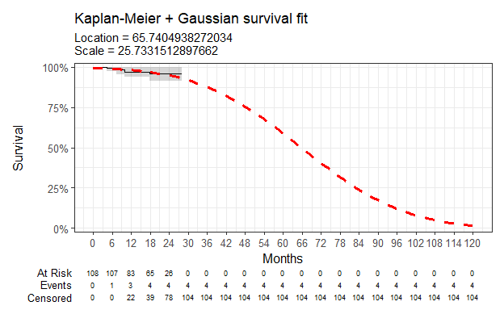
Figure 19: Overall survival against Gaussian survival function

Parameter | Estimate | Std. Error | z | p-value
(Intercept) | 65.740 | 20.951 | 3.137860 | 1.701861e-03
Log(scale) | 3.248 | 0.427 | 7.611054 | 2.718686e-14
log-likelihood = -30.1690705828917
AIC = 64.3381411657834
BIC = 69.7024036200318
Table 15: Survival model fit summary (Gaussian distribution)

Gamma
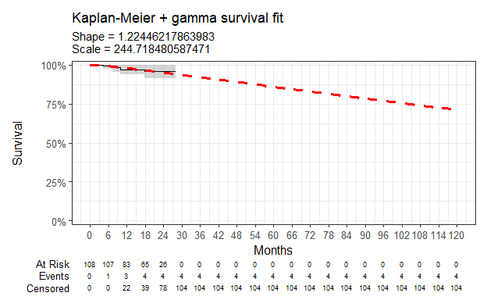
Figure 20: Overall survival against gamma survival function

Parameter | Estimate | Std. Error | L95. | U95.
shape | 1.224 | 0.618 | 0.4551392371 | 3.294174
rate | 0.004 | 0.007 | 0.0001538979 | 0.108501
log-likelihood = -28.7286998442332
AIC = 61.4573996884663
BIC = 66.8216621427147
Table 16: Survival model fit summary (gamma distribution)

Gompertz
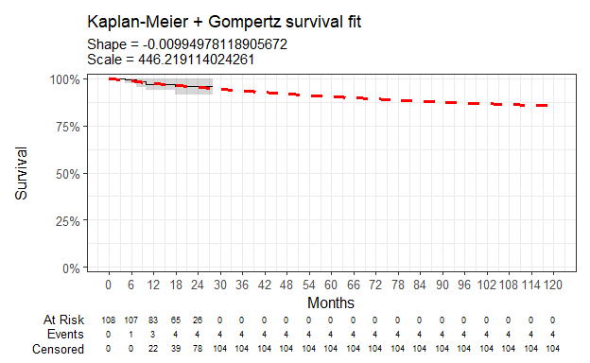
Figure 21: Overall survival against Gompertz survival function

Parameter | Estimate | Std. Error | L95. | U95.
shape | -0.010 | 0.075 | -0.1565310504 | 0.13663149
rate | 0.002 | 0.002 | 0.0003906724 | 0.01285556
log-likelihood = -28.7958623310017
AIC = 61.5917246620033
BIC = 66.9559871162517
Table 17: Survival model fit summary (Gompertz distribution)

Chloe J. Bright et al., “Data Resource Profile: The Systemic Anti-Cancer Therapy (SACT) dataset,” International Journal of Epidemiology 49, no. 1 (February 2020): 15–15l, https://dx.doi.org/10.1093/ije/dyz137.
NICE health technology evaluations: the manual (2025) NICE process and methods PMG36. Last updated 23 October 2025, n.d., https://www.nice.org.uk/process/pmg36.
Latimer Nicholas, NICE DSU Technical Support Document 14: Undertaking survival analysis for economic evaluations alongside clinical trials - extrapolation with patient-level data, 2011, http://www.nicedsu.org.uk/.

