NDRS – NICE Partnership Report ID6155

Background
This report was produced in partnership by the National Disease and Registration Service (NDRS) and National Institute for Health and Care Excellence (NICE). NDRS and NICE have established a partnership focused on routinely collected data to support NICE decision making on the appraisals of cancer treatments. The partnership uses NDRS datasets, including the information submitted by trusts to the Systemic Anti-Cancer Therapy (SACT) data dataset, to provide an understanding of current practice.
To determine a severity modifier, NICE considers factors such as the age, gender, and overall survival of the patient cohort affected by the disease. Additionally, knowing the time-on-treatment for each therapy is useful, as it validates assumptions made in technology appraisal evaluations about the duration of treatment use.
This partnership is focused on producing demographic and survival information using NDRS data, alongside supplementary information tailored to each technology appraisal. These may include, for example, the time patients spend on particular treatments, genetic data where this is available, or other information on real-world care pathways. Interpretation of the data isn’t included in this report, it is the information as provided to the NICE technology appraisal committees. Detail on how NICE health technology appraisals use this data can be found in the NICE health technology evaluations manual , with specific information relating to the survival analysis modelling available in Technical Support Document 14.
The focus of this report is the indication ID6155 - Acalabrutinib with bendamustine and rituximab for untreated mantle cell lymphoma.
Two cohorts were assessed for this indication:
- Cohort 1: Patients receiving bendamustine and rituximab with untreated mantle cell lymphoma
- Cohort 2: Patients receiving R-CHOP with untreated mantle cell lymphoma

Age, Gender and Overall Survival for Bendamustine and Rituximab

Introduction
This report was produced in partnership by the National Disease Registration Service (NDRS) and National Institute for Health and Care Excellence (NICE). It presents patient demographic characteristics and overall survival among patients who have received a first line treatment of bendamustine and rituximab for mantle cell lymphoma (MCL).

Method
A snapshot of SACT data was taken on 4th January 2025 and made available for analysis on 20th January 2025. SACT data is only considered complete when 90% of trusts have submitted data. As a result, SACT data is considered complete up to 31st March 2024. Patients were traced for their vital status on 5th October 2024.
Descriptive statistics of age and gender were computed, as well as overall survival (OS) Kaplan-Meier graphs and parametric fits.
Linkage to the Hospital Episode Statistics (HES) data and cancer registration data were made in order to identify whether a patient had an autologous stem cell transplant and obtain relevant ICD-O-3 morphology codes.

Cohort inclusions / exclusions
Patients were included in this cohort where:
- country code was ‘England’
- age at start of treatment (using start date of regimen) was 18 or over
- gender field was known (male or female)
- diagnosis occurred between 2017 and 2022
- ICD-O-3 morphology code was 9673
- first systemic treatment was bendamustine + rituximab (first regimen on or after diagnosis date was bendamustine + rituximab)
and excluded where:
- the patient received an autologous stem cell transplant

Patient Acknowledgement
This work uses data that has been provided by patients and collected by the NHS as part of their care and support. The data is collated, maintained and quality assured by the National Cancer Registration and Analysis Service, which is part of NHS England.

Results

Age at start of treatment
The table below sets out the mean age, standard (std.) deviation, median age and interquartile range (IQR) of patients who have received bendamustine and rituximab. Age is measured at the commencement of the first treatment regimen containing bendamustine and rituximab.
Cohort 1 Table 1: Mean age, standard deviation, median age and IQR of patients who have received bendamustine and rituximab
Characteristic | Female N = 106¹ | Male N = 283¹
Age at start of regimen | 74, (8) : 75 (70, 79) | 75, (7) : 75 (70, 79)
¹Mean, (SD) : Median (Q1, Q3)

Cohort 1 Figure 1: Age distribution of patients who have received bendamustine and rituximab
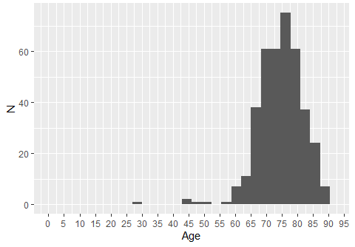

Cohort 1 Figure 2: Age distribution of patients who have received bendamustine and rituximab, by gender
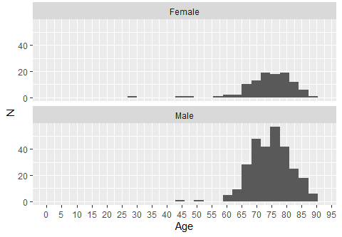

Overall Survival

Base K-M plot
The Kaplan-Meier plot below shows survival over time for those receiving a treatment regimen of bendamustine and rituximab.

Cohort 1 Figure 3: Overall survival amongst patients who have received bendamustine and rituximab
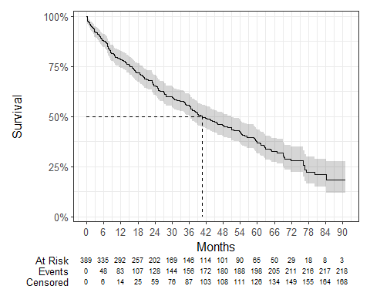
Median survival was 40.51 months, and restricted mean survival (over the whole curve) was 45.4 months. The minimum follow-up time was 0.1 months, median 25.1 months, and maximum follow-up time of 91.1 months.

Exponential
Cohort 1 Figure 4: Overall survival against exponential survival function
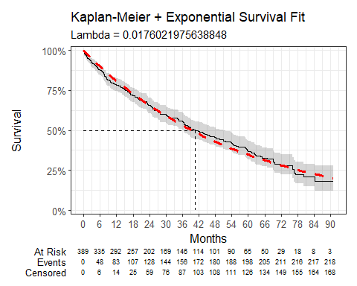
Cohort 1 Table 2: Survival Model Fit Summary (Exponential distribution)
Parameter | Estimate | Std. Error | z | p-value
(Intercept) | 4.040 | 0.068 | 59.64592 | 0
log-likelihood = -1098.66147204631
AIC = 2199.32294409263
BIC = 2203.28652343625

Weibull
Cohort 1 Figure 5: Overall survival against Weibull survival function
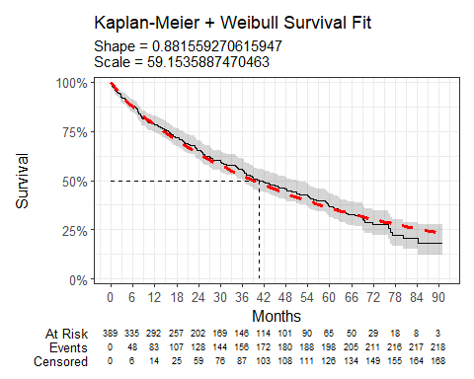
Cohort 1 Table 3: Survival Model Fit Summary (Weibull distribution)
Parameter | Estimate | Std. Error | z | p-value
(Intercept) | 4.080 | 0.080 | 51.157663 | 0.00000000
Log(scale) | 0.126 | 0.058 | 2.156261 | 0.03106328
log-likelihood = -1096.20604966639
AIC = 2196.41209933277
BIC = 2204.33925802001

Log-Normal
Cohort 1 Figure 6: Overall survival against Log-Normal survival function
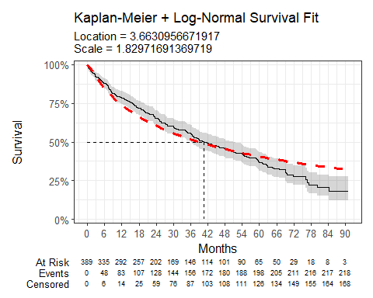
Cohort 1 Table 4: Survival Model Fit Summary (Log-Normal distribution)
Parameter | Estimate | Std. Error | z | p-value
(Intercept) | 3.663 | 0.109 | 33.63792 | 4.682534e-248
Log(scale) | 0.604 | 0.051 | 11.94987 | 6.502479e-33
log-likelihood = -1115.24883067187
AIC = 2234.49766134374
BIC = 2242.42482003098

Log-Logistic
Cohort 1 Figure 7: Overall survival against Log-Logistic survival function
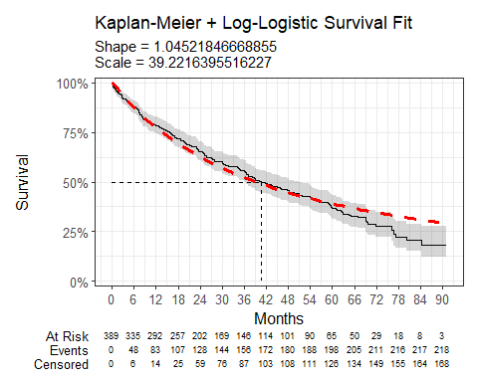
Cohort 1 Table 5: Survival Model Fit Summary (Log-Logistic distribution)
Parameter | Estimate | Std. Error | z | p-value
(Intercept) | 3.669 | 0.092 | 39.9977729 | 0.0000000
Log(scale) | -0.044 | 0.058 | -0.7603991 | 0.4470161
log-likelihood = -1104.35520146403
AIC = 2212.71040292806
BIC = 2220.6375616153

Gaussian
Cohort 1 Figure 8: Overall survival against Gaussian survival function
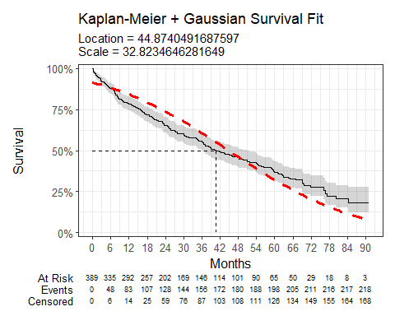
Cohort 1 Table 6: Survival Model Fit Summary (Gaussian distribution)
Parameter | Estimate | Std. Error | z | p-value
(Intercept) | 44.874 | 1.954 | 22.96212 | 1.115076e-116
Log(scale) | 3.491 | 0.050 | 69.71482 | 0.000000e+00
log-likelihood = -1181.20083376518
AIC = 2366.40166753035
BIC = 2374.32882621759

Gamma
Cohort 1 Figure 9: Overall survival against Gamma survival function
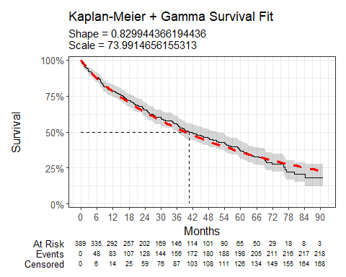
Cohort 1 Table 7: Survival Model Fit Summary (Gamma distribution)
Parameter | Estimate | Std. Error | L95. | U95.
shape | 0.830 | 0.063 | 0.71535526 | 0.96288892
rate | 0.014 | 0.002 | 0.01039736 | 0.01756766
log-likelihood = -1095.49548535397
AIC = 2194.99097070795
BIC = 2202.91812939518

Generalised Gamma
Cohort 1 Figure 10: Overall survival against Generalised Gamma survival function
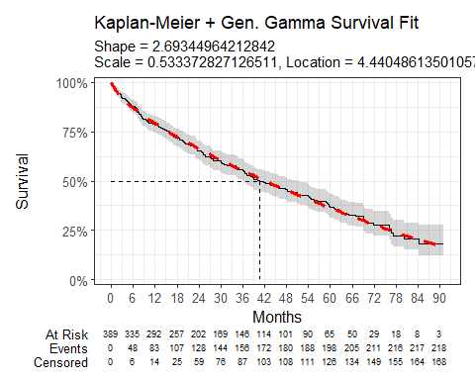
Cohort 1 Table 8: Survival Model Fit Summary (Generalised Gamma distribution)
Parameter | Estimate | Std. Error | L95. | U95.
mu | 4.440 | 0.290 | 3.8714051 | 5.009567
sigma | 0.533 | 0.443 | 0.1046456 | 2.718573
Q | 2.693 | 2.338 | -1.8895017 | 7.276401
log-likelihood = -1093.0319307162
AIC = 2192.0638614324
BIC = 2203.95459946325

Gompertz
Cohort 1 Figure 11: Overall survival against Gompertz survival function
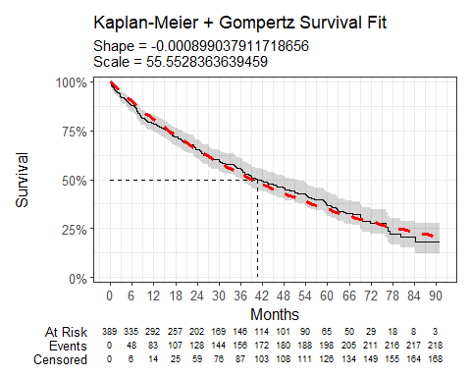
Cohort 1 Table 9: Survival Model Fit Summary (Gompertz distribution)
Parameter | Estimate | Std. Error | L95. | U95.
shape | -0.001 | 0.003 | -0.007703898 | 0.005905822
rate | 0.018 | 0.002 | 0.014528267 | 0.022303536
log-likelihood = -1098.62763667123
AIC = 2201.25527334246
BIC = 2209.18243202969

Age, Gender and Overall Survival for R-CHOP

Introduction
This report was produced in partnership by the National Disease Registration Service (NDRS) and National Institute for Health and Care Excellence (NICE). It presents patient demographic characteristics and overall survival among patients who have received a first line treatment of R-CHOP for mantle cell lymphoma (MCL).

Method
A snapshot of SACT data was taken on 4th January 2025 and made available for analysis on 20th January 2025. SACT data is only considered complete when 90% of trusts have submitted data. As a result, SACT data is considered complete up to 31st March 2024. Patients were traced for their vital status on 5th October 2024.
Descriptive statistics of age and gender were computed, as well as overall survival (OS) Kaplan-Meier graphs and parametric fits.
Linkages to the Hospital Episode Statistics (HES) data and cancer registration data were made in order to identify whether a patient had an autologous stem cell transplant and obtain relevant ICD-O-3 morphology codes.

Cohort inclusions / exclusions
Patients were included in this cohort where:
- country code was ‘England’
- age at start of treatment (using start date of regimen) was 18 or over
- gender field was known (male or female)
- diagnosis occurred between 2017 and 2022
- ICD-O-3 morphology code was 9673
- first systemic treatment was R-CHOP (first regimen on or after diagnosis date was cyclophosphamide + doxorubicin + rituximab + vincristine)
and excluded where:
- the patient received an autologous stem cell transplant, identified via linkage with HES and the presence of OPCS codes indicative of this procedure

Patient Acknowledgement
This work uses data that has been provided by patients and collected by the NHS as part of their care and support. The data is collated, maintained and quality assured by the National Cancer Registration and Analysis Service, which is part of NHS England.

Results

Age at start of treatment
The table below sets out the mean age, std. deviation, median age and IQR of patients who have received R-CHOP. Age is measured at the commencement of the first treatment regimen containing R-CHOP.
Cohort 2 Table 1: Mean age, standard deviation, median age and IQR of patients who have received R-CHOP

Characteristic | Female N = 129¹ | Male N = 379¹
Age at start of regimen | 71, (10) : 72 (66, 77) | 69, (9) : 71 (64, 75)
¹Mean, (SD) : Median (Q1, Q3)

Cohort 2 Figure 1: Age distribution of patients who have received R-CHOP
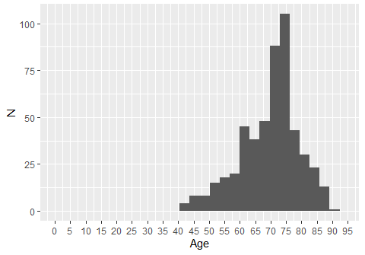

Cohort 2 Figure 2: Age distribution of patients who have received R-CHOP, by gender
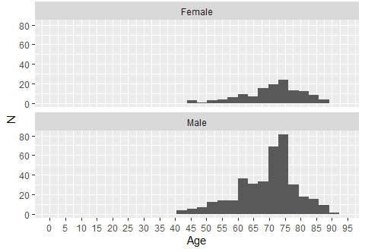

Overall Survival

Base K-M plot
The Kaplan-Meier plot below shows survival over time for those receiving a treatment regimen of R-CHOP.

Cohort 2 Figure 3: Overall survival amongst patients who have received R-CHOP
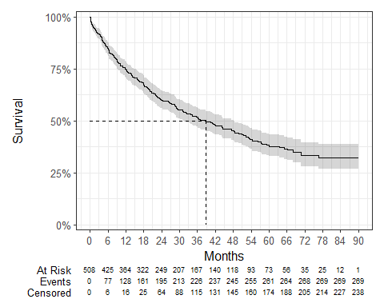
Median survival was 38.8 months, and restricted mean survival (over the whole curve) was 45.98 months. The minimum follow-up time was 0.1 months, median 23.4 months, and maximum follow-up time of 90.1 months.

Exponential
Cohort 2 Figure 4: Overall survival against Exponential survival function
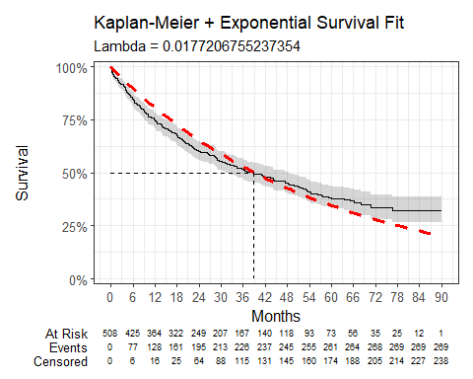
Cohort 2 Table 2: Survival Model Fit Summary (Exponential distribution)
Parameter | Estimate | Std. Error | z | p-value
(Intercept) | 4.033 | 0.061 | 66.1465 | 0
log-likelihood = -1353.88324414229
AIC = 2709.76648828458
BIC = 2713.99696973216

Weibull
Cohort 2 Figure 5: Overall survival against Weibull survival function
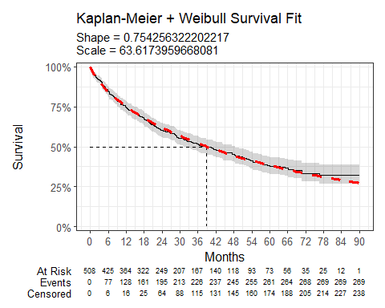
Cohort 2 Table 3: Survival Model Fit Summary (Weibull distribution)
Parameter | Estimate | Std. Error | z | p-value
(Intercept) | 4.153 | 0.086 | 48.30689 | 0.000000e+00
Log(scale) | 0.282 | 0.053 | 5.28702 | 1.243253e-07
log-likelihood = -1338.08681008253
AIC = 2680.17362016506
BIC = 2688.63458306022

Log-Normal
Cohort 2 Figure 6: Overall survival against Log-Normal survival function
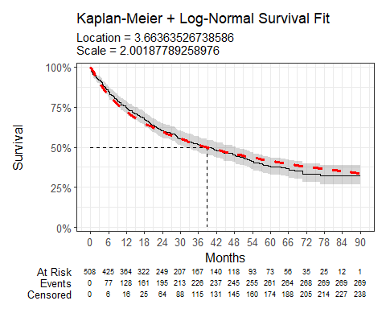
Cohort 2 Table 4: Survival Model Fit Summary (Log-Normal distribution)
Parameter | Estimate | Std. Error | z | p-value
(Intercept) | 3.664 | 0.107 | 34.37983 | 5.048189e-259
Log(scale) | 0.694 | 0.047 | 14.90981 | 2.845451e-50
log-likelihood = -1342.02409622722
AIC = 2688.04819245444
BIC = 2696.5091553496

Log-Logistic
Cohort 2 Figure 7: Overall survival against Log-Logistic survival function
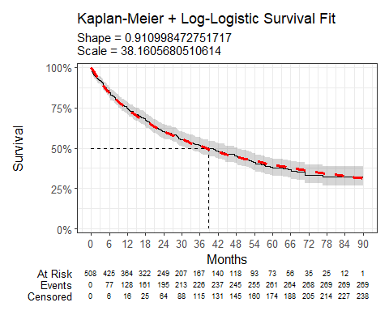
Cohort 2 Table 5: Survival Model Fit Summary (Log-Logistic distribution)
Parameter | Estimate | Std. Error | z | p-value
(Intercept) | 3.642 | 0.094 | 38.789047 | 0.00000000
Log(scale) | 0.093 | 0.053 | 1.770747 | 0.07660284
log-likelihood = -1337.69732052872
AIC = 2679.39464105745
BIC = 2687.8556039526

Gaussian
Cohort 2 Figure 8: Overall survival against Gaussian survival function
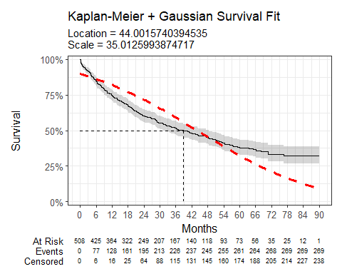
Cohort 2 Table 6: Survival Model Fit Summary (Gaussian distribution)
Parameter | Estimate | Std. Error | z | p-value
(Intercept) | 44.002 | 1.860 | 23.65661 | 1.009285e-123
Log(scale) | 3.556 | 0.046 | 76.64452 | 0.000000e+00
log-likelihood = -1500.82946335829
AIC = 3005.65892671658
BIC = 3014.11988961174

Gamma
Cohort 2 Figure 9: Overall survival against Gamma survival function
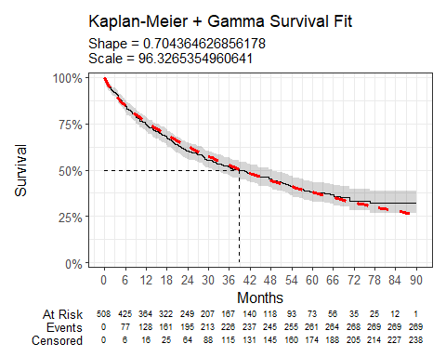
Cohort 2 Table 7: Survival Model Fit Summary (Gamma distribution)
Parameter | Estimate | Std. Error | L95. | U95.
shape | 0.704 | 0.048 | 0.616989655 | 0.8041132
rate | 0.010 | 0.001 | 0.007995648 | 0.0134789
log-likelihood = -1339.21374125672
AIC = 2682.42748251343
BIC = 2690.88844540859

Generalised Gamma
Cohort 2 Figure 10: Overall survival against Generalised Gamma survival function
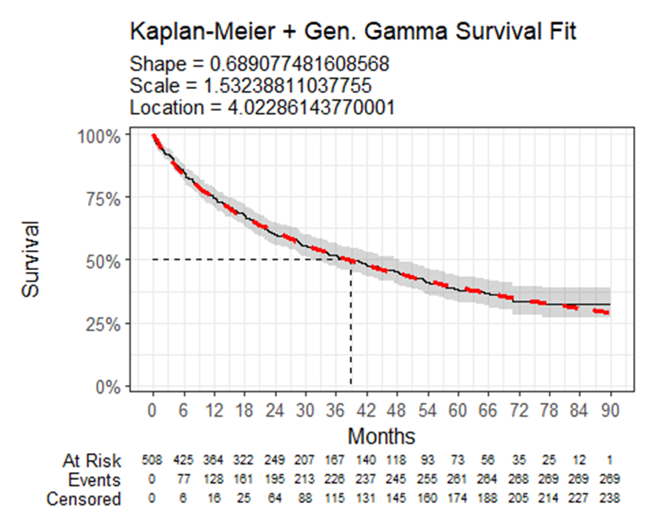
Cohort 2 Table 8: Survival Model Fit Summary (Generalised Gamma distribution)
Parameter | Estimate | Std. Error | L95. | U95.
mu | 4.023 | 0.137 | 3.754747 | 4.290976
sigma | 1.532 | 0.174 | 1.226072 | 1.915233
Q | 0.689 | 0.227 | 0.244845 | 1.133310
log-likelihood = -1337.25866696758
AIC = 2680.51733393517
BIC = 2693.2087782779

Gompertz
Cohort 2 Figure 11: Overall survival against Gompertz survival function
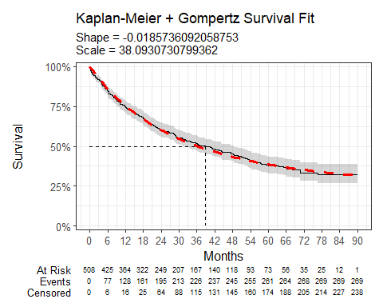
Cohort 2 Table 9: Survival Model Fit Summary (Gompertz distribution)
Parameter | Estimate | Std. Error | L95. | U95.
shape | -0.019 | 0.004 | -0.02594659 | -0.01120063
rate | 0.026 | 0.002 | 0.02191287 | 0.03144914
log-likelihood = -1339.99998215606
AIC = 2683.99996431212
BIC = 2692.46092720728

Data Resource Profile: The Systemic Anti-Cancer Therapy (SACT) dataset | International Journal of Epidemiology | Oxford Academic
Introduction to health technology evaluation | NICE health technology evaluations: the manual | Guidance | NICE
Survival analysis TSD | NICE Decision Support Unit | The University of Sheffield

