Correction Notice:
A previous version of this report used an inconsistent snapshot of registrations data, such that the death date field did not match the censor date and consequently some deaths that occurred prior to the censor date were not captured. We have republished the corrected report, along with this summary table of the changes:

Population | Median OS (months) |  | Restricted mean survival - whole curve  (months) |  | Median follow-up (months) |  | At risk | Events
Population | Previous | Corrected | Previous | Corrected | Previous | Corrected |  | Previous | Corrected
Received trastuzumab emtansine (including subsequent trastuzumab deruxtecan) | 25.4 | 24.0 | 40.8 | 35.1 | 21.3 | 20.9 | 1,190 | 723 | 828
Received trastuzumab emtansine (but no subsequent trastuzumab deruxtecan) | 17.6 | 16.9 | 32.1 | 29.0 | 15.4 | 15.0 | 820 | 575 | 620

No changes were made to cohort definitions, treatment classification or methods.

NDRS-NICE partnership report

Background
This report was produced in partnership by the National Disease and Registration Service (NDRS) and National Institute for Health and Care Excellence (NICE). NDRS and NICE have established a partnership focused on routinely collected data to support NICE decision making on the appraisals of cancer treatments. The partnership uses NDRS datasets, including the information submitted by trusts to the Systemic Anti-Cancer Therapy (SACT) dataset, to provide an understanding of current practice.
To determine a severity modifier, NICE considers factors such as the age, gender, and overall survival of the patient cohort affected by the disease. Additionally, knowing the time-on-treatment for each therapy is useful, as it validates assumptions made in technology appraisal evaluations about the duration of treatment use.
This partnership is focused on producing demographic and survival information using NDRS data, alongside supplementary information tailored to each technology appraisal. These may include, for example, the time patients spend on particular treatments, genetic data where this is available, or other information on real-world care pathways. Interpretation of the data is not included in this report, it is the information as provided to the NICE technology appraisal committees. Detail on how NICE health technology appraisals use this data can be found in the NICE health technology evaluations manual, with specific information relating to the survival analysis modelling available in Technical Support Document (TSD).
The focus of this report is the indication ID5121: Trastuzumab deruxtecan for treating HER2-positive unresectable or metastatic breast cancer after 1 or more anti-HER2 therapies
Two cohorts were assessed for this indication:
- Cohort 1: Adults with HER2 positive unresectable, locally advanced or metastatic breast cancer who have received trastuzumab emtansine after trastuzumab and a taxane (including individuals who subsequently received trastuzumab deruxtecan)
- Cohort 2: Adults with HER2 positive unresectable, locally advanced or metastatic breast cancer who have received trastuzumab emtansine after trastuzumab and a taxane (excluding individuals who subsequently received trastuzumab deruxtecan)

Age and overall survival for HER2-positive unresectable or metastatic breast cancer (cohort 1 - including trastuzumab deruxtecan)

Introduction
This report was produced in partnership by the National Disease and Registration Service (NDRS) and National Institute for Health and Care Excellence (NICE). It presents overall survival and age distributions among patients aged 18 or over with HER2-positive unresectable, locally advanced or metastatic breast cancer who have received trastuzumab emtansine after trastuzumab and a taxane, including individuals who subsequently received trastuzumab deruxtecan (cohort 1).

Method
A snapshot of SACT data was taken on 5th October 2025 and made available for analysis on 17th October 2025. SACT data is only considered complete when 90% of trusts have submitted data. As a result, SACT data is considered complete up to 28th February 2025. Patients were traced for their vital status on 5th July 2025.
Descriptive statistics of age were computed, along with Kaplan-Meier estimates and parametric fits for overall survival (OS). Patients were censored at the date of the most recent trace (5th July 2025), representing the last date on which vital status was confirmed.
Time-on-treatment was measured by the difference between a patient’s first and last trastuzumab emtansine administration date, plus a prescription length of 21 days (standard cycle length). If an individual died before the end date of the current treatment cycle, the treatment end date was revised to their date of death. If the patient’s treatment end date extended beyond the treatment censoring date (28th February 2025), the patient is censored.

Cohort inclusions / exclusions
Patients were included if they met all of the following:
- diagnosed between 1st January 2010 and 31st December 2022
- gender recorded as male or female
- country code was England, based on postcode of residence at diagnosis
- age at diagnosis date was 18 or over
- ICD-10 diagnosis code was ‘C50*’ (Malignant melanoma of breast)
- tumour stage (at diagnosis) was 3 or 4
- only one breast cancer tumour recorded during the study period
- prior treatment with trastuzumab and a taxane, followed by trastuzumab emtansine between relevant dates (see points below)
- Trastuzumab emtansine was initiated on or after 19th July 2017 (NICE TA458 publication date). Usage before this point would be through the Cancer Drugs Fund or compassionate use schemes.
- Trastuzumab emtansine was initiated on or before the point at which SACT is considered complete (28th February 2025).
- Trastuzumab emtansine was not recorded as being administered in an adjuvant/neoadjuvant or curative setting

Flow chart
Figure 1: Inclusion / Exclusion Flow Chart
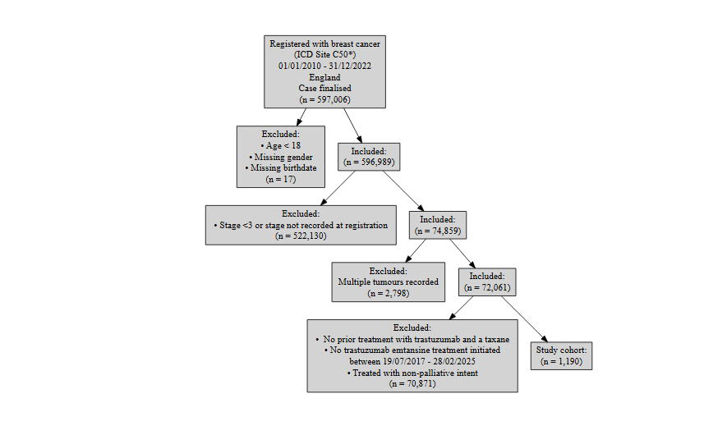

Patient acknowledgement
This work uses data that has been provided by patients and collected by the NHS as part of their care and support. The data is collated, maintained and quality assured by the National Cancer Registration and Analysis Service, which is part of NHS England.

Results

Age at start of treatment
The table below sets out the mean age, standard deviation, median age and interquartile range (IQR) of patients who have received trastuzumab emtansine for HER2 positive unresectable, locally advanced or metastatic breast cancer (including individuals who subsequently received trastuzumab deruxtecan). Age is measured at the commencement of the first treatment regimen of trastuzumab emtansine.
Characteristic | N = 1,190¹
Age at start of regimen | 57, (13) : 56 (48, 66)
¹Mean, (SD) : Median (Q1, Q3)
Table 1: Mean age, standard deviation, median age and IQR of patients who have received trastuzumab emtansine (including individuals who subsequently received trastuzumab deruxtecan)

Figure 2: Age distribution of patients who have received trastuzumab emtansine
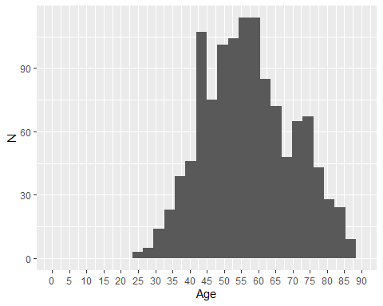

Overall survival

Base K-M plot
The Kaplan-Meier plot below shows survival over time for those receiving a treatment regimen of trastuzumab emtansine (including individuals who subsequently received trastuzumab deruxtecan).
Median survival was 23.95 months, and restricted mean survival (over the whole curve) was 35.05 months. The minimum follow-up time was 0 months, median 20.9 months, and maximum follow-up time of 93.9 months.
Figure 3: Overall survival amongst patients who have received trastuzumab emtansine
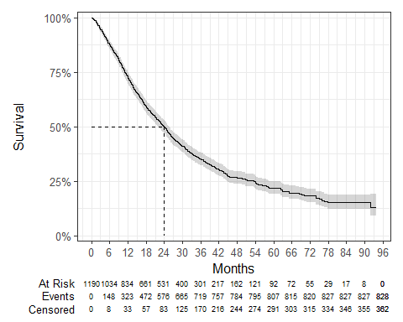

Exponential
Figure 4: Overall survival against exponential survival function
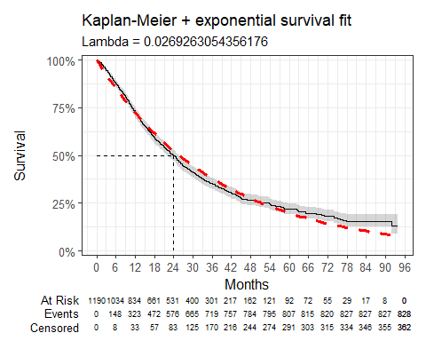

Parameter | Estimate | Std. Error | z | p-value
(Intercept) | 3.615 | 0.035 | 104.0116 | 0
log-likelihood = -3820.93150242912
AIC = 7643.86300485824
BIC = 7648.94471344434
Table 2: Survival model fit summary (exponential distribution)

Weibull
Figure 5: Overall survival against Weibull survival function
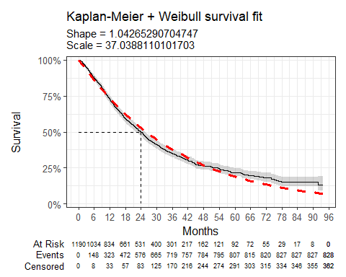

Parameter | Estimate | Std. Error | z | p-value
(Intercept) | 3.612 | 0.033 | 108.253644 | 0.0000000
Log(scale) | -0.042 | 0.029 | -1.461568 | 0.1438596
log-likelihood = -3819.88453946942
AIC = 7643.76907893884
BIC = 7653.93249611105
Table 3: Survival model fit summary (Weibull distribution)

Log-normal
Figure 6 Overall survival against log-normal survival function
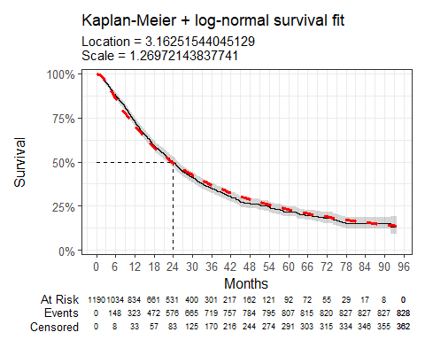

Parameter | Estimate | Std. Error | z | p-value
(Intercept) | 3.163 | 0.040 | 79.756206 | 0.000000e+00
Log(scale) | 0.239 | 0.026 | 9.263546 | 1.977538e-20
log-likelihood = -3816.2867260872
AIC = 7636.5734521744
BIC = 7646.73686934661
Table 4: Survival model fit summary (log-normal distribution)

Log-logistic
Figure 7 Overall survival against log-logistic survival function
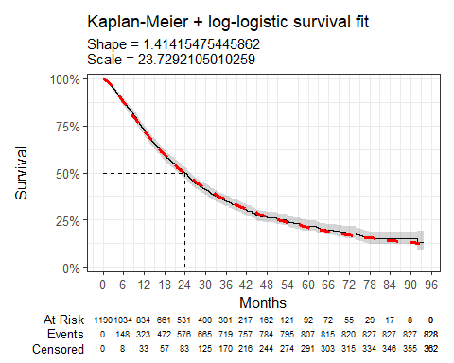

Parameter | Estimate | Std. Error | z | p-value
(Intercept) | 3.167 | 0.037 | 86.12867 | 0.000000e+00
Log(scale) | -0.347 | 0.029 | -11.86633 | 1.770672e-32
log-likelihood = -3798.24028645435
AIC = 7600.4805729087
BIC = 7610.64399008091
Table 5: Survival model fit summary (log-logistic distribution)

Gaussian
Figure 8: Overall survival against Gaussian survival function
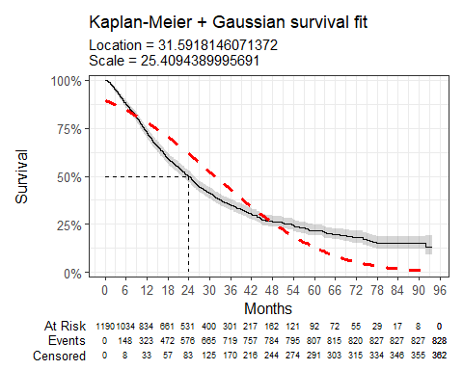

Parameter | Estimate | Std. Error | z | p-value
(Intercept) | 31.592 | 0.793 | 39.81738 | 0
Log(scale) | 3.235 | 0.026 | 125.52865 | 0
log-likelihood = -4152.06131207851
AIC = 8308.12262415702
BIC = 8318.28604132923
Table 6: Survival model fit summary (Gaussian distribution)

Gamma
Figure 9: Overall survival against gamma survival function
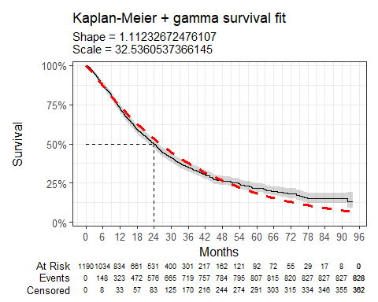

Parameter | Estimate | Std. Error | L95. | U95.
shape | 1.112 | 0.047 | 1.0241951 | 1.20804206
rate | 0.031 | 0.002 | 0.0272543 | 0.03466053
log-likelihood = -3817.8204018787
AIC = 7639.6408037574
BIC = 7649.80422092961
Table 7: Survival model fit summary (gamma distribution)

Generalised gamma
Figure 10: Overall survival against generalised gamma survival function
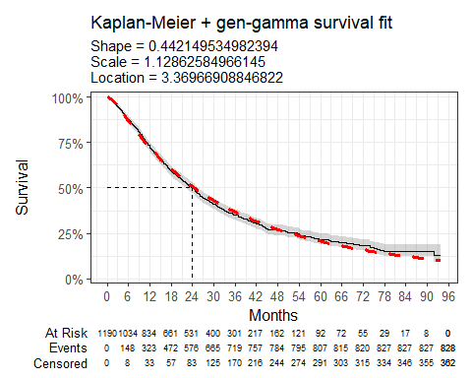

Parameter | Estimate | Std. Error | L95. | U95.
mu | 3.370 | 0.055 | 3.2610454 | 3.4782928
sigma | 1.129 | 0.042 | 1.0497282 | 1.2134535
Q | 0.442 | 0.092 | 0.2615582 | 0.6227409
log-likelihood = -3804.10583388303
AIC = 7614.21166776606
BIC = 7629.45679352438
Table 8: Survival model fit summary (generalised gamma distribution)

Gompertz
Figure 11: Overall survival against Gompertz survival function
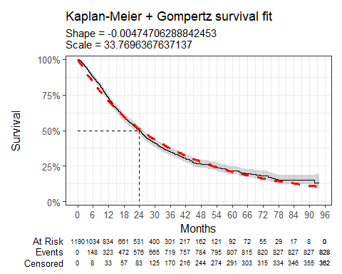

Parameter | Estimate | Std. Error | L95. | U95.
shape | -0.005 | 0.002 | -0.008770824 | -0.0007233014
rate | 0.030 | 0.002 | 0.026702864 | 0.0328389592
log-likelihood = -3818.16943156047
AIC = 7640.33886312094
BIC = 7650.50228029315
Table 9: Survival model fit summary (Gompertz distribution)

Time on treatment - trastuzumab emtansine
The Kaplan-Meier plot below shows time-on-treatment (ToT) for patients receiving trastuzumab emtansine (including individuals who subsequently received trastuzumab deruxtecan). The median ToT was 7 months, CI (6.4 months, 7.6 months).
Figure 12: Time-on-treatment for patients receiving trastuzumab emtansine (including individuals who subsequently received trastuzumab deruxtecan)

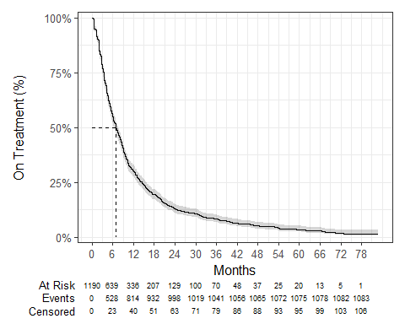

Age and overall survival for HER2-positive unresectable or metastatic breast cancer (cohort 2 - excluding trastuzumab deruxtecan)

Introduction
This report was produced in partnership by the National Disease and Registration Service (NDRS) and National Institute for Health and Care Excellence (NICE). It presents overall survival and age distributions among patients aged 18 or over with HER2-positive unresectable, locally advanced or metastatic breast cancer who have received trastuzumab emtansine after trastuzumab and a taxan, excluding individuals who subsequently received trastuzumab deruxtecan (cohort 2).

Method
A snapshot of SACT data was taken on 5th October 2025 and made available for analysis on 17th October 2025. SACT data is only considered complete when 90% of trusts have submitted data. As a result, SACT data is considered complete up to 28th February 2025. Patients were traced for their vital status on 5th July 2025.
Descriptive statistics of age were computed, along with Kaplan-Meier estimates and parametric fits for overall survival (OS). Patients were censored at the date of the most recent trace (5th July 2025), representing the last date on which vital status was confirmed.
Time-on-treatment was measured by the difference between a patient’s first and last trastuzumab emtansine administration date, plus a prescription length of 21 days (standard cycle length). If an individual died before the end date of the current treatment cycle, the treatment end date was revised to their date of death. If the patient’s treatment end date extended beyond the treatment censoring date (28th February 2025), the patient is censored.

Cohort inclusions / exclusions
Patients were included if they met all of the following:
- Diagnosed between 1st January 2010 and 31st December 2022
- Gender recorded as male or female
- Country code was ‘England’, based on postcode of residence at diagnosis
- Age at diagnosis date was 18 or over
- ICD-10 diagnosis code was ‘C50*’ (Malignant melanoma of breast)
- Tumour stage (at diagnosis) was 3 or 4
- Only one breast cancer tumour recorded during the study period
- Prior treatment with trastuzumab and a taxane, followed by trastuzumab emtansine between relevant dates (see points below)
- Trastuzumab emtansine was initiated on or after 19th July 2017 (NICE TA458 publication date). Usage before this point would be through the Cancer Drugs Fund or compassionate use schemes.
- Trastuzumab emtansine was initiated on or before the point at which SACT is considered complete (28th February 2025).
- Trastuzumab emtansine was not recorded as being administered in an adjuvant/neoadjuvant or curative setting
Patients were excluded if:
- Subsequent treatment included trastuzumab deruxtecan

Flow chart
Figure 13: Inclusion / Exclusion Flow Chart
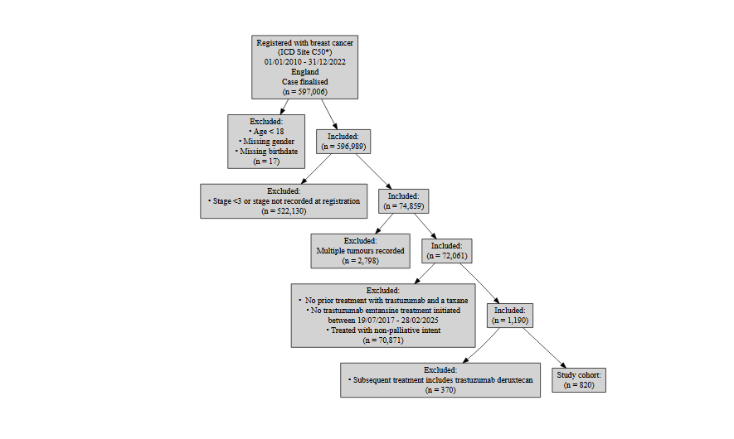
P

Patient acknowledgement
This work uses data that has been provided by patients and collected by the NHS as part of their care and support. The data is collated, maintained and quality assured by the National Cancer Registration and Analysis Service, which is part of NHS England.

Results

Age at start of treatment
The table below sets out the mean age, standard deviation, median age and interquartile range (IQR) of patients who have received trastuzumab emtansine for HER2 positive unresectable, locally advanced or metastatic breast cancer (excluding individuals who subsequently received trastuzumab deruxtecan). Age is measured at the commencement of the first treatment regimen of trastuzumab emtansine.
Characteristic | N = 820¹
Age at start of regimen | 58, (13) : 58 (49, 69)
¹Mean, (SD) : Median (Q1, Q3)
Table 10: Mean age, standard deviation, median age and IQR of patients who have received trastuzumab emtansine

Figure 14: Age distribution of patients who have received trastuzumab emtansine (excluding individuals who subsequently received trastuzumab deruxtecan)
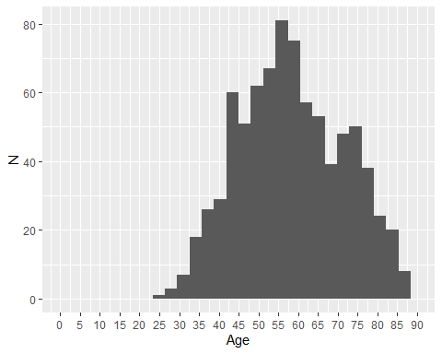

Overall survival

Base K-M plot
The Kaplan-Meier plot below shows survival over time for those receiving a treatment regimen of trastuzumab emtansine (excluding individuals who subsequently received trastuzumab deruxtecan).
Median survival was 16.85 months, and restricted mean survival (over the whole curve) was 29 months. The minimum follow-up time was 0 months, median 15.1 months, and maximum follow-up time of 93.9 months.
Figure 15: Overall survival amongst patients who have received trastuzumab emtansine
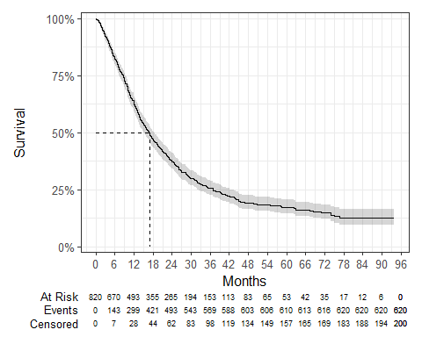

Exponential
Figure 16: Overall survival against exponential survival function
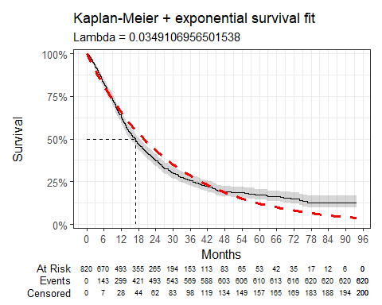

Parameter | Estimate | Std. Error | z | p-value
(Intercept) | 3.355 | 0.040 | 83.53788 | 0
log-likelihood = -2700.07645931116
AIC = 5402.15291862233
BIC = 5406.86222296259
Table 11: Survival model fit summary (exponential distribution)

Weibull
Figure 17: Overall survival against Weibull survival function
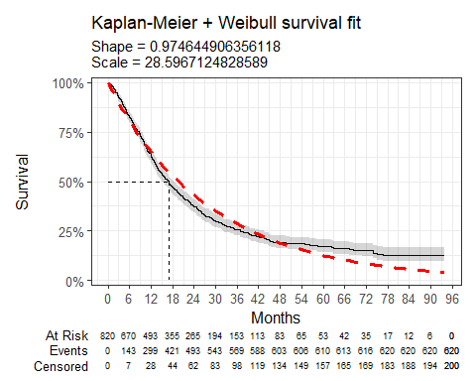

Parameter | Estimate | Std. Error | z | p-value
(Intercept) | 3.353 | 0.041 | 81.2942994 | 0.0000000
Log(scale) | 0.026 | 0.032 | 0.7974424 | 0.4251942
log-likelihood = -2699.75432533132
AIC = 5403.50865066264
BIC = 5412.92725934316
Table 12: Survival model fit summary (Weibull distribution)

Log-normal
Figure 18: Overall survival against log-normal survival function
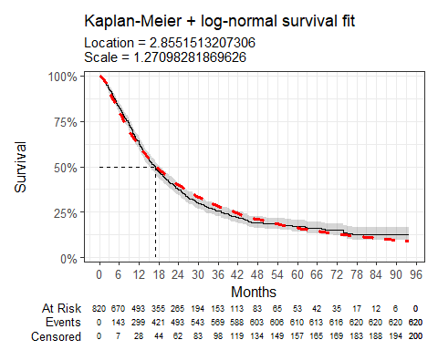

Parameter | Estimate | Std. Error | z | p-value
(Intercept) | 2.855 | 0.047 | 61.195126 | 0.000000e+00
Log(scale) | 0.240 | 0.030 | 8.105113 | 5.269665e-16
log-likelihood = -2681.89117301945
AIC = 5367.7823460389
BIC = 5377.20095471941
Table 13: Survival model fit summary (log-normal distribution)

Log-logistic
Figure 19: Overall survival against log-logistic survival function
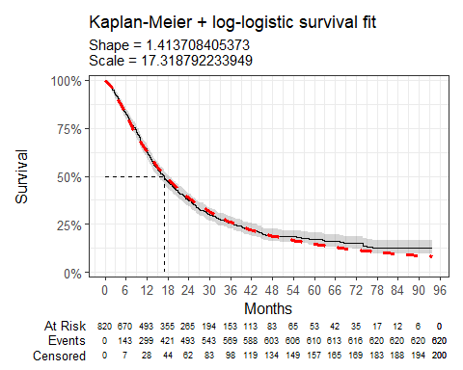

Parameter | Estimate | Std. Error | z | p-value
(Intercept) | 2.852 | 0.044 | 65.34991 | 0.000000e+00
Log(scale) | -0.346 | 0.034 | -10.27964 | 8.705396e-25
log-likelihood = -2666.97340000117
AIC = 5337.94680000235
BIC = 5347.36540868286
Table 14: Survival model fit summary (log-logistic distribution)

Gaussian
Figure 20: Overall survival against Gaussian survival function
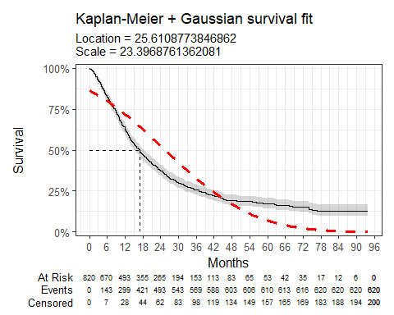

Parameter | Estimate | Std. Error | z | p-value
(Intercept) | 25.611 | 0.859 | 29.82445 | 1.883332e-195
Log(scale) | 3.153 | 0.030 | 106.46800 | 0.000000e+00
log-likelihood = -3015.70483763384
AIC = 6035.40967526769
BIC = 6044.8282839482
Table 15: Survival model fit summary (Gaussian distribution)

Gamma
Figure 21: Overall survival against gamma survival function
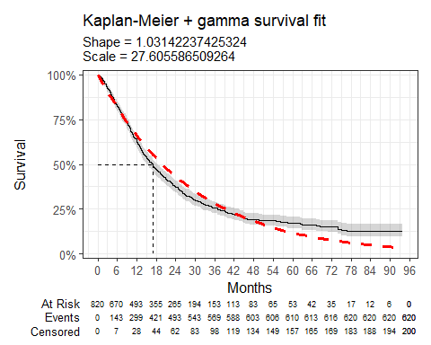

Parameter | Estimate | Std. Error | L95. | U95.
shape | 1.031 | 0.050 | 0.93728674 | 1.13501245
rate | 0.036 | 0.003 | 0.03156123 | 0.04157691
log-likelihood = -2699.87726836959
AIC = 5403.75453673918
BIC = 5413.1731454197
Table 16: Survival model fit summary (gamma distribution)

Generalised gamma
Figure 22: Overall survival against generalised gamma survival function
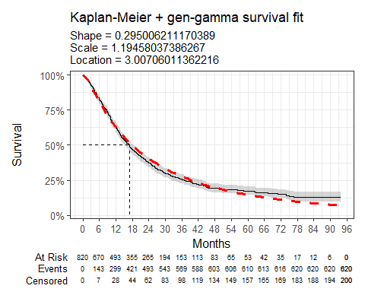

Parameter | Estimate | Std. Error | L95. | U95.
mu | 3.007 | 0.066 | 2.8772975 | 3.1368227
sigma | 1.195 | 0.043 | 1.1124448 | 1.2827803
Q | 0.295 | 0.097 | 0.1055441 | 0.4844683
log-likelihood = -2677.05010376246
AIC = 5360.10020752493
BIC = 5374.2281205457
Table 17: Survival model fit summary (generalised gamma distribution)

Gompertz
Figure 23: Overall survival against Gompertz survival function
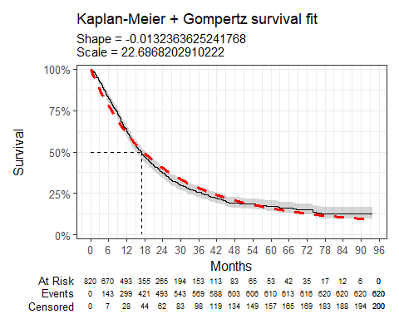

Parameter | Estimate | Std. Error | L95. | U95.
shape | -0.013 | 0.003 | -0.01836867 | -0.008104051
rate | 0.044 | 0.003 | 0.03935713 | 0.049366152
log-likelihood = -2685.77434017889
AIC = 5375.54868035778
BIC = 5384.9672890383
Table 18: Survival model fit summary (Gompertz distribution)

Time on treatment - trastuzumab emtansine
The Kaplan-Meier plot below shows time-on-treatment (ToT) for patients receiving trastuzumab emtansine (excluding individuals who subsequently received trastuzumab deruxtecan). The median ToT was 6.9 months, CI (6 months, 7.4 months).
Figure 24: Time-on-treatment for patients receiving trastuzumab emtansine (excluding individuals who subsequently received trastuzumab deruxtecan)
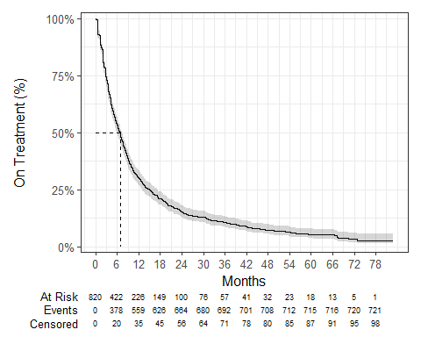

Chloe J. Bright et al., “Data Resource Profile: The Systemic Anti-Cancer Therapy (SACT) dataset,” International Journal of Epidemiology 49, no. 1 (February 2020): 15–15l, https://dx.doi.org/10.1093/ije/dyz137.
NICE health technology evaluations: the manual (2025) NICE process and methods PMG36. Last updated 23 October 2025, n.d., https://www.nice.org.uk/process/pmg36.
Latimer Nicholas, NICE DSU Technical Support Document 14: Undertaking survival analysis for economic evaluations alongside clinical trials - extrapolation with patient-level data, 2011, http://www.nicedsu.org.uk/.

