NDRS – NICE Partnership Report ID3863

Background
This report was produced in partnership by the National Disease and Registration Service (NDRS) and National Institute for Health and Care Excellence (NICE). NDRS and NICE have established a partnership focused on routinely collected data to support NICE decision making on the appraisals of cancer treatments. The partnership uses NDRS datasets, including the information submitted by trusts to the SACT dataset, to provide an understanding of current practice.
To determine a severity modifier, NICE considers factors such as the age, gender, and overall survival of the patient cohort affected by the disease. Additionally, knowing the time-on-treatment for each therapy is useful, as it validates assumptions made in TA evaluations about the duration of treatment use.
This partnership is focused on producing demographic and survival information using NDRS data, alongside supplementary information tailored to each technology appraisal. These may include, for example, the time patients spend on particular treatments, genetic data where this is available, or other information on real world care pathways. Interpretation of the data isn’t included in this report. The report contains the information as provided to the NICE TA committees. Details on how NICE health technology appraisals use this data can be found in the NICE health technology evaluations manual , with specific information relating to the survival analysis modelling available in Technical Support Document (TSD) 14.
The focus of this report is the indication ID3863: Lifileucel for previously treated unresectable or metastatic melanoma

Age, Gender, Treatment and BRAF mutation status information for Unresectable or Metastatic Melanoma Tumours

Introduction
This report was produced in partnership by the National Disease and Registration Service (NDRS) and National Institute for Health and Care Excellence (NICE). It presents patient demographic characteristics and treatment pathways among patients aged 18 or over with unresectable or metastatic melanoma.

Method
A snapshot of Systemic Anti-Cancer Therapy (SACT) data was taken on 2nd August 2025 and made available for analysis on 3rd August 2025. SACT data is only considered complete when 90% of trusts have submitted data. For this report, SACT data is thus considered complete up to 31st Jan 2025. The treatment period of interest runs from June 2018 up to this date, for a cohort of individuals diagnosed between June 2018 and December 2022.
Descriptive statistics of age and gender were computed, together with treatment counts and BRAF mutation status.

Identifying Metastatic and Unresectable Cases at Registration
Identifying Data on patients with unresectable or metastatic melanoma presented significant challenges. Staging information is recorded at registration/diagnosis but not as the disease progresses. There was no data item which explicitly recorded resectability. Consequently, identifying metastatic and unresectable cases necessitated either 1) filtering based on staging at diagnosis, 2) inferring progression from treatment patterns, or 3) employing a combination of both approaches. The first approach (filtering on staging at registration) is methodologically straightforward but cruder in approach. For example, restricting the cohort to those with a recorded stage of 3 or 4 reduces the risk of including non-metastatic case. However, it also excludes patients whose disease may have progressed and become metastatic after initial registration, thereby reducing the cohort size.

Distinguishing between adjuvant/neo-adjuvant use and primary systemic therapies
The alternate approach of inferring metastatic or unresectable status from treatment patterns was complicated by the fact that some of the common treatments are also given as adjuvant or neoadjuvant therapies (alongside curative treatment options) as well as primary systemic therapies where the disease has progressed to metastatic status. Consequently, it was not possible to infer metastatic status from treatment patterns without explicit information on the treatment intent (that is to say, whether the treatment was given on an adjuvant or neoadjuvant basis or as the primary treatment).
Alongside, the transition from version 2 to version 3 of the SACT data standard during the reporting period altered the allowable values in the treatment intent fields. As a result, it became difficult to reliably distinguish adjuvant therapies from systemic primary treatments, increasing the risk of unintentionally excluding patients receiving the latter. We therefore included only patients whose tumour was stage 3 or 4 at diagnosis, and whose treatment intent was recorded as palliative (including ‘life extending’).
Consequently, the number of patients included in this report is likely lower than the total number actually treated for unresectable or metastatic melanoma with systemic therapy. For example, there were around 17,500 newly diagnosed melanomas, and 2,300 melanoma skin cancer deaths, each year between 2017-19. We identified first line treatments for 2,334 over a much longer time frame (June 2018 – Jan 2025). The relatively small sample size introduces greater uncertainty around the point estimates. Patient numbers at the second line of treatment are particularly low, which precludes the generation of meaningful survival curves in the second-line setting.

Recording of combination therapies
Due to the number of combination immunotherapy regimens indicated for this condition, it was sometimes difficult to identify where combination regimens or monotherapies were given at first and second line. This analysis was conducted using SACT records data at the regimen level, but trusts may record combination therapies either as a combination or as two separate regimens running concurrently. We adopted the following heuristic to categorise apparently split regimens descriptions into lines of treatment, but it should be noted that no rule can deal with all edge cases, for example cases where one element of a combination is started but not continued due to toxicity or adverse reaction. This difficulty in classifying regimens into lines of treatment creates additional uncertainty into the counts of combination and associated monotherapies, particularly in the case of second line Nivolumab, which is given as a maintenance therapy following the Ipilimumab + Nivolumab combination at first line, but also as a second line treatment following other first line regimens. It is possible that the heuristic used understates the proportion of genuine Nivolumab second line monotherapy treatments.

Line of treatment heuristic
This heuristic uses only the regimen name field as recorded in the SACT dataset and does not incorporate drug-level detail. Examples of regimen names include ‘Ipilimumab + Nivolumab’, ‘Nivolumab’, ‘Ipilimumab’, ‘Dabrafenib + Trametinib’, ‘Dabrafenib’, and ‘Trametinib’.

First line
- Where a regimen is described as a combination therapy -> treatment description is categorised as that combination. For example, if regimen = ‘Ipilimumab + Nivolumab’, then it is treated as such without further inference.
Where a regimen description contains:
- ‘Ipilimumab’ and is immediately followed by a regimen description containing ‘Nivolumab’ within 31 days -> categorised as combination ‘Ipilimumab + Nivolumab’
- ‘Nivolumab’ and is immediately followed by a regimen description containing ‘Ipilimumab’ within 31 days-> categorised as combination ‘Ipilimumab + Nivolumab’
- ‘Dabrafenib’ and is immediately followed by a regimen description containing ‘Trametinib’ within 31 days -> categorised as combination ‘Dabrafenib + Trametinib’
- ‘Trametinib’ and is immediately followed by a regimen description containing ‘Dabrafenib’ within 31 days -> categorised as combination ‘Dabrafenib + Trametinib’
- ‘Binimetinib’ and is immediately followed by a regimen description containing ‘Encorafenib’ within 31 days -> categorised as combination ‘Binimetinib + Encorafenib’
- ‘Encorafenib’ and is immediately followed by a regimen description containing ‘Binimetinib’ within 31 days -> categorised as combination ‘Binimetinib + Encorafenib’

Second line
Following this, second line regimens are identified as a change in regimen name following the first line treatment, except where a combination changes to a monotherapy of one of its components, which is considered part of the first line. In most cases, this happens when Ipilimumab + Nivolumab regimens are replaced by Nivolumab maintenance (mono)therapy, which we define as part of the first-line treatment.

Cohort inclusions / exclusions
Patients were included in this cohort where:
- Diagnosed between 1st June 2018 and 31st December 2022 (the latest available year of cancer registration data, at the time of report production)
- The country code was ‘England’ based on the patient’s postcode of residence at diagnosis
- ICD-10 diagnosis code was ‘C43*’ - Malignant melanoma of skin (defined in both registrations data and the SACT dataset)
- Age at diagnosis date was 18 or over (defined in registrations data)
- Gender field was known (male or female in registrations data)
- Only a single melanoma tumour was recorded in the period
- Recorded SACT treatment was not given as part of a trial (defined using SACT clinical trial field and regimen description)
- Tumour stage (at diagnosis) was 3 or 4
- Intent of treatment fields (in SACT) contained at least one of the following
  - Palliative
  - Disease Modification
  - Palliative - Aiming to extend life expectancy
  - Palliative - Aiming to relieve or control malignancy related symptoms
  - Palliative - Aiming to relieve and/or control malignancy related symptoms
  - Palliative - Aiming to achieve remission
  - Palliative - Aiming to delay tumour progression

Figure 1: Inclusion / Exclusion Flow Chart
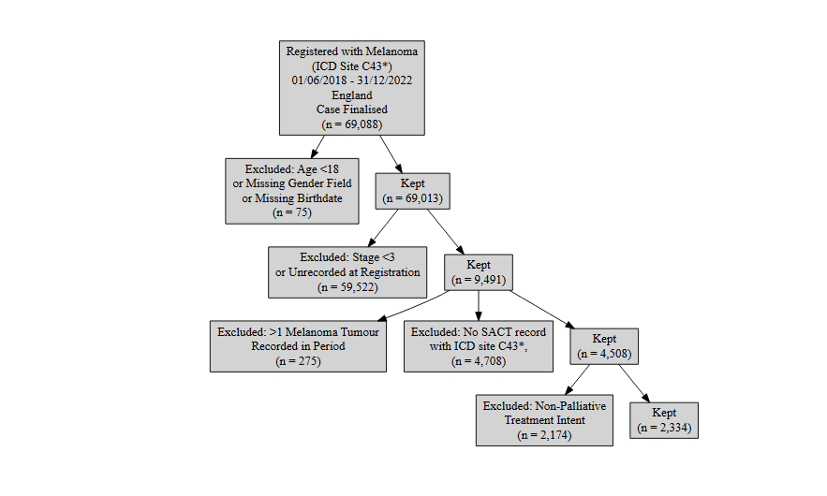

Patient Acknowledgement
This work uses data that has been provided by patients and collected by the NHS as part of their care and support. The data is collated, maintained and quality assured by the National Disease Registration Service, which is part of NHS England.

Results

Age at start of treatment
The table below sets out the mean age, standard (std.) deviation, median age and interquartile range (IQR) of patients who have received systemic treatment for unresectable or metastatic melanoma. Age is measured at the commencement of the first treatment regimen.
Table 1: Mean age, standard deviation, median age and IQR of patients who have received systemic treatment for unresectable or metastatic melanoma
Characteristic | Female N = 889¹ | Male N = 1,445¹
Age at start of regimen | 65, (14) : 67 (55, 76) | 67, (13) : 69 (59, 77)
¹Mean, (SD) : Median (Q1, Q3)

Treatment Counts
The tables below set out the indicative count of patients for the first two lines of treatment, excluding best supportive care (no life extending treatment) details of which are out of the scope of SACT data collections. Regimen descriptions including hormones, zoledronic acid, denusumab and bleomycin were removed as not being relevant to the analysis.
Note also that amalgamating regimens into lines of treatment can be difficult. For example, if a patient has a record of an Ipilimumab + Nivolumab regimen, followed by a Nivolumab monotherapy regimen, this may be the expected move to maintenance therapy, or a genuine switch to Nivolumab monotherapy. For second line categorisation purposes, we have assumed that where the regimen description indicates a combination therapy (for example Ipilimumab + Nivolumab) and is followed by a monotherapy of one of the components, this is either a case of maintenance therapy (Nivolumab maintenance following Ipilimumab), or a data entry issue where the regimen was split across multiple lines, not a genuine second line treatment. This approach may understate the number of monotherapies in some circumstances. Further details of the approach are set out in the method section above. Of the 2334 first line cases, 11 had a revised description applied to them. 5 split regimens of Trametinib and Dabrafenib were reassigned to ‘Dabrafenib + Trametinib’ and 6 split regimens of Ipilimumab and Nivolumab were assigned to ‘Ipilimumab + Nivolumab’.

Indicative proportions of patients receiving each treatment at first line
Table 2: Counts and Proportions of First Line Treatments
 | N = 2,334¹
Ipilimumab + Nivolumab | 814 (35%)
Pembrolizumab | 656 (28%)
Dabrafenib + Trametinib | 322 (14%)
Nivolumab | 199 (8.5%)
Binimetinib + Encorafenib | 172 (7.4%)
Ipilimumab | 84 (3.6%)
Other | 41 (1.8%)
Nivolumab + Relatlimab | 24 (1.0%)
Dabrafenib | 22 (0.9%)
¹n (%)

Indicative proportions of patients receiving each treatment at second line
Table 3: Counts and Proportions of Second Line Treatments
 | N = 652¹
Binimetinib + Encorafenib | 148 (23%)
Dabrafenib + Trametinib | 133 (20%)
Ipilimumab + Nivolumab | 106 (16%)
Pembrolizumab | 56 (8.6%)
Ipilimumab | 52 (8.0%)
Nivolumab | 52 (8.0%)
Dabrafenib | 37 (5.7%)
Other | 32 (4.9%)
Dacarbazine | 23 (3.5%)
Carboplatin + Paclitaxel | 13 (2.0%)
¹n (%)

BRAF mutation status
This table splits out the first line treatment regimen descriptions according to BRAF mutation status. BRAF mutation status is based on any test recorded between June 2016 and December 2021 inclusive, regardless of diagnosis year. There are some gaps in data collection for BRAF during the collection period . For example, see the table on Somatic Molecular Data for completeness of our most recent data year (2021). We were unable to identify a recorded BRAF status test for most patients in the cohort.
Table 4: Counts and Proportions of First Line Treatments by BRAF Status
 | BRAF Positive N = 496¹ | BRAF Negative N = 552¹ | No record of test N = 1,286¹
Ipilimumab + Nivolumab | 127 (26%) | 198 (36%) | 489 (38%)
Pembrolizumab | 95 (19%) | 230 (42%) | 331 (26%)
Dabrafenib + Trametinib | 157 (32%) | 2 (0%) | 163 (13%)
Nivolumab | 28 (6%) | 59 (11%) | 112 (9%)
Binimetinib + Encorafenib | 56 (11%) | 0 (0%) | 116 (9%)
Ipilimumab | 12 (2%) | 45 (8%) | 27 (2%)
Other | 7 (1%) | 14 (3%) | 20 (2%)
Nivolumab + Relatlimab | 3 (1%) | 4 (1%) | 17 (1%)
Dabrafenib | 11 (2%) | 0 (0%) | 11 (1%)
¹n (%)

Introduction to health technology evaluation | NICE health technology evaluations: the manual | Guidance | NICE
Survival analysis TSD | NICE Decision Support Unit | The University of Sheffield
Data Resource Profile: The Systemic Anti-Cancer Therapy (SACT) dataset | International Journal of Epidemiology | Oxford Academic

