

Document filename: BaRS Clinical Safety Case Report
Directorate / Programme |  | Project Booking and Referral Standard
Document Reference
Director | Richard Ashcroft | Status | Draft
Owner | Lee Montgomery  Booking and Referral Standard (BaRS) Clinical Safety Case Report | Version | 1.9
Author | Lee Montgomery & Julie Harris | Version issue date | 29/08/24

Document Management
Revision History
Version | Date | Summary of Changes
0.01 | 01/11/2021 | draft
0.02 | 06/02/2022 | Comment by the BaRS Team
0.03 | 25/02/2022 | Comments by the BaRS Team
0.04 | 06/03/2022 | Additional information added
0.05 | 28/07/2022 | Updated in line with comments and additional information added
0.06 | 28/07/2022 | For peer and CSG review
0.07 | 01/09/2022 | Updated in line with review comments, added integration system pre-requisites.
0.08 | 12/09/2022 | Addressed Lead CSO comments, updated Clinical Risk Process
0.09 | 01/11/2022 | Completed test section and appendix
1.0 | 09/11/2022 | Final version
1.01 | 01/02/2023 | Added 999-CAS Test section and assessment of outstanding Test Issues (Appendix C).  Added 111-UTC to the 111-ED BaRS application.  Added non-Pathways 999-CAS validation details.  Moved clinical assessment of outstanding 111-ED Test Issues to Appendix C  Added Integration Test Summary tables as per review comments on previous version from CSG.  Added detail on formal transference of risk to suppliers to section 5.4.5 as per comments from BaRS Programme Director on previous version.  Updated the document to state NHS England rather than NHS Digital where appropriate, subsequent to the merger.  Addressed comments from BARS team, CSO and Programme Lead Review
1.1 | 09/02/2023 | Addressed CSG comments and finalised
1.11 | 02/04/2023 | Updated to include BaRS v1.0.0 scope and the associated clinical assessment.  Removed 999-CAS use cases until public beta is completed, they are assigned an application, and the standard is uplifted to include them.  Restructured report to support new application and use case hierarchy (Appendix A).  Added BaRS development lifecycle and aligned processes accordingly (section 5)  Added public beta section 9.4.  Addressed review comments
1.2 | 06/04/23 | Finalised version
1.21 | 06/072023 | Updated to include BaRS pre-release applications and BaRS v1.1.0 change in scope (including new naming convention for BaRS applications.
1.22 | 14/07/2023 | Incorporation of all peer review comments and CSO signoff
1.3 | 14/07/2023 | Finalised version
1.31 | 05/09/2023 | Updated with assessment of BaRS v1.2 scope
1.4 | 07/09/2023 | Peer review comment addressed and CSO sign off. Finalised version
1.41 | 13/11/23 | Updated with assessment of BaRS v1.3 scope
1.42 | 27/11/23 | Updated with review comments and Core changes
1.5 | 30/11/23 | Finalised version
1.51 | 10/01/24 | Updated with assessment of BaRS v1.4 scope
1.52 | 16/01/24 | Peer review comment addressed and CSO sign off.
1.6 | 16/01/24 | Finalised version
1.61 | 08/03/24 | Updated with assessment of BaRS 1.5 scope
1.62 | 14/03/24 | Peer review comment addressed and CSO sign off.
1.7 | 14/03/24 | Finalised version
1.71 | 15/05/24 | Updated with assessment of BaRS 1.6 scope
1.72 | 23/05/24 | Peer review comment addressed and CSO sign off.
1.8 | 23/05/24 | Finalised version
1.81 | 06/08/2024 | Updated with assessment of BaRS 1.8 scope
1.82 | 29/08/2024 | Updated with App5 GP/OCS to BP and OC use cases and App5 Public Beta outputs  Peer review comment addressed and CSO sign off.
1.9 | 29/08/2024 | Finalised version

Reviewers
This document has been reviewed by the following people:
Reviewer name | Title / Responsibility | Date | Version
Julie Harris | BaRS BA & Clinical Safety Officer | 06/08/2024 | 1.81
Lee Montgomery | BaRS Clinical Informatics Manager & Lead Clinical Safety Officer | 09/08/2024 | 1.81
Camille Gilmer | BaRS Product Manager | 21/08/2024 | 1.81
Anne Wilson | BaRS Lead Delivery Manager | 12/08/2024 | 1.81
Dylan Hainsworth | BaRS Product Owner/BA | 21/08/2024 | 1.81

Approved by
This document has been approved by the following people:
Name | Title | Date | Version
Lee Montgomery | BaRS Clinical Informatics Manager & Lead Clinical Safety Officer | 28/08/2024 | 1.9
Chris Dickson | Senior Clinical Lead | (delegated to LM) | 1.9
Richard Ashcroft | Programme Director | (delegated to AW/CG) | 1.9
For reviewers/approvers of previous versions of this report, please see the relevant version.

References
Ref | Document Reference number | Title | Version/Date
1 | N/A | NHS Booking and Referral Standard (BaRS) | 1.8.0
2 | N/A | NHS Booking and Referral Standard (BaRS) Clinical Safety Case Report | 17
3 | FHIR-PUB-04 | FHIR API Maturity ‘Publication Requirements’ section of the NHS FHIR Policy. | FHIR-PUB-04
4 | CSMS PROC 01 | NHS England Clinical Safety Management System | 1.0
5 | N/A | BaRS Clinical Risk Management Plan | v1.2
6 | DCB0129 | Clinical Risk Management: its Application in the Manufacture of Health IT Systems – Specification | V4.2
7 | N/A | NHSE CSG Letter of Endorsement - BaRS | 11/04/23
8 | N/A | NHS Booking and Referral Standard (BaRS) Hazard Log | V1.8
9 | DCB0160 | Clinical Risk Management: its Application in the Deployment and Use of Health IT Systems – Specification | 4.2
10 | N/A | Booking and Referral Standard NHS England | Current
11 | N/A | BaRS Implementation Guide | v1.6.0
12 | N/A | Bars Core Implementation Guide | v1.1
13 | N/A | BaRS API specification | V1.2.0
14 | N/A | BaRS TKW | V1.0.6
15 | N/A | Booking and Referrals into UEC (application 1) implementation guide | V1.0.3
16 | N/A | Booking and Referrals into UEC (application 2) implementation guide | V1.03
17 | N/A | Referral into UEC (application 3) implementation guide | v1.0.0
18 | N/A | Referral into UEC for validation (application 4) implementation guide | v1.1.0
19 | N/A | Referral into Pharmacy (application 5) implementation guide | v1.0.0_beta3
19a | N/A | Referrals into an Ambulance Service Trust (Application 6) | V1.0.0_beta
20 | HTTP IETF RFC 7540 | Hypertext Transfer Protocol Version 2 (HTTP/2) RFC 7540 subsequently succeeded by HTTP IETF RFC 9113 | May 2015 (June 2022)
20a | N/A | BaRS Principles and pre requisites | v1.6
21 | N/A | BaRS Version negotiation guidance | v1.6
21a |  | Standard patterns for BaRS Operations | v1.6
22 | N/A | Principles for rendering BaRS payloads | V1.6
22a | N/A | BaRS User Research Process
23 | N/A | BaRS Release Notes | V1.6
23a | N/A | BaRS onboarding process | V1.6
24 | N/A | BaRS Integration Test Scripts | Various
25 | N/A | UK Core FHIR | 10th September 2021 0.1.0 – STU1 4.0.1
26 | N/A | BaRS FHIR Profiles | v1.1.0
27 | N/A | BaRS v1.0.0-Alpha Supplier Conformance Assessment List (SCAL) | V0.5 May 22
27a | N/A | NHS digital Onboarding process
28 | N/A | BaRS 111-ED User Stories | Sep 06, 2021
29 | N/A | 999-CAS Referral User Stories | V1.0
30 | N/A | 999-CAS Validation User Stories | v1.0
31 | N/A | GP to Pharmacy requirements | v1.0
32 | N/A | PRSB Core Information Standard | V2.0
33 | N/A | PRSB 111 Referral Standard | V0.3
34 | N/A | PRSB Developing an information standard for 111 Referrals – Survey Results and Analysis | April 2022
35 | N/A | PRSB Endorsement of 111 Referral data model | V0.3
36 | N/A | 999-CAS Data Model for Endorsement | V2.0
37 | N/A | E-mail from Mark Gough NHSE and Ambulance Improvement Programme endorsing the 999 – CAS Data Model | 12/07/2022
38 | N/A | Agreement form NHSE UTC Policy Team that BaRS 111-ED application is approved for use unchanged for 111-UTC referrals | Jan 2023
39 | N/A | BaRS Referral into Pharmacy data model endorsement
40 | N/A | BaRS Path to Live document | v1.0
41 | N/A | UK Core FHIR | 10/09/2021 0.1.0 – STU1 4.0.1
42 | N/A | BaRS FHIR Profiles | v1.2
43 | N/A | BaRS UAT templates | V1.2
43a | N/A | BaRS Issue Tracker 999-CAS Public Beta | v1.0
44 | N/A | BaRS Application Beta Phase Ways of Working | V2.0
45 | N/A | Guidance: Medical device stand-alone software including apps (including IVDMDs) | v1.10f
46 |  | The UK Medical Devices Regulations 2002 | 2002
47 |  | BaRS Hazard Log | V1.0
48 |  | BaRS v1.0 _Alpha Hazard Workshop minutes | Oct 22
49 |  | BaRS v1.0 Hazard Workshop Minutes | 29th March 2023
50 |  | BaRS v1.1 Hazard Workshop minutes | 20th June 2023
51 | CU000142PR643 | BaRS secure FHIR code review | V1.0 March 22
52 | N/A | BaRS Capacity & Demand Assurance Statement | Oct 21
53 | N/A | Integration Test Report 111 to ED | V1.0
54 | N/A | Integration Test Report 999-CAS | V1.0
55 | N/A | Clinical risk assessment of Incident analysis - CS0290207 (INC0046047) BaRS - Significant Receiver Outage | 1.0
56 | N/A | NHS 111 Help Us Help You. A new way to manage access to Emergency Departments | version 1.4 2020
57 | N/A | NHS Digital Internet First Policy | October 2020
58 | N/A | NHS Long Term Plan | Jan 2019
59 | N/A | NHS Direct Booking Standard (CareConnect) | 2.0.4-live
60 | N/A | ITK 111 Report | 2.0
60a | N/A | Emergency Department Digital Integration (EDDI) Product Description | V1.0
61 | N/A | 999-111 Discovery Report | v1.0
62 | N/A | 999-111 Alpha Report | v1.0
63 | N/A | ITK Ambulance Request | v2.1
64 | N/A | Feedback on use of ITK Ambulance Report for CAD-to-CAD transfer | V1.0
65 | 20220725 | Ambulance Quality Indicators: Data specification for Systems Indicators (AmbSYS) | 25/07/2022
66 | N/A | IUC Service Specification | 25 August 2017
67 | N/A | Evaluation of pilot study implementing additional clinical assessment (validation) for selected Category 3 emergency ambulance calls | February 2021
68 | N/A | Category 3 / 4 999 Validation (AMPDS) Principles for National Implementation | October 2021
69 | N/A | NHS England Ambulance Digital Strategy | v1.0
70 | N/A | Lord Carter’s review into unwarranted variation in NHS ambulance trusts | Sept 2018
71 | N/A | Community Pharmacy advanced service specification: NHS Community Pharmacist Consultation Service | June 23
72 | N/A | BaRS GP to Pharmacy use case user centred design | V1.0
74 | N/A | CAD to CAD User Centred design | V1.0
74a |  | Application 6 CAD to CAD endorsement | v1.0
75 | N/A | ITK Task and Finish Group -IRP ITK 999-999 CAD changes | 1.1
76 | 08296 | Ambulance Response Programme Review | March 2018
77 | N/A | BaRS Application 6 Hazard workshop minutes | Jan 2024
78 | N/A | Endorsement of additional use cases for application 1 from Marc Thomas | 23/02/24
79 | N/A | BaRS Application 1 Public Beta Sender Conformance Certificate
80 | N/A | BaRS Application 1 Public Beta Sender CATR
81 | N/A | BaRS Application 1 Public Beta Receiver Conformance Certificate
82 | N/A | BaRS Application 1 Public Beta Receiver CATR
83 | N/A | Endorsement of additional use cases for application 2 from Marc Thomas | 01/03/2024
84 | N/A | BaRS Application 2 Public Beta Sender Conformance Certificate
85 | N/A | BaRS Application 2 Public Beta Sender CATR
86 | N/A | BaRS Application 2 Public Beta Receiver Conformance Certificate
87 | N/A | BaRS Application 2 Public Beta Receiver CATR
88 | N/A | BaRS Application 3 Public Beta Sender Conformance Certificate
89 | N/A | BaRS Application 3 Public Beta Sender CATR
90 | N/A | BaRS Application 3 Public Beta Receiver Conformance Certificate
91 | N/A | BaRS Application 3 Public Beta Receiver CATR
92 | N/A | BaRS Application 4 Public Beta Sender Conformance Certificate
93 | N/A | BaRS Application 4 Public Beta Sender CATR
94 | N/A | BaRS Application 4 Public Beta Receiver Conformance Certificate
95 | N/A | BaRS Application 4 Public Beta Receiver CATR
96 | N/A | BaRS Clinical Safety Case Report | V1.2
97 | N/A | BaRS Clinical Safety Case Report | V1.5
98 | N/A | BaRS v1.6 Hazard Workshop Minutes | V1.0
100 | N/A | BaRS v1.8 Hazard Workshop Minutes | V1.0
101 | N/A | Interim Endpoint Catalogue Test Report
102 | N/A | Minutes from Application 4 extension endorsement meeting
103 | N/A | Application 5 extension endorsement
104 | N/A | Application 7 data model; for endorsement
105 | N/A | Application 7 endorsement
106 | N/A | Application 5 extension to include GP/OCS to Pharmacy Blood Pressure and Oral contraception - endorsement
107 | N/A | BaRS Application 5 Sender Conformance Certificate – EMIS PharmRefer
108 | N/A | BaRS Application 5 Receiver Conformance Certificate – Positive Solutions Ltd Hx Consult
109 | N/A | Beta Exit Report BaRS Application 5 | V1.0

Glossary of Terms
Term / Abbreviation | What it stands for
ARP | Ambulance Response Programme
AST | Ambulance Service Trust
API | Application Programming Interface
BaRS | Booking and Referral Standard
BP | Blood Pressure
CAD | Computer Aided Dispatch system
CAS | Clinical Assessment Service
CATR | Clinical Authority to Release
CAT1 | ARP Category 1 ambulance response - Life Threatening
CAT2 | ARP Category 2 ambulance response Emergency
CAT3 | ARP Category ambulance response Urgent
CAT4 | ARP Category ambulance response non-urgent
CAT5 | Non-ambulance response
CDSS | Clinical Decision Support Software
CPCS | Community Pharmacy Consultation Service
CQSG | Clinical Quality & Safety Group
CSG | NHS England Clinical Safety Group
CSMS | Clinical Safety Management System
CSO | Clinical Safety Officer
DSIC | Digital Services for Integrated Care
ECPAG | Emergency Care Planning Advisory Group
EOC | Emergency Operations Centre
CSCR | Clinical Safety Case Report
EDDI | Emergency Department Digital Integration
DNA | Did Not Attend
DoS | Directory of Services
ED | Emergency Department
EMD | Emergency Medical Dispatcher
ERS | Electronic Referral Service
FHIR | Fast Healthcare Interoperability Resource
FOT | First of Type
GP | General Practitioner
HA | NHS 111 Health Advisor
HCP | Healthcare Professional
ITK | Interoperability Toolkit
INT | Integration Testing
IUC | Integrated Urgent Care, covering 111 and Clinical Assessment Services
MDR | Medical Device Regulations
NHS | National Health Service
NRL | National Record Locator
NEMS | National Event Monitoring Service
OCS | Online Consultation System
OC | Oral contraception
OOH | Out of hours
PaCCS | Pathways Clinical Consultation Support
PDS | Personal Demographics Service
Pharmacy First | A scheme to enable community pharmacists to supply prescription-only medicines, including antibiotics and antivirals where clinically appropriate, to treat seven common health conditions without the need to visit a GP
PMS | Patient Management System
PRSB | Professional Record Standards Body
Public Beta | Deployment of a system developed against a pre-release standard into a live service, under pilot conditions
SCAL | Supplier Conformance Assessment List
SDEC | Same Day Emergency Care
S&R | Streaming and Redirection
TKW | Toolkit workbench
UAT | User Acceptance Test
UCR | Urgent Community Response
TRG | Technical Review Group
UCR | Urgent Community Response
UEC | Urgent and Emergency Care
UTC | Urgent Treatment Centre
WNB | Was Not Brought

Document Control:
The controlled copy of this document is maintained in the NHS England corporate network. Any copies of this document held outside of that area, in whatever format (e.g. paper, email attachment), are considered to have passed out of control and should be checked for currency and validity.

1 Executive Summary 12
2 Introduction 13
3 System overview 14
3.1 Background 14
3.2 Programme Purpose 14
4 BaRS Product Scope 15
4.1 BaRS Core 16
4.2 BaRS API specification 18
4.3 BaRS Implementation Guide 18
4.4 BaRS Applications 21
4.5 BaRS Toolkit Workbench 21
4.6 Changes in scope from BaRS v1.7.0 21
4.7 Out of scope for this Release 22
5 BaRS Processes 24
5.1 BaRS development methodology 24
5.2 Discovery 24
5.3 The BaRS Alpha process 25
5.4 The BaRS Private Beta 26
5.5 The BaRS Public Beta 27
6 Regulatory Assessment 28
7 Clinical Risk Management System 28
7.1 Staffing and responsibilities 29
7.2 Clinical and Corporate Governance Structure: 29
8 Clinical Risk Management Activities 32
8.1 Risk Analysis and Clinical Risk Evaluation 32
8.2 Clinical Risk Control. 35
9 Test Summary 37
9.1 Security Testing 37
9.2 Volume and performance testing 37
9.3 Functional Testing 37
9.4 Public Beta 38
10 Summary Safety Statement 38
11 Quality Assurance and Document Approval 39
12 Configuration Control / Management 39
Appendix A - BaRS Applications 40
A.1 Bookings and referrals into urgent and emergency care services (application 1) 40
A.2 Bookings and Referrals into UEC (application 2) 49
A.3 Referral into UEC (application 3) 55
A.4 Referral into UEC for validation (application 4) 61
A.5 BaRS Pharmacy Referrals (application 5) 70
Appendix B - BaRS Pre-Release applications 76
B.1 Referrals into an Ambulance Service Trust (Application 6 76
B.2 Booking and Referrals into GP (application 7) 84
Appendix C - Risk Criteria 89
C.1 Hazard Consequence definitions 89
C.2 Hazard likelihood definitions 89
C.3 Clinical Risk Management Risk Matrix 90
C.4 Risk Acceptability Criteria 90

Executive Summary
This Clinical Safety Case Report (CSCR) summarises the clinical safety activities carried out for the NHS Booking and Referral Standard (BaRS) v1.8.0 [Ref 1] to support the roll out of live implementations. The CSCR is structured to be iterative as new use cases and changes are introduced.
The BaRS is a standard that enables the digitisation of workflows transferring patients between services. It consists of documentation (which defines the standard and provides implementation guidance) and infrastructure, to support the routing of referral information to the selected healthcare service. It is not a system, a service nor just an Application Programming Interface (API).
The BaRS implementation requires Healthcare IT system manufacturers to develop Fast Healthcare Interoperability Resource (FHIR) APIs in accordance with the BaRS implementation guide, which connect through the BaRS infrastructure. This enables the safe communication of booking and referral information between NHS service providers in a format that is useful to clinicians and can drive workflows.
The BaRS has been proven in use in Public Beta deployments for the following BaRS applications and use cases:
- Booking and Referrals into UEC (application 1)
  - NHS 111 (telephony) to Emergency Department (ED)
  - NHS 111 (telephony) to Urgent Treatment Centre (UTC)
  - Integrated Urgent Care (IUC) Clinical Assessment Service (CAS) to ED
  - IUC CAS to UTC
  - NHS 111 (telephony) to Same Day Emergency Care (SDEC)
  - IUC CAS to SDEC
  - 999 Ambulance Service Trust (AST) to ED (Pathways only)
  - 999 AST to UTC (Pathways only)
  - 999 AST to SDEC (Pathways only)
- Booking and Referrals into UEC (application 2)
  - 111 Online to ED
  - 111 Online to UTC
  - Streaming and redirection (S&R) to ED
  - S&R to UTC
- Referral into UEC (application 3)
  - 999 AST to CAS Referral
- Referral into UEC for validation (application 4)
  - 999 AST to CAS Validation
  - 999 AST to Falls Service
  - 999 AST to Community Services
- Referrals into Pharmacy (application 5)
  - GP to Community Pharmacy (Pharmacy First) Minor illness
  - Online Consultation System (OCS) to Community Pharmacy (Pharmacy First) Minor illness
  - GP/OCS to Community Pharmacy (Pharmacy First) – Blood Pressure (BP)
  - GP/OCS to Community Pharmacy (Pharmacy First) – Oral contraception (OC)
This Release includes support for Public Beta implementations of the following use cases shown below, and which are assessed in Appendix B of this report:
- Referrals into an Ambulance Service Trust (application 6)
  - Computer Aided Dispatch (CAD) to CAD Out of Area Referral
  - CAD to CAD Call Assist Request
  - CAD to CAD Mutual Aid Request
- Booking and Referrals into GP (application 7)
Patient Facing Services (PFS) to GP (MVP booking only)Nine Hazards have been identified. The residual risk assessment is summarised below in Table 1 and discussed in further detail in the main body of this report.
No new Hazards were introduced as a result of this Release.
The conclusion of Lee Montgomery (Clinical Safety Officer (CSO)) is that the clinical risk is acceptable, subject to system supplier and service provider clinical risk management activities in accordance with DCB0129 and DCB1060 respectively (see section 10).
Hazard | Initial Risk |  |  | Residual Risk
Hazard | Conse-quence | Likeli-hood | Risk Class | Conse-quence | Likelihood | Risk Class
H01 Patient is not assessed or treated as Recipient does not receive the referral or booking. | Major | Medium | 3 | Major | Very Low | 2
H02 Patient is not assessed or treated within the appropriate timeframe | Major | Medium | 3 | Major | Very Low | 2
H03 Patient does not receive appropriate care due to lack of clarity regarding the action required by the receiving Service Provider. | Major | Medium | 3 | Major | Very Low | 2
H04 HCP providing care is sent to the wrong location. | Major | Low | 3 | Major | Very Low | 2
H05 Failure to contact patient | Major | Medium | 3 | Major | Very Low | 2
H06 Patient care compromised due to incomplete information in referral | Considerable | Medium | 3 | Considerable | Low | 2
H07 Patient care compromised as Clinician acts on incorrect information in referral | Major | Medium | 3 | Major | Very Low | 2
H08 Patient care is compromised when HCP is misled by the display of information in referral | Considerable | Medium | 3 | Considerable | Low | 2
H09 Patient, HCPs and/or other third parties come to harm due to safeguarding failures. | Major | Low | 3 | Major | Very Low | 2
Table 1 BaRS clinical risk analysis summary

Introduction
This CSCR is applicable to the NHS Booking and Referral Standard (BaRS) Release 1.8.0 [Ref 1] subsequently referred to as ‘this Release’ in this report. It builds on the BaRS Clinical Safety Case Report v1.8 [Ref 2]
The maturity label of this Release, as defined in the NHS FHIR Policy [Ref 3] is Live, and supporting the service in a sustainable way, and continuing to iterate and make improvements.
This clinical risk assessment is being undertaken in accordance with the NHS England Clinical Safety Management System [Ref 4] and the BaRS Clinical Risk Management Plan [Ref 5] and addresses requirements of DCB0129 [Ref 6]. The NHS England Clinical Safety Group (CSG) has endorsed the Clinical Risk Management approach for the development of this standard [Ref 7].
This clinical safety case has been developed to continuously monitor the development of the standard, monitor and mitigate hazards and issues as they arise. This is to ensure that clinical safety is upheld and maintained and that any potential hazards are mitigated to an acceptable level so as not to compromise patient safety and that of clinical services and professionals. Hazards and associated causes and controls are detailed in the associated Hazard Log which is published separately to this report [Ref 8].
Whilst the BaRS will eventually be an any-to-any, care setting agnostic standard, the scope of this Release is to support only the stated use cases (see section 4).
The responsibility for managing clinical risk in the development and implementation of the BaRS conformant solutions lies with the manufacturers in accordance with DCB0129 [Ref 6].
The responsibility for managing clinical risk in the deployment and use of BaRS conformant solutions resides with the deploying Healthcare Organisation in accordance with DCB0160 Clinical Risk Management: its Application in the Deployment and Use of Health IT Systems [Ref 9].
This report is intended to inform those activities.

System overview

Background
The BaRS is an interoperability standard, with supporting infrastructure, which enables booking and referral information to be sent between NHS service providers, quickly, safely, in a format that can drive workflows and is useful to clinicians. It is a partner programme to the Electronic Referral Service (e-RS) which focuses on elective care and is part of an overarching programme to update and modernise all bookings, referrals and appointments management in the NHS. Whilst this Release of the BaRS includes six applications, it has been designed in a way that it can be reused with minimal adaptation in subsequent Releases, to meet new use cases as they are commissioned.
Additional information can be found at Booking and Referral Standard - NHS England [Ref 10]

Programme Purpose
The Booking and Referral Standard programme aims to improve health outcomes as well as enhancing the patient experience, by simplifying the transfer of important clinical information and easing patient flow through services at times where an onward care is needed. The programme delivers this by:
- Providing a framework that allows multiple systems to communicate with each other in a simple and logical way.
- Publishing a standard that supports the administrative task of booking a patient into their next care setting, as well as providing the correct and relevant clinical referral information to care providers so that they can make or accept a patient referral.
- The production of a standard that is accepted, agreed and adopted by health care system providers and rolled out across the health system to improve patient experience and care outcomes.
The delivery of the above introduces the following improvements for different stakeholders to access healthcare:
- For the Patient – We want to make the process to access healthcare simpler and more efficient, so patients don't have to repeatedly provide the same or similar information and that this information is then used appropriately throughout in their care journey.
- For the Healthcare professionals – We want to provide staff with relevant patient booking and referral information that is easy to understand and with sufficient detail so that they can accept the patient, prepare for their arrival and support the onward management of their care.
- For the System – We want to provide information/data that is easy to digest and integrate into workflows without the need for manual intervention across different scenarios and/or care settings.
- For Suppliers and Providers – We want to provide staff with relevant patient booking and referral information that is easy to understand and with sufficient detail so that they can accept the patient, prepare for their arrival and support the onward management of their care.

BaRS Product Scope
This Release includes the following BaRS Products:

Product | Version | Use cases supported
Implementation Guide [Ref 11] | 1.8 | All
BaRS Core [Ref 12] | 1.0.4, 1.1.4  1.2.0-alpha | All
API Specification [Ref 13] | 1.0.0, 1.1.0-beta, 1.2.0-alpha | All
BaRS Toolkit Workbench (TKW9 [Ref 14] | 1.0.11 | N/A
Booking and Referrals into UEC (application 1) [Ref 15] | 1.0.4 | Primary use case  - NHS 111 (telephony) to ED
Booking and Referrals into UEC (application 1) [Ref 15] | 1.0.4 | Secondary use case(s)  - IUC CAS to ED  - NHS 111 (telephony) to UTC  - IUC CAS to UTC  - NHS 111 (telephony) to SDEC  - IUC CAS to SDEC  - 999 AST to ED (Pathways only)  - 999 AST to UTC (Pathways only)  - 999 AST to SDEC (Pathways only)
Booking and Referrals into UEC (application 2) [Ref 16] | 1.0.4 | Primary use case  - 111 Online to ED
Booking and Referrals into UEC (application 2) [Ref 16] | 1.0.4 | Secondary use case(s)  - 111 Online to UTC  - S&R to ED  - S&R to UTC
Referral into UEC (application 3) [Ref 17] | 1.0.1 | Primary use case  - 999 AST to CAS Referral
Referral into UEC for validation (application 4) [Ref 18] | 1.2.) | Primary use case  - 999 AST to CAS Validation
Referral into UEC for validation (application 4) [Ref 18] | 1.2.) | Secondary use cases  - 999 AST to Falls Service  - 999 AST to Community Services
Referral into Pharmacy (application 5) [Ref 19] | 1.1.0 | Primary use case  - GP to Community Pharmacy (Pharmacy First) – Minor illness
Referral into Pharmacy (application 5) [Ref 19] | 1.1.0 | Secondary use cases  - Online Consultation Service (OCS) to Community Pharmacy (Pharmacy First) – Minor illness  - GP/OCS to Community Pharmacy (Pharmacy First) – Blood Pressure (BP)  - GP/OCS to Community Pharmacy (Pharmacy First) – Oral Contraception (OC)
Referrals into an Ambulance Service Trust (Application 6) [Ref 19a] | 1.0.0_beta.1 | Primary use cases(s)  - CAD to CAD Out of Area Referral  - CAD to CAD Call Assist Request  - CAD to CAD Mutual Aid Request
Booking and Referrals into GP (application 7) | 1.0.0_alpha | Primary use case  PFS to GP (Constrained to NHS App MVP booking only)

BaRS Core
The BaRS Core provides the core functionality for booking and referrals. It provides implementation guidance for generic booking and referral workflows and is used by developers in conjunction with the implementation guidance for specific use cases in the BaRS Applications catalogue. It includes the following Product Components:
- Transport layer (everything needed to enable communication between systems)
- Architecture
- Use of communication protocols
- Security

BaRS Transport Layer
The BaRS Transport layer includes all that is required for communication between BaRS conformant systems.

BaRS Architecture
The BaRS API is the focal infrastructure component of the BaRS and is hosted and maintained by NHS England on a centralised platform. It is comprised of several components from a developer perspective, it can be thought of as a proxy. All requests are routed through it, it brokers the endpoint for a given service (on behalf of a Sender) and delivers the request to the Receiver.
It can support both national and regional scale service implementations, including any type of service discovery tool. The purpose of this centralised infrastructure is to assist with speeding up development and rollout by handling the burden of establishing endpoints and connectivity; a Sender always communicates with the BaRS API and a Receiver only accepts request from it.
A high-level view of the of architecture is shown below in Figure 1.
Figure 1 BaRS Infrastructure
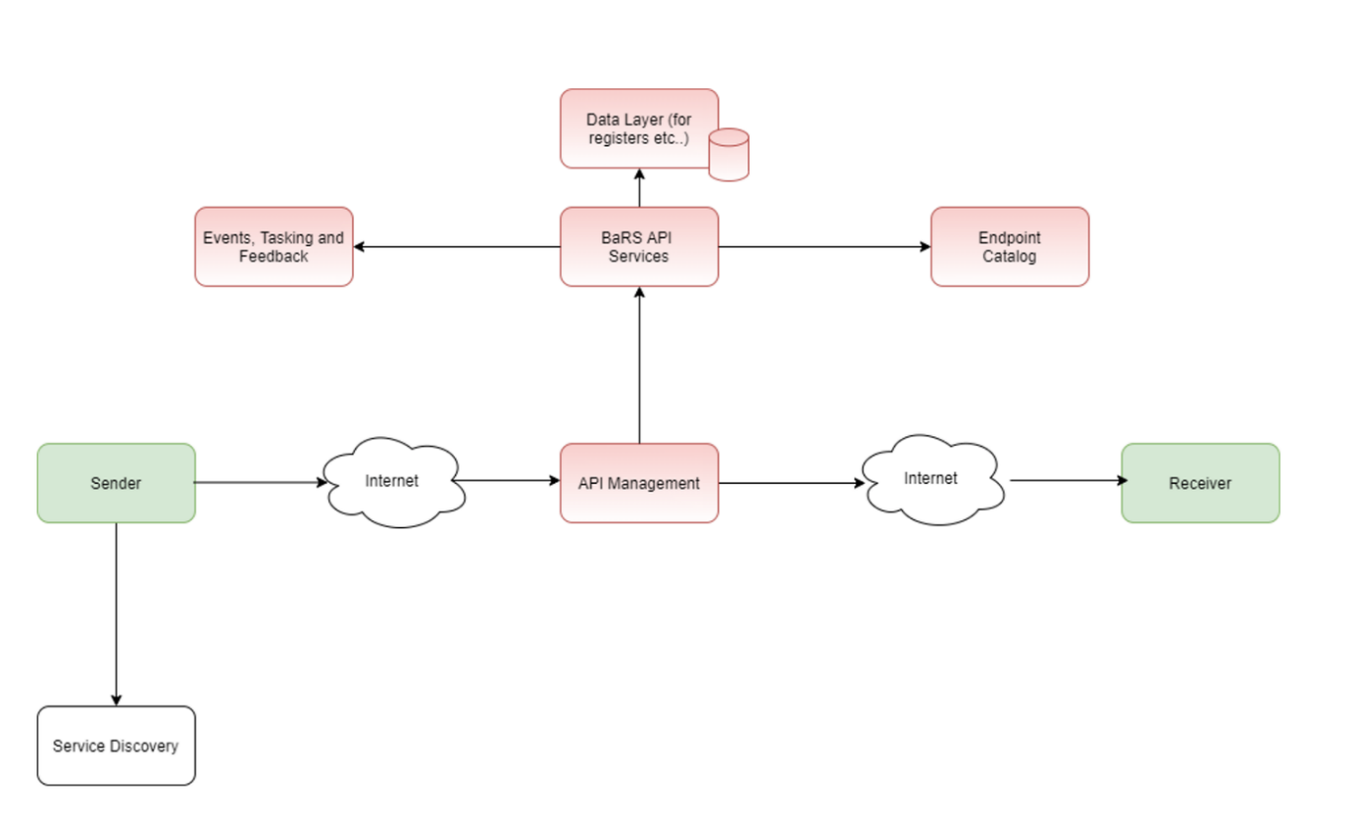
The components of the BaRS centralised infrastructure for this Release are detailed in Table 2 below.
Component | Description
BaRS API services | The API Senders direct all requests to the BaRS API, for both booking and referral workflows, when implementing the Standard.
Endpoint Catalogue | A component which holds Service Identifiers and their corresponding physical addresses. It can support National and Local directory of services or even standalone endpoints configured within a single system.
BaRS Proxy | The BaRS proxy makes the request to the Receiver and handles security.
Table 2 BaRS Components

BaRS Use of global communication protocols
The BaRS uses globally standard communication protocols which are a set of established patterns that are robust and proven in use. It uses HTTP IETF RFC 7540 [Ref 20] protocol, to exchange resources between client devices and servers over the internet.

BaRS Security
The BaRS Proxy employs two forms of authentication depending on whether the party is a sender or a receiver, both in combination help to secure end-to-end communication.
Senders must present an Access token obtained from the platform’s OAuth endpoint, which requires them to be registered with the platform and supply a JSON Web Token secured with a private key that confirms their identity. Each token is valid for 5 minutes. Unless multiple pieces of information are shared including their private key, it would prove difficult to spoof the authentication while making requests via BaRS. This facilitates our application-restricted security model.
The BaRS utilises TLS Mutual Authentication (MA) to communicate with receiving endpoints. Receiving endpoints require a certificate under the NHS Root Certificate Authority to facilitate TLS-MA. The BaRS will need to trust the certificate and the receiver will also need to trust the BaRS presented certificate. This allows the BaRS to refuse to send messages to receivers without a certificate and receiving systems can refuse connections from any party that does not present a certificate from the NHS Root Authorities. Additionally, HTTP Header values are also used by the Receiver to denote access control.

BaRS API specification
The BaRS API forms part of the Booking and Referral Standard. The API specification [Ref 13] is used by suppliers, in conjunction with the BaRS implementation guide.
The API is used to send booking and referral information between NHS service providers to:
- get a specific booking
- get bookings for a patient
- process a message, either a booking, referral or a response
- get message definition
- get capability statement
- get a specific referral
- get referrals for a patient
- get slots

BaRS Implementation Guide
The BaRS Implementation Guide [Ref 11] is a set of rules about how FHIR resources are used (or should be used) when building a BaRS conformant solution. It includes associated documentation to support and clarify the usage.

BaRS Principles
The BaRS has the following Principles , which are further detailed in Ref 20a, that underpin the standard to increase the consistency of interoperability between systems, thus enabling the transfer of patients between services and increasing the ease of adoption of the standard for suppliers:
- Maintain reusable workflows
- Non conformant payloads should be rejected in their entirety
- Clinical information from external sources should be referenced in preference to duplicating unnecessarily, where clinically appropriate (e.g. Summary Care Record)
- Prior to a sender updating previously transmitted resources, the latest version of the primary resources must first be read from the original receiver and reconciled with locally held information
- The receiver always specifies the payload, not the sender
- When transporting information, clinical intent must be preserved between systems
- Minimise technical burden by building reusable technology that is easy to adopt
- Maintain core data structure to support multiple applications
- Only workflows identified by research are supported by the standard
- Suppliers MUST support continuous development of the standard

BaRS Prerequisites
The following pre-requisites, further detailed in Ref 20a, apply to supplier products and providers using their systems.
- Systems MUST support Service Discovery
- Services MUST profile their services on the chosen Service Directory so that each ServiceID is associated with a single workflow. (All products)
  - Systems MUST have a public facing internet connection
- Systems MUST support JSON formats for all API interactions
- System Suppliers MUST complete the BaRS onboarding process
- Systems SHOULD have a FHIR Server or FHIR functionality in place
- Systems SHOULD implement RESTful behaviour patterns

BaRS Principles for integration systems
It is recognised that some solutions may be delivered using integration systems. To ensure the operational value of deploying a BaRS compliant solution and the spirit of the standard (HIMSS interoperability level 4) is adhered to, a set of principles (Table 3) has been developed that integration systems should abide by [see also Ref 20a].
Table 3 BaRS Integration system principles
Integration system principle | Example
The end users are unaware that there is an integration system being used (No screen scraping, No double keying/swivel chair). | The information transmitted to an end user's system via an integration system is available natively in that system with sufficient resolution and integrity to be able to complete their tasks.
The information transferred through BaRS MUST be able to be used to drive workflow for the end user. | A worklist on the end user system can be ordered according to priority information received by their system.
Information must not be modified or lost between the sender and the end user system, in particular clinical meaning and intent must not be lost or modified in any way between the sender and the end user. | A key piece of diagnostic information (such as a clinical modifier) is not lost through truncation of a particular field.
The end user system should be able to consume BaRS referral information in a way that will support the onward transfer of care. | If an end user system needs to make an onward referral, the BaRS journey ID (episodeofcare.id) is available to include in that referral (as it has not been lost through "flattening" of the structure FHIR message).
Business acknowledgements work as per the design. | When an integration system accepts a referral, this completes the process for the sender and is not reliant on further interop to a downstream system (therefore our synchronous activity is not obstructed with caching in the integration system).
Providers can easily join up their reporting data across the multiple systems involved. | N/A
End-to-end service must be maintained- any issues downstream of the BaRS connected system are managed by the BaRS compliant supplier. | N/A
End user systems that send or receive BaRS referrals by an integration system are not considered BaRS compliant. | N/A
All information accessed by the end user must be delivered in real-time and be kept up to date (including not overwriting locally updated information). | N/A

BaRS Version negotiation
As BaRS matures and more than one published version of BaRS is available, suppliers may develop their BaRS conformant solutions against different versions of BaRS, which may or may not be compatible. Where versions are incompatible it may result in a BaRS message not being processed or being partially processed by the receiver. BaRS version negotiation guidance [ Ref 21] informs suppliers how to manage major/minor conflicts between senders and receivers of the following BaRS entities:
- BaRS API version
- BaRS Core Version
- BaRS application use case version
This enables BaRS conformant systems encountering a version incompatibility to either negotiate down to a BaRS version supported by both the sender and receiver, or to fail gracefully,

BaRS Standard Patterns
Most implementations of the BaRS that are applying the standard to support a particular use case or operational workflow will follow the same basic set of foundational operations with little deviation.
In order to establish a guarantee of compatibility between different solutions compliant with the standard, the BaRS Implementation Guide describes the underlying foundational operations and patterns which must be supported by all implementations of the standard [Ref 21a].

Standard pattern for appointment management
Standard pattern for appointment management describes the requirements and interactions to support the Appointment Management Service, an API-first capability for patients to manage all their appointments in a consistent manner. It is being developed to reduce instances where people miss their outpatient appointments (‘did not attends’ or ‘DNAs’) to improve patient experience, free up capacity to treat long-waiting patients and support the delivery of the NHS’s plan for tackling the elective care backlog.
The 6 capabilities are as follows:
- Publish
  - The system of record publishes a link/pointer to the appointment along with relevant metadata in the NRL (National Record Locator) service
- List
  - Consumer systems retrieve a list of the appointments for a patient
- Retrieve
  - Consumer system retrieves the detail of a specific appointment
- Cancel
  - Consumer systems amend the state of a specific appointment
- Slot Search
  - Consumer systems search for available appointment slots within a previously selected service (see Service Discovery below) to enable an appointment to be rescheduled
- Rebook
  - Consumer systems amend the date and time for a specific appointment. The expectation is that the original appointment will be cancelled, and a new appointment created within the same service.
As the BaRS is only responsible for defining the standard pattern for appointment management and not for the implementation of this pattern in different programmes and systems, the responsibility for Clinical Risk Management relating to this lies with the relevant programmes and system suppliers. If any of the BaRS Applications adopt this pattern, a detailed clinical risk assessment will be undertaken at this time.

BaRS Applications
A BaRS application consists of implementation guidance that describes how a supplier builds a solution for a specific workflow using the BaRS toolbox. Note: A BaRS application is not an ‘app’.
Each BaRS Application may support a number of use cases that share a common workflow and data model. E.g. Application 1 supports several uses cases including 111 Telephony to ED and 999 to SDEC.
The BaRS applications in this Release are summarised in section 4 and detailed in Appendices A and B.

BaRS Toolkit Workbench
The Toolkit Workbench (TKW) [Ref 14] for the BaRS has been developed to assist organisations who wish to obtain simulated responses for the BaRS requests during the build and test phases. It consists of test Suites to support suppliers testing their solutions and provides test evidence for the BaRS Onboarding process:
The BaRS TKW is outside of the clinical safety wrapper and will be updated iteratively as required.

Changes in scope from BaRS v1.7.0
The changes in scope from BaRS v1.7.0 are detailed in the BaRS Release Notes [ Ref 23] and are summarised below:
Product | Version | Change summary
Implementation Guide | 1.8 | Updated guidance relating to Incident Reporting  Updated deployment guide
BaRS Core | 1.0.4, 1.1.4, 1.2.0_alpha | Endpoint Catalogue features
API Specification | 1.0.0, 1.1.0-beta, 1.2.0-alpha | No change
TKW | 1.0.11 | No change
BaRS-APP1 | 1.0.4 | No change
BaRS-APP2 | 1.0.4 | No change
BaRS-APP3 | 1.0.1 | No change
BaRS-APP4 | 1.2.0 | New use cases (999 – Falls, 999- Community Services)  New code system
BaRS-APP5 | 1.0.0 | New use case OCS to CP, GP/OCS to CP for BP and OC.
BaRS-APP6 | 1.0.0-beta.2 | Added references to bundle examples
BaRS-APP7 | 1.0.0_Alpha | - New application

Endpoint catalogue features
The BaRS Endpoint Catalogue holds Service Identifiers and their corresponding physical addresses (endpoints). It’s primary function is route requests to the intended Receiver endpoint, based on the Service ID provided by the Sender, ascertained during service discovery.
The Endpoint Catalogue is being updated to increase its availability and resilience so it can support an increasing number of endpoints and queries as use of the BaRS grows.
The Endpoint Catalogue file is being moved to an AWS S3 bucket which increases resilience.
Note: This is an interim update and not the planned target architecture (delivery date tbc).

Out of scope for this Release
The following are out of scope for this Release

Any other use-case or application
Whilst the long-term aim for the BaRS is to be an any-to-any booking and referral standard, this Release ONLY supports the use cases described in section 4.4. All other use cases are out of scope.
If suppliers use the BaRS to enable ANY OTHER use case than those supported, then they do so at their own risk.

Business Transformation and wider rollout
Business transformation and wider roll out of the BaRS will be managed by the NHS England Transformation Directorate. The responsibility for managing clinical risk in the deployment and use of BaRS conformant Health IT systems lies with the deploying Healthcare Organisation in accordance with DCB0160 Clinical Risk Management: its Application in the Deployment and Use of Health IT Systems [Ref 8].

Planned BaRS architectural components
The following architectural components, which are planned for subsequent Releases of the BaRS are also out of scope (Table 4).
Table 4 Planned BaRS architecture components
Component | Description
BaRS use of the National Record Locator (NRL) as a Registry | A store of pointers to bookings and referrals made through the BaRS. Receivers will create and maintain the status of any pointers for the lifecycle of the events they refer to. It is a store of currently active events and cannot be interrogated for historical ones.  Whilst the standard patterns for this has been defined and NRL developed to support this, the clinical risk assessment will be undertaken when it is used in the first BaRS Application.
BaRS use of the National Events Management Service (NEMS) for Events, tasking and feedback | Closely tied with the Registry, this will notify parties (directly related or interested 3rd parties) of events occurring on pointers in the Registry.
Endpoint catalogue API | API to support self-service to the BaRS Endpoint catalogue

Service Discovery
As a pre-requisite to sending a booking, referral or response, the BaRS requires the ServiceID of the recipient in order to identify their endpoint in the Endpoint Catalogue. Service Discovery is outside of the scope of the BaRS and the BaRS is agnostic to how Service Discovery is performed by the sending service. Examples of how this might be performed include the following:
- Use of the Urgent and Emergency Care (UEC) Directory of Services (DoS)
- Use of other National DoS
- Use of Local DoS
- Local mapping in the sending system
- Use of nationally agreed polygons for ambulance services
It is assumed that suppliers will use a service directory that is appropriate to the use case being supported and will comply with the acceptable use policy for that service directory.
Where a specific service directory is dictated by the referral use case being supported by BaRS and there is no available external guidance specific to that use case, guidance may be included in the BaRS implementation guide to support suppliers of BaRS conformant solutions. However, it remains the responsibility of the supplier to undertake a clinical risk assessment of how their solution integrates with the service directory, and to manage that risk in accordance with DCB0129.

Display of information in receiving systems
This Release does not specify how the BaRS conformant systems should display booking and referral information beyond providing Principles for rendering BaRS payloads [Ref 22]. System suppliers are responsible for assessing the safety of rendering clinical information in their product, during their clinical safety activities under DCB0129 [Ref 6]. Where this is locally configured providers are responsible for assessing the safety of rendering clinical information in their deployment during their clinical safety activities under DCB0160 [Ref 9].

Selection of patient cohorts for Referral
Where a cohort of patients is required for a BaRS workflow, Providers are responsible for selecting that cohort. For example, it is the 999 AST’s responsibility for determining which cases are appropriate to send to CAS for Ambulance Validation.

Real-time conformance of FHIR payloads with a FHIR validation tool
The aim of the BaRS is for conformant sender and receiver systems to undertake real-time FHIR validation of FHIR payloads with a FHIR validation tool against the BaRS Profiles. There is currently no standard way to perform this, and the performance of tools tested so far has not supported real-time validation. A decision has therefore been made to remove this as a requirement for suppliers for this Release. Suppliers will still need to validate their bundles to ensure they are BaRS conformant, but it will be a real-time manual/hardcoded process, rather than being automatic and dynamic through use of a FHIR validation service/tool

BaRS Processes
The following BaRS processes contribute to the safety profile of this Release:

BaRS development methodology
The development of BaRS has follows agile methodology specified in the Gov.UK service manual as per the figure below. 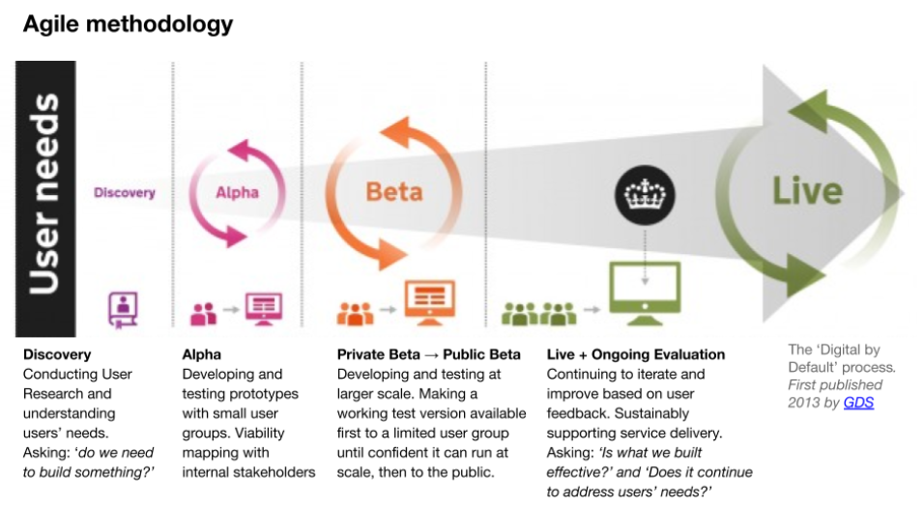
Figure 2 Gov UK Agile methodology

Discovery
Discovery is undertaken for each application by conducting user research and understanding user needs.

The BaRS User Research
The BaRS User Research process [Ref 22a] is followed for each new use case., User research undertaken by the BaRS team focusses on staff (primary users), appreciating the potential need for ancillary research with users who may not be directly impacted (secondary users). This includes liaising with system suppliers and commissioning organisations to understand the experience and needs of those secondary users and only conducting direct research with those users to realise specific research objectives which it would not otherwise be possible to achieve.

The BaRS Alpha process
The BaRS Alpha phase involves suppliers working in the BaRS sandpit to develop their BaRS conformant solutions. Learning from this is incorporated into the emerging standard iteratively by the BaRS team. Suppliers’ solutions are then onboarded to the BaRS Integration Platform so that they can undertake end to end testing in supplier sender-receiver pairs for each application. The alpha phase is supported by the following processes.

Supplier onboarding to the BaRS platform
The BaRS onboarding process [Ref 23a] explains how suppliers can integrate their software with the BaRS API. It includes the following steps:
- Sender registration
- System authentication
- Receiver certification
- Domain Namespace (DNS) registration
- BaRS endpoint registration

Support for Integration Testing
Integration testing (INT) is performed by suppliers connecting their systems to the BaRS Integration Test Environment, using test scripts developed by the BaRS team [Ref 24] to ensure coverage of all BaRS use case flows (happy path and exception). This can be undertaken using the BaRS TKW (see section 4.3).

FHIR payload validation
During the design, build process suppliers perform FHIR validation of their developed resources/code, against the UK Core [Ref 25] and BaRS FHIR profiles [Ref 26] published in Simplifier. This ensures that all mandatory resources and elements are present and that any values conform with the CodeSystem/Valueset binding for the BaRS payload definition and application.
Suppliers can also use the FHIR Validator inline tool to check their validation against the package (https://simplifier.net/validate?scope=UK.NHSDigital.BARS.R4@<package-version>).

Supplier Conformance Assessment List (SCAL)
The BaRS SCAL [Ref 27] is a self-assessment document that requires suppliers to provide technical information about their product as specified by the BaRS team and NHS England Solution Assurance (SA). The SCAL ensures that the system meets all requirements for the BaRS Application for which conformance is being sought, is safe, secure and meets information governance standards. Suppliers submit evidence to back up their claims and this is reviewed by the BaRS team and SA. Once this is completed and approved, a Technical Conformance Certificate for the BaRS application(s) being assessed, is issued to the supplier for their product release.
From BaRS version 1.1.0 the SCAL is completed online using the Digital Onboarding Service.[Ref 27a]
Note: The SCAL is outside of the BaRS clinical safety wrapper and is updated iteratively as required.

The BaRS data model endorsement
The BaRS Team worked in collaboration with the Professional Records Standard Body (PRSB) to develop the baseline BaRS data model. Following user research (see section 5.1) and business analysis, user stories were developed for BaRS applications 1 and 2 [Ref 28-30]. The acceptance criteria for each user story were developed and this was used to derive the data required to fulfil the user story. The data requirements were aligned to the PRSB Core information Standard [Ref 32] which was then updated to include any additional data items required by the BaRS for the 111 Referral into ED use case and incorporated into the PRSB 111 Referral Standard [Ref 33]. PRSB then consulted with a wide range of users via a survey [Ref 34] prior to issuing endorsement [Ref 35]
Figure 3 Derivation of data model
Data Model
Subsequent BaRS Application-level data model additions will be endorsed by appropriate national forums. See relevant application specific appendix for evidence.

The BaRS Private Beta
Following the integration testing undertaken during the alpha phase, suppliers move their BaRS conformant solutions to customer UAT environments so that they can be configured in a ‘live like’ manner. User Acceptance is undertaken using the BaRS integration environment. The Beta phase is supported by the following processes.

The BaRS infrastructure Path to Live governance
The BaRS team work with the NHSE Service and Transition team who manage the transition of Product Management responsibilities from Programmes into Live Services business as usual teams. This includes:
- Programme governance
- Live Services (Design Considerations)
- Technical Operations & ITOC Integration
- Solutions Assurance
- Commercial governance
- Legal governance
- Clinical Safety (CSG)
- Live Services Clinical Assurance
- Cyber Security
- People Transparency & Ethics (including Information Governance)
- Live Services Operations (Onboarding)
- Live Services Cell
- Approvals by Other Governance Boards (Technical Reference Group, Enterprise Architecture Board)
Each of these aspects are signed off by the appropriate authority before the final sign off at Live Services Board.

The BaRS infrastructure assurance
NHSE API Management (APIM) team are responsible for the BaRS Infrastructure and its assurance. This is evidenced in Ref 40.

FHIR payload validation
During the design, build process suppliers perform FHIR validation of their developed resources/code, against the UK Core [Ref 41] and BaRS FHIR profiles [Ref 42] published in Simplifier (https://simplifier.net/NHSBookingandReferrals/~packages). This ensures that all mandatory resources and elements are present and that any values conform with the CodeSystem/Valueset binding for the BaRS payload definition and application.
Suppliers can also use the FHIR Validator inline tool to check their validation against the package (https://simplifier.net/validate?scope=UK.NHSDigital.BARS.R4@<package-version>).

Support for supplier DCB0129 compliance
In order to support suppliers, the BARS clinical Safety Case Report and Hazard Log is shared with suppliers (via the Digital Onboarding Service) to communicate controls that are transferred to suppliers.
Suppliers will formally accept this transference of risk in the Digital Onboarding Service by declaring that they have read the BaRS Clinical Safety Case Report and Hazard Log, and for communication and management of risk have reviewed and integrated the risks identified into their own Hazard Log, where risk(s) have been transferred, and implemented the appropriate mitigation stipulated.

Support for user acceptance testing (UAT)
Providers are responsible for UAT of the system release that includes the BaRS development, in a non-production environment with a configuration that reflects the Provider’s Live environment. To support Public Beta Providers undertaking UAT, the BaRS team provide guidance [Ref 43] which includes end-to-end test scripts to ensure coverage of all BaRS use case flows (happy path and exception). These scripts have clinical input and review, are based on the tests undertaken by Suppliers during INT [Ref 24] prior to SCAL completion and require Providers to work in sender/receiver pairs.

The BaRS Public Beta
The requirements for providers supporting the BaRS Public Beta are set out in the BaRS Application Beta Phase Ways of Working [Ref 44]. Prior to the Provider’s Live environment being upgraded with a BaRS conformant system release, a Connection Agreement is required to integrate with the BaRS Production infrastructure. Following this the Provider is then responsible for a controlled test of the live environment prior to making a Go/No go decision to move into Public Beta.
The Public Beta minimum acceptance criteria for each BaRS Application is determined by the Service Risk Level as agreed with NHSE Clinical Safety Group in the BaRS Clinical Risk Management Plan [Ref 5]:
Acceptance criteria | Service Risk Level
Acceptance criteria | Low | Medium | High
Minimum number of referrals (including responses where relevant) | 20 | 50 | 75
Minimum verification period (with no safety related incidents due to the BaRS implementation) | 14 days | 28 days | 48 days

In addition to NHS England Live Services support, the BaRS team provide additional early live support, including test issue management, with daily meetings.
Once the Public Beta is completed the BaRS Team take the learning from this and use it to update the standard, prior to publishing the BaRS release to support general roll out.
The lessons learned activities include:
- Supplier review of the BaRS to ensure
  - The BaRS is fit for purpose in supporting suppliers to deliver a BaRS conformant solution
- Provider review of the deployed BaRS conformant systems to ensure:
  - System is fit for purpose to support the in-scope workflows
  - No unresolved safety-related issues directly related to the BaRS deployment in the Public Beta period
  - Any test issues have been identified and resolved according to their priority
The output of the Public Beta for the BaRS applications 1 to 4 is detailed in Appendix A.

Regulatory Assessment
The BaRS has been assessed by NHS England using the Medicines and Healthcare products Regulatory Agency ‘Medical device stand-alone software including apps’ [Ref. 45] guidance, which provides an introductory guide into the classification of a Medical Device in accordance with the UK Medical Device Regulations (MDR) 2002 [Ref. 46].
The BaRS has been assessed and is NOT classified as a Medical Device under the UK MDR 2002. [Ref.46].

Clinical Risk Management System
This clinical risk assessment is being undertaken in accordance with the NHS England Clinical Safety Management System [Ref 4].
The NHSE BaRS Team clinical risk management activities cover the following:
- Risk Analysis
  - Scope Definition (Section 4)
  - Clinical Hazard Identification (Section 8.1)
  - Clinical Risk Estimation (Section 8.1)
- Risk Evaluation
  - Evaluation of initial level of risk of each identified hazard using pre-defined criteria (Section 8.1)
- Risk Control
  - Control Option Analysis (Section 8.2)
  - Clinical Risk Benefit Analysis (Section 8.2)
  - Control Measure Implementation (Section 8.2)
  - Completeness Evaluation (Section 8.2)
Note: This comprehensive and repeatable clinical risk management process is applied throughout the lifecycle of the product.

Staffing and responsibilities
The DCB0129 Standard requires that a Clinical Safety Officer (CSO) is responsible for the approval of clinical risk management deliverables (including this CSCR). The CSO must be a registered clinician who is appropriately trained and experienced in clinical risk management.
Key individuals in the NHSE BaRS team have collaborated to undertake the clinical risk management activities in support of the deployment of this Release as outlined in Table 5.
Table 5 BaRS Clinical Safety Team
Personnel | Role
Lee Montgomery | NHSE BaRS Clinical Informatics Manager and Lead CSO
Julie Harris | NHSE BaRS CSO and Business Analyst

The BaRS CSOs collaborated with the NHS England Clinical Safety Group (CSG) members assigned to the programme (Table 6)
Table 6 NHSD CSG personnel assigned to BaRS
Personnel | Role
Ian Tomlinson | NHSE CSG Safety Engineer
Zak Bickhan | NHSE CSG CSO

The CSOs work closely with the programme team supporting the standard’s development and advising on use cases and clinical utility. The CSOs focus on managing and mitigating clinical risk, identification of clinical benefits, and establishing robust clinical governance and assurance around the programme.
Programme key clinical risks identified are documented on NHS England’s live risk management system (Aspyre), including mitigation/control and continuous risk monitoring.
The clinical informatics manager reports any clinical risks identified within the programme to the senior clinical lead accountable and responsible for all Platform and Infrastructure programmes including BaRS.
The CSOs for the BaRS programme lead on the development of specific clinical safety documentation, they work closely with the NHS England clinical safety, solution assurance and information governance teams. The Clinical informatics manager provides oversight to service design, research and other key areas of the programme that may have an impact on clinical process and the patient journey through the healthcare system.
Internal to NHS England, any clinical issues that cannot be addressed at the clinical risk / issues meeting are escalated to the Clinical Quality and Safety Group (CQSG) that includes the Medical Director and Clinical Governance and Safety Directors.

Clinical and Corporate Governance Structure:
The programme board meets every two weeks and provides the strategic direction for the programme outcomes. It provides appropriate governance and decision making to support the programme delivery. The key role of the Board is to provide effective strategic oversight for programme outcomes with a focus on management of scope, deliverables, benefits, costs, risks and resources. The Board, and its members, will ensure appropriate stakeholder involvement. The Board is made up of key stakeholders from NHSE and has representation from Technical, Clinical, Business Analysis and Programme Management.

Programme Governance Structure
The BaRS Programme Governance Structure is shown below in Figure 4

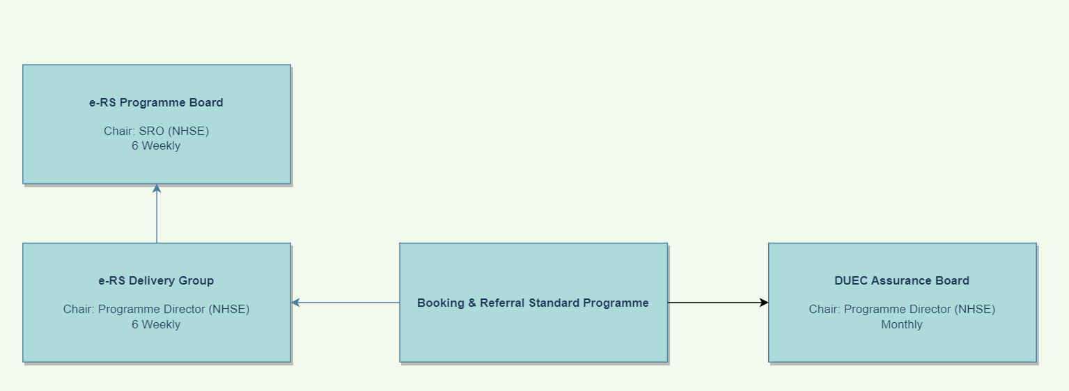

Figure 4 BaRS Programme Governance Structure

Clinical risk and issue management process
The BaRS wider clinical risk and issue management process is detailed in the figure below. (Please note that the Risk Management system has recently been changed from CRIS to Aspyre)
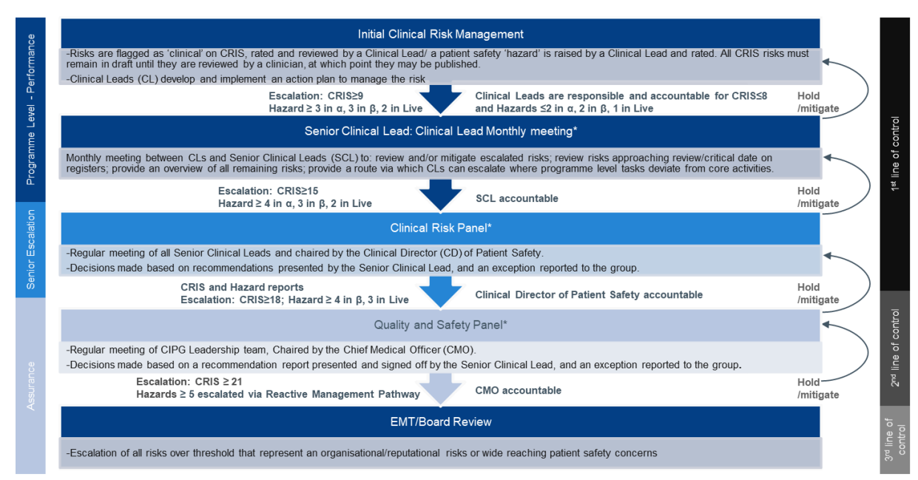
Figure 5 BaRS clinical risk and issue management process

Clinical Risk Management Activities

Risk Analysis and Clinical Risk Evaluation
The baseline BaRS Hazard Log [ Ref 47] was delivered following clinical risk assessment undertaken during the initial Hazard Workshops undertaken from 17/11/2021 to 03/03/2022, and 29th March 2023 the minutes of which are at [Ref 48].
For each subsequent release of the implementation guide the clinical risk assessment is reviewed by the CSOs, and the Hazard Log updated where applicable in accordance with the BaRS Clinical Risk Management Plan [Ref 5]. Where a new BaRS application is introduced, the assessment is undertaken in Hazard Workshops with HCPs, CSOs and subject matter experts (SMEs) for the use cases the application supports. The outcome of which is summarised in the table below.

BaRS Implementation Guide Version | Hazard Workshop | Hazard log | Clinical Safety Case Report | New Hazards | New Causes | New Controls | BaRS Safety Profile
1.0 alpha | Ref 48 | V1.0 | V.10  V1.1 | 9 | 31 | 155 | Acceptable
1.0 | Ref 49 | V1.2 | V1.2 | 0 | 1 | 9 | Unchanged
1.1 | Ref 50 | V1.3 | V1.3 | 0 | 4 | 6 | Unchanged
1.2 | N/A | V1.4 | V1.4 | 0 | 1 | 4 | Unchanged
1.3 | N/A | v1.5 | v1.5 | 0 | 2 | 4 | Unchanged
1.4 | N/A | v1.6 | v1.6 | 0 | 0 | 0 | Unchanged
1.5 | Ref 77 | V1.5 | V1.7 | 0 | 3 | 20 | Unchanged
1.6 | Ref 98 | V1.7 | V1.8 | 0 | 0 | 0 | Unchanged
1.7 | N/A | N/A | N/A | 0 | 0 | 0 | Unchanged
1.8 | Ref 100 | V1.9 | V1.9 This report | 0 | 3 | 11 | Unchanged

Risk analysis for BaRS is summarised in the table below using criteria defined in the CSMS [Ref 4 and reproduced at Appendix C. Further details can be found in the Hazard Log [Ref 8].
Table 7 Hazard Initial Analysis
Hazard | Effect | Harm | Conse quence | Likeli hood | Initial Risk
H01 Patient is not assessed or treated as Recipient does not receive the referral or booking  - e.g. 1. ED does not receive referral from 111  - e.g. 2. CAS does not receive ambulance validation request or referral | If a referral or booking is not received the receiving healthcare professional (HCP) will be unaware of the patient's clinical needs and may not be able to provide clinical care at that time. This may lead to a delay in the delivery of care which may lead to harm. | This may lead to the deterioration of a worsening patient’s condition. The severity of the harm caused by the realisation of this hazard. will be proportional to the acuity of the patient's condition and the length of the delay | Major | Medium | 3
H02 Patient is not assessed or treated within the appropriate timeframe | This may lead to a delay in the delivery of care which may cause harm | This may lead to the deterioration of a worsening patient’s condition. The severity of the harm caused by the realisation of this hazard. will be proportional to the acuity of the patient's condition and the length of the delay | Major | Medium | 3
H03 Patient does not receive appropriate care due to lack of clarity regarding the action required by the receiving Service Provider.  This may be regarding the initial Service Request or the subsequent Service Request Response  e.g. A CAS received a message from a 999 Service but does not know if it is a referral or validation request | HCP will be unaware of the patient's clinical needs and may not be able to provide appropriate clinical care at that time. This may lead to a delay in the delivery of care which may lead to harm. | This may lead to the deterioration of a worsening patient’s condition. The severity of the harm caused by the realisation of this hazard. will be proportional to the acuity of the patient's condition and the length of the delay. | Major | Medium | 3
H04 HCP providing care is sent to the wrong location. This may be the patient's address, another property location or a non-property location.  e.g. Ambulance sent to the wrong incident location | This may lead to a delay in the arrival of an HCP, ambulance or Patient Transport Services and a subsequent delay in the delivery of care | This may lead to the deterioration of a worsening patient’s condition. The severity of the harm caused by the realisation of this hazard will be proportional to the acuity of the patient's condition and the length of the delay | Major | Low | 3
H05 Failure to contact patient  This may be failure to contact a referred patient or their representative.  E.g. Failure to call back a patient who is awaiting their triage to be validated before an ambulance is sent. | If a patient is not contacted this may lead to a delay in the delivery of care | This may lead to the deterioration of a worsening patient’s condition. The severity of the harm caused by the realisation of this hazard will be proportional to the acuity of the patient's condition and the length of the delay | Major | Medium | 3
H06 Patient care compromised due to incomplete information in referral | This may lead to a delay in the delivery of care whilst the HCP sources the missing information from the patient or alternative sources.  More rarely incorrect treatment or advice may be given based on incomplete clinical information. | This may lead to the deterioration of a worsening patient’s condition. The severity of the harm caused by the realisation of this hazard will be proportional to the acuity of the patient's condition and the length of the delay.  Incorrect treatment MAY cause harm. | Considerable | Medium | 3
H07 Patient care compromised as Clinician acts on incorrect information in referral | Incorrect treatment or advice may be given based on incorrect clinical information. | If inappropriate treatment or advice is given there is a chance that the patient may be harmed if the advice leads to the patient worsening, or the treatment is suboptimal or contraindicated. | Major | Medium | 3
H08 Patient care is compromised when HCP is misled by the display of information in referral | This may lead to a delay in the delivery of care whilst the HCP clarifies the misleading information from the patient or alternative sources.  More rarely incorrect treatment or advice may be given based on misleading clinical information. | This may lead to the deterioration of a worsening patient’s condition. If treatment is delayed, the harm caused by the realisation of this hazard will be proportional to the acuity of the patient's condition and the length of the delay.  If inappropriate treatment or advice is given there is a chance that the patient may be harmed | Considerable | Medium | 3
H09 Patient, HCPs and other third parties come to harm due to safeguarding failures.  E.g. Failure to safeguard patient at risk  E.g. Failure to disclose information that may be a threat to an HCP or third party (violent patient, vicious dog on premises, CBRN threat) | HCPs may not be informed about a patient's vulnerability and risk of harm (physical, social and psychological  HCPs and third parties may not be aware that they are at risk of harm | Patient may not be protected against the risk and may come to harm through deterioration in condition or other factors.  HCPs and third parties may come to harm if they are not made aware of risks, including those from the patient, the incident location or the patient's social circumstances.  The degree of harm would be dependent on the specific risk" | Major | Medium | 3

Clinical Risk Control.
The impact on the hazard risk and evidence of effective implementation is discussed in Table 8:
Table 8 Hazard 01 Residual Analysis
Hazard | Conse quence | Likeli hood | Residual Risk | Justification
H01 Patient is not assessed or treated as Recipient does not receive the referral or booking | Major | Very Low | 2 | Strong control measures identified and implemented reduces the likelihood to very low.  Proven in use over public beta for BaRS-APP1,2, 3 and 4 applications with no recorded safety incidents
H02 Patient is not assessed or treated within the appropriate timeframe | Major | Very Low | 2 | Strong control measures identified and implemented reduces the likelihood to very low.  Proven in use over public beta for BaRS-APP1 2, 3 and 4 applications with no recorded safety incidents
H03 Patient does not receive appropriate care due to lack of clarity regarding the action required by the receiving Service Provider | Major | Very Low | 2 | Strong control measures identified and implemented reduces the likelihood to very low.  Proven in use over public beta for BaRS-APP1 2, 3 and 4 applications with no recorded safety incidents
H04 HCP providing care is sent to the wrong location | Major | Very Low | 2 | Strong control measures identified and implemented reduces the likelihood to very low.  Proven in use over public beta for BaRS-APP1 2, 3 and 4 applications with no recorded safety incidents
H05 Failure to contact patient | Major | Very Low | 2 | Strong control measures identified and implemented reduces the likelihood to very low.  Proven in use over public beta for BaRS-APP1 2, 3 and 4 applications with no recorded safety incidents
H06 Patient care compromised due to incomplete information in referral | Considerable | Low | 2 | Strong control measures identified and implemented reduces the likelihood to very low.  Proven in use over public beta for BaRS-APP1 2, 3 and 4 applications with no recorded safety incidents
H07 Patient care compromised as Clinician acts on incorrect information in referral | Major | Very Low | 2 | Strong control measures identified and implemented reduces the likelihood to very low.  Proven in use over public beta for BaRS-2, 3 and 4 applications with no recorded safety incidents
H08 Patient care is compromised when HCP is misled by the display of information in referral | Considerable | Low | 2 | Strong control measures identified and implemented reduces the likelihood to very low.  Proven in use over public beta for BaRS-APP1 2, 3 and 4 applications with no recorded safety incidents
H09 Patient, HCPs and/or other third parties come to harm due to safeguarding failures | Major | Very Low | 2 | Strong control measures identified and implemented reduces the likelihood to very low.  Proven in use over public beta for BaRS-APP1 2, 3 and 4 applications with no recorded safety incidents

Test Summary

Security Testing
MTI Technology Ltd were commissioned by NHS Digital (now NHSE) to perform a secure code review [Ref 51] against its booking and referral FHIR API application source code. The purpose of this review was to ensure the code does not contain vulnerabilities that may allow a malicious user to compromise the environment and the data processed by it.
The secure code review of the booking and referral FHIR application identified that the source code has been well written as no significant vulnerabilities were identified affecting the code.
Several low rated issues were identified; however, these do not present a security concern that would prevent progression to live usage.
All the minor issues identified are regarded as low-rated and all pertain to misconfigurations within the source code, including the use of a hard-coded port number, public repos in use and the application binding to all network interfaces.
All the issues contained within this report were investigated and the appropriate mitigating action taken to improve the overall security of the environment, its users and data.

Volume and performance testing
APIM undertook Volume and Performance testing [Ref 52]. This is evidenced as part of the BaRS Path to Live report [ Ref 40].
Additional volume and performance testing has been conducted on the Interim Endpoint Catalogue solution to demonstrate that it is fit to support the current Live BaRS use cases (Ref 101). Its suitability to support further use cases will be assessed as they are added to the BaRS and before any public beta activities commence for that use case.

Functional Testing
Functional testing of the APIM Platform for BaRS is evidenced by the testing of supplier system and APIs developed against the BaRS. The testing of BaRS Applications 1,2,3 and 4 conformant solutions had additional scrutiny as they were the baseline Applications for the early versions of the BaRS before it was proven in use. This is detailed in the BaRS Clinical Risk Management Plan [Ref 5].
BaRS Functional testing includes the following:
- Integration Testing undertaken by all Public Beta Suppliers (see Application specific appendix).
- User Acceptance Testing undertaken by all Public Beta providers (see Application specific appendix)
- Public Beta activities undertaken by all Public Beta Providers (see application specific appendix).

Integration testing
End-to-end integration testing is undertaken by system suppliers developing BaRS conformant systems for Public Beta deployments of each application. This is undertaken using the BaRS integration environment utilising test scripts provided by the BaRS team [Ref 43] to ensure coverage of the BaRS scope of interactions. Evidence of supplier integration testing is provided in the relevant application specific appendix in this report.

Public Beta
BaRS Public Beta deployments are undertaken in provider production environments using a cohort of patients, chosen by the provider, under pilot conditions. Evidence of Public beta activities undertaken for each BaRS application can be found in the relevant Application specific appendix in this report.

Summary Safety Statement
Nine hazards were identified, each with an initial risk rating of 3. Introduction of pre-emptive and re-active additional controls is conservatively estimated to reduce the likelihood of resulting in a residual risk rating for the hazards of this Release of 2.
- No new Hazards were identified as a result of the changes introduced in this release.
- 3 new causes to existing hazards were identified.
- 11 controls to existing hazards were identified.
- There was no change to the safety profile of the standard.
Evidence of effective mitigation is presented in the Hazard Log [Ref 8].
The clinical safety statement is based on the safety argument below, based on two of the following criteria: -
1. Demonstration of adherence to a fit for purpose clinical safety process:
The Clinical Safety process described in within the CSCR has been carried out and is consistent with NHS England’s CSMS [Ref. 4] and DCB 0129 outlined in [Ref. 6].
2. The mitigation is deemed to be appropriate and commensurate with the scale of risk. Risk is deemed to be accepted with a recommendation it is reviewed as new BaRS applications and use cases are added.
The CSO approves the roll out of the BaRS v1.8.0 for:
- Live deployments for BaRS applications 1, 2, 3, 4 and 5 for the use cases that they are endorsed to support (see section 4.4).
- Public Beta deployments for BaRS application 6 for the use cases that it is endorsed to support (see section 4.4).
- Note: Application 7 Booking and Referrals into Primary Care is constrained to NHS App to GP for this release and is ONLY approved for supplier feedback and NOT for deployment.
- Note BaRS Core v1.2.0_alpha is ONLY appr0oved for supplier feedback and NOT for deployement
This is subject to the participating system suppliers (Healthcare IT system manufacturers) and service providers (Healthcare Organisations) undertaking assurance and clinical risk management activities in accordance with DCB0129 and DCB0160 respectively for use of their BaRS conformant solution with this Release of the BaRS.

Quality Assurance and Document Approval
Each authorised change to this document is logged and documented in the Document Management section with details of reviewers and approvers.

Configuration Control / Management
The Clinical Safety Case Report and all other clinical safety documentation are stored and managed on the BaRS Confluence site and share point. All supporting information and documentation are stored in the same location as the clinical safety documentation and cross-referenced from the patient safety assessment.

          - BaRS Applications
            - Bookings and referrals into urgent and emergency care services (application 1)
              - Purpose
The BaRS application 1 supports bookings and referrals into urgent and emergency care services that follow the workflow in Figure 6. It has been commissioned to support the use cases in the table below but will be extended in future as more use cases with identical workflow and data requirements are endorsed for use.
Table 9 Use cases supported by BaRS application 1
BaRS Application | Use cases supported | Abbreviation
Booking and Referrals into UEC (application 1) | NHS 111 (telephony) to Emergency Department (ED)  NHS 111 (telephony) to Urgent Treatment Centre (UTC)  Integrated Urgent Care (IUC) Clinical Assessment Service (CAS) to ED  IUC CAS to UTC  NHS 111(telephony) to Same Day Emergency Care (SDEC)  IUC CAS to SDEC  999 Ambulance Service Trust (AST) to-ED (Pathways only)  999 AST to UTC (Pathways only)  999 AST to SDEC (Pathways only) | 111-ED  111-UTC  CAS-ED  CAS-UTC  111-SDEC  CAS-SDEC  999-ED  999-UTC  999-SDEC

The BaRS ‘Bookings and referrals into urgent and emergency care services’ (application 1) [Ref 15] was commissioned by NHS England in the wake of the Help Us Help You [Ref 56] and NHS 111 First [Ref 57] campaigns which aim to encourage members of the public to contact NHS 111 as the primary means to access urgent healthcare. It will enable Integrated Urgent Care (IUC) staff to refer and book patients into an arrival time slot at ED with an aim of managing the flow of patients into these services to reduce the risks of nosocomial (hospital acquired) COVID infection and to ensure that healthcare demand is more proactively and effectively managed.
The Long-Term Plan [Ref 58] sets out action to ensure patients get the care they need, fast, and to relieve pressure on EDs. New service channels such as urgent treatment centres are now growing far faster than hospital ED attendances, and UTCs are being designated across England. Following consultation with the NHS England Urgent Treatment Centre (UTC) policy team it was determined that the workflow and payload required to support a referral from NHS111 to a UTC was identical to that required for a referral from NHS 111 to ED. It was therefore agreed [Ref 38] to extend the scope of the BaRS application 1 to include NHS 111 - UTC referrals.
              - BaRS Bookings and Referrals into UEC (application 1) Actors
The BaRS Bookings and Referrals into UEC (application 1) uses the Urgent Referral Payload from the payload definition library and supports booking and referrals from/to the following service provider types and associated systems
Table 10 BaRS application 1 Actors
Use Case | BaRS role | Provider type | System Type | System user role
111-ED | Sender | NHS 111 telephony service | NHS 111 system hosting NHS Pathways clinical decision support (including Pathways Clinical Consultation Support (PaCCS). e.g. Advanced Adastra, IC24 Cleo, Cleric Respond2, MIS C3 | 111 Health advisor  111 Clinician
111-ED | Receiver | Emergency Department | ED system e.g. Harris Flex (used as end ED system), WASP (used as end ED system) EMIS Symphony, Lorenzo ED, Advanced Adastra. | ED Administrator  ED Clinician
111-UTC | Sender | NHS 111 telephony service | NHS 111 system hosting NHS Pathways clinical decision support (including Pathways Clinical Consultation Support (PaCCS). e.g. Advanced Adastra, IC24 Cleo, Cleric Respond2, MIS C3 | 111 Health advisor  111 Clinician
111-UTC | Receiver | Urgent Treatment Centre | UTC system e.g. Harris Flex, WASP, Advanced Adastra, TPP SystmOne , EMIS Symphony, IC24 Cleo, | UTC Administrator  UTC Clinician
CAS-ED | Sender | Integrated Urgent Care Clinical Assessment Service | IUC CAS system hosting Pathways e.g. Advanced Adastra, IC24 Cleo, Cleric Respond2, MIS C3 | CAS Clinician
CAS-ED | Receiver | Emergency Department | ED system e.g. Harris Flex (used as end ED system), WASP (used as end ED system) EMIS Symphony, Lorenzo ED, Advanced Adastra. | ED Administrator  ED Clinician
111-SDEC | Sender | NHS 111 telephony service | NHS 111 system hosting NHS Pathways clinical decision support (including Pathways Clinical Consultation Support (PaCCS). e.g. Advanced Adastra, IC24 Cleo, Cleric Respond2, MIS C3 | CAS Clinician
111-SDEC | Receiver | Same Day Emergency Care Service | ED system e.g. Harris Flex (used as end ED system), WASP (used as end ED system) EMIS Symphony, Lorenzo ED, Advanced Adastra. | SDEC Administrator  SDEC Clinician
CAS-SDEC | Sender | Integrated Urgent Care Clinical Assessment Service | IUC CAS system hosting Pathways e.g. Advanced Adastra, IC24 Cleo, Cleric Respond2, MIS C3 | CAS Clinician
CAS-SDEC | Receiver | Same Day Emergency Care Service | ED system e.g. Harris Flex (used as end ED system), WASP (used as end ED system) EMIS Symphony, Lorenzo ED, Advanced Adastra. | SDEC Administrator  SDEC Clinician
999-ED | Sender | 999 Ambulance Service Trust | Computer Aided Dispatch(CAD) system hosting NHS Pathways clinical decision support.  E.g. Hexagon Intergraph, MIS C3, Cleric Respond2 | 999 Call handler  999 Clinician  999 Emergency Medical Dispatcher
999-ED | Receiver | Emergency Department | ED system e.g. Harris Flex (used as end ED system), WASP (used as end ED system) EMIS Symphony, Lorenzo ED, Advanced Adastra. | ED Administrator  ED Clinician
999 -UTC | Sender | 999 Ambulance Service Trust | Computer Aided Dispatch(CAD) system hosting NHS Pathways clinical decision support.  E.g. Hexagon Intergraph, MIS C3, Cleric Respond2 | 999 Call handler  999 Clinician  999 Emergency Medical Dispatcher
999 -UTC | Receiver | Urgent Treatment Centre | UTC system e.g. Harris Flex, WASP, Advanced Adastra, TPP SystmOne , EMIS Symphony, IC24 Cleo, | UTC Administrator  UTC Clinician
999-SDEC | Sender | 999 Ambulance Service Trust | Computer Aided Dispatch(CAD) system hosting NHS Pathways clinical decision support.  E.g. Hexagon Intergraph, MIS C3, Cleric Respond2 | 999 Call handler  999 Clinician  999 Emergency Medical Dispatcher
999-SDEC | Receiver | Same Day Emergency Care Service | ED system e.g. Harris Flex (used as end ED system), WASP (used as end ED system) EMIS Symphony, Lorenzo ED, Advanced Adastra. | SDEC Administrator  SDEC Clinician
It has been informed by and is intended to replace the following standards in this area:
- NHS Direct Booking Standard (CareConnect) [Ref 59]
- ITK 111 Report (deprecated) (Ref 60)
Additionally, systems developed against the BaRS Bookings and Referrals into UEC (application 1) , will replace the functionality currently provided by Emergency Department Digital Integration (EDDI) [Ref 60a].
              - Clinical Context
The clinical use of the BaRS Bookings and Referrals into UEC (application 1) is depicted in the figure and table below.
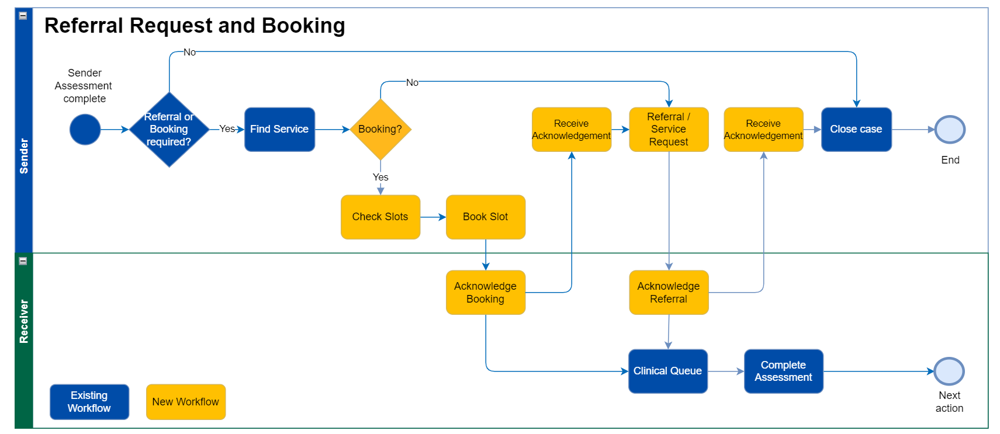
Figure 6 BaRS Bookings and Referrals into UEC (application 1) Workflow

Table 11 BaRS Bookings and Referrals into UEC (application 1) Clinical Use
Step | Description
1 | Prior to any potential referral the sending service will undertake a triage of the patient to determine the acuity of the case. If the Sending service identify a new or pre-existing safeguarding concern it is recorded on the PMS and transmitted in any subsequent referral made for them through the BaRS. Similarly, any locally held Special Patient Notes (SPNs) or externally retrieved shared healthcare record locations (not the data itself but where to obtain it) may be shared in any referral made.
2 | For cases requiring a booking and/or referral, a suitable Receiving Service is identified based on the patient’s clinical need and location. Service discovery will use UEC DOS, the Service ID of the selected service is then used for interactions with the Receiver via the BaRS API.  Selection of a suitable service to meet the patient’s needs may involve negotiation when the patient refuses to attend the first suggested service. Any services rejected, prior to the one selected, will be made available for review by the Receiving service for reporting and, potentially, patient instruction.
3 | The Service ID is used to query the BaRS endpoint catalogue, via the BaRS API, to identify the receiving service system's endpoint details and whether they support BaRS or not. If supported the workflow continues as outlined, otherwise, existing alternative methods of referral and/or booking are followed e.g. CDA (Clinical Document Architecture) message over ITK (Interoperability Toolkit) and CareConnect Booking.
4 | Receiver systems that accept bookings for patient arrival times will publish available slots which are available for selection on the Senders Patient Management System (PMS). The relevant healthcare professional (HCP) negotiates with the patient, then selects a suitable slot at the selected service and makes the booking request. If successful, an acknowledgement is received, and the HCP moves on in the workflow.
5 | The Sending Service will send the referral to the Receiving Service, including the information required by Receiving Service to continue the patient's clinical care. This will also include the JourneyID created at the patient's first contact to enable the Sender’s and Receiver’s encounters to be linked for reporting purposes.  If a booking has been made at a prior step in the workflow, the referral made will make reference to it, allowing the Receiving system to easily combine the two together.
6 | The Receiving system will acknowledge the referral on receipt and create a pending encounter. A human readable reference for the pending encounter is returned to Sending Service, allowing the relevant HCP to provide this to the patient to relay when they arrive at the Receiving Service. This helps support joined up care between services for the patient.
7 | On the patient’s arrival at the Receiving Service, they will report to reception. The receptionist updates the patient’s ED or UTC encounter on the system to ‘arrived’ and the patient will wait to be triaged, verifying the acuity of their need and, if appropriate, redirect them to a lower acuity service
8 | If the patient stays in the Receiving Service, they will undergo an assessment by an appropriate clinician. Treatment may be provided by the Receiving Service directly, or the patient may be admitted or referred elsewhere.
              - Scope of interactions
The scope of interactions for the BaRS Bookings and Referrals into UEC (application 1) is depicted in the table below.

Table 12 BaRS Bookings and Referrals into UEC (application 1) Interactions (detail)
Sender | Receiver
Request and Interpret Capability Statement | Provide Capability Statement on demand
Request and Interpret Message Definitions | Provide Message Definition(s) for a Service on demand (based on the 'context' parameter on the GET /MessageDefinition endpoint)
Make Referral Request | Accept Referral Request  Provide representation of Referral Request
Record Safeguarding concerns (new or existing) and transmit in referral | Indicate Safeguarding concern to user if present
Update Referral Request to cancel (Note: the ability to amend a booking or referral is out of scope for this Release) | Accept update to Referral Request to cancel
Revoke current open Referral prior to sending new. Only one active/open Service Request during this routine | Accept re-request of Referral Request (revoke current open Referral prior to sending new. Only one active/open Service Request during this routine)
Make Booking Request | Accept Booking
Cancel Booking Request | Accept Cancel Booking
              - Governance and assurance
                - Service Risk Level
The BaRS Bookings and Referrals into UEC (application 1) Service risk level has been assessed by the BaRS CSO, in accordance with the criteria defined in the BaRS Clinical Risk Management Plan [Ref 5] and determined to be Medium.
                - Data Model Endorsement
The BaRS Team worked in collaboration with the Professional Records Standard Body (PRSB) to develop the BaRS data model. The data requirements were aligned to the PRSB Core information Standard [Ref 32] which was then updated to include any additional data items required by the BaRS for the 111 Referral into ED use case and incorporated into the PRSB 111 Referral Standard [Ref 33]. PRSB then consulted with a wide range of users via a survey [Ref 34] prior to issuing endorsement [Ref 35].
                - Secondary use case endorsement
BaRS Application 1 has been endorsed for use for the following secondary use cases following review and approval by the relevant policy team stakeholders.
Secondary use case | Endorsement
111-UTC | NHSE UTC Policy team [Ref 38]
CAS-ED | PRSB [Ref 35]
111-SDEC | Digital Urgent and emergency Care team [Ref 78]
CAS-SDEC | Digital Urgent and emergency Care team [Ref 78]
999-ED (NHS Pathways only) | Digital Urgent and emergency Care team [Ref 78]
999 -UTC (NHS Pathways only) | Digital Urgent and emergency Care team [Ref 78]
999-SDEC (NHS Pathways only) | Digital Urgent and Emergency Care team [Ref 78]
                - Supplier Assurance
Public beta | Sender | Receiver
Suppliers | Cleric | Wasp
Supplier assurance complete | BaRS Application 1 Sender Conformance Certificate (Ref 79  BaRS Application 1 Sender CATR (Ref 80) | BaRS Application 1 Receiver Conformance Certificate (Ref 81 )  BaRS Application 1 Receiver CATR (Ref 82)

                - Public Beta
The Public Beta providers for the BaRS application 1 are detailed below.
Table 13 BaRS application 1 Public Beta providers
Sender | Receiver
North West Ambulance Service (NWAS)111 | Warrington Hospital (Warrington & Halton Hospitals NHS Foundation Trust) ED  Halton Hospital (Warrington & Halton Hospitals NHS Foundation Trust) UTC

On 30th March 2023 the deployment had been live for 30 days and had processed the following numbers of bookings and referrals.
Table 14 BaRS application 1 public beta booking and referral figures
111 to ED | 111 to UTC | Total
77 | 92 | 169
NHS England Live Services support, and the BaRS team provided additional early live support, including test issue management, with daily meetings. A summary of the issues identified in the public beta phase and the clinical risk assessment of outstanding test issues can be found in the BaRS Clinical Safety Case Report v1.2[ Ref 96].

            - Bookings and Referrals into UEC (application 2)
              - Purpose
The BaRS Bookings and Referrals into UEC (application 2) was developed to support the workflow when a patient uses an online triage service, such as 111 Online, and their triage outcome necessitates a referral and/or booking into a downstream service. It will enable patients undertaking triage using an approved NHS online triage service to make a booking and or/send a referral into an arrival time slot at an ED with an aim of managing the flow of patients into ED to reduce the risks of nosocomial (hospital acquired) COVID infection and to ensure that healthcare demand is more proactively and effectively managed.
It uses the Urgent Referral Payload from the payload definition library and supports booking and referrals from/to the following service provider types and associated systems (Table 4):
It has been commissioned to support the use cases in the table below but will be extended in future as more use cases with identical workflow and data requirements are endorsed for use.
Table 15 Bookings and Referrals into UEC (application 2) use cases
BaRS Application | Use cases supported | Abbreviation
Booking and Referrals into UEC (application 2) | 111 Online to ED  111 Online to UTC  Streaming and Redirection service to ED  Streaming and Redirection service to UTC | 111OL-ED  111OL-UTC  S&R -ED  S&R -UTC
              - BaRS Bookings and Referrals into UEC (application 2) Actors
BaRS Bookings and Referrals into UEC (application 2) uses the Urgent Referral Payload from the payload definition library and supports booking and referrals from/to the following service provider types and associated systems:
Table 16 Bookings and Referrals into UEC (application 2) actors
 | Provider type | System Type | System user role
Sender | Patient Facing Triage System e.g. 111 Online, Streaming and Redirection service | Patient Facing Triage System e.g. 111 Online, Streaming and Redirection | Patient
Receiver | Emergency Department Urgent Treatment Centre (UTC) | UTC system e.g. Harris Flex, WASP, Advanced Adastra, TPP SystmOne , EMIS, IC24 Cleo | ED/UTC Administrator  ED/UTC Clinician
It has been informed by and is intended to replace the following standards in this area:
- NHS Direct Booking Standard (CareConnect) [Ref 19]
- ITK 111 Report (deprecated) (Ref 20)
              - Clinical Context
The clinical use of the BaRS Bookings and Referrals into UEC (application 2) is depicted in the figure and table below.
Table 17 Bookings and Referrals into UEC (application 2) workflow
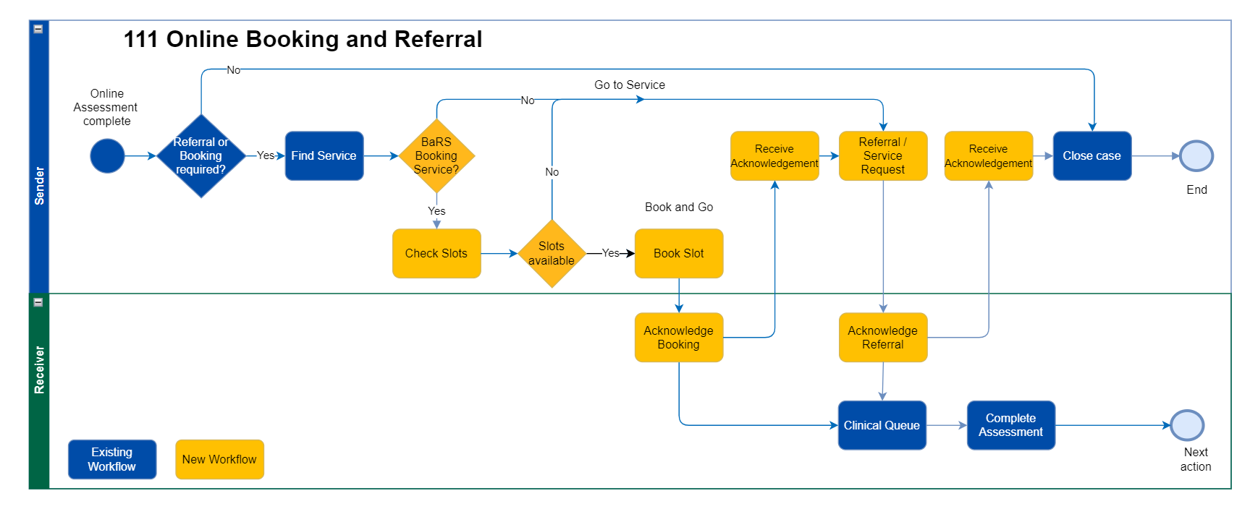
This workflow differs from the Bookings and Referrals into UEC (application1) patient journey due to the following:
- An online triage service is not an NHS Provider organisation manned by Healthcare Professionals that can receive and act on information sent back from the provider organisation that they referred to e.g. safeguarding response for patients that do not attend or were not brought to ED appointments.
- An online triage service does not persist patient information once it has been sent to a referral recipient e.g. it cannot support subsequent updates or cancellations
- An online triage service does not have access to other patient record sources (e.g. Summary Care Record)
- An online triage service is patient facing so does not have an HCP end user to raise safeguarding concerns
Table 18 Bookings and Referrals into UEC (application 2) clinical use
 | Description
1 | Prior to any potential referral the patient will undertake an online triage to determine the acuity of the case. This will typically be undertaken by a patient or their representative using a patient facing online triage system, such as the 111 Online Service which is underpinned by NHS Pathways Clinical Decision Support System (CDSS).
2 | For triage outcomes that require a booking and/or referral, a suitable Service is identified based on the patient’s clinical need and location. Service discovery will use UEC DOS, the Service ID of the selected service is then used for interactions with the Receiver via the BaRS API.  A prioritised list of suitable services is displayed to the patient for selection. Any service higher on the list than the service selected is considered a ‘rejected service’ and will be made available for review by the Receiving service for reporting and, potentially, patient instruction.
3 | The Service ID is used to query the BaRS endpoint catalogue, via the BaRS API, to identify the receiving service’s system endpoint details and whether they support BaRS or not. If supported the workflow continues as outlined, otherwise, existing alternative methods of referral and/or booking are followed e.g. CDA (Clinical Document Architecture) message over ITK (Interoperability Toolkit) and CareConnect Booking.
4 | Receiving Service systems that accept bookings for patient arrival or appointment times will publish available slots which are available for selection on the patient facing online triage system. The patient selects a suitable slot at the selected service and makes the booking request. If successful, an acknowledgement is received, and the patient has their booking details conformed on screen. If there are no slots or the booking fails, the patient is instructed to go to the service directly
5 | The online triage system will send the referral to the Receiving Service, including the information required by the Receiving Service to continue the patient's clinical care. This will also include the JourneyID created at the patient's first contact to enable the online triage service and receiving service encounters to be linked for reporting purposes.
6 | The Receiving Service’s system will acknowledge the referral on receipt and create a pending encounter. A human readable reference for the pending encounter is online triage system, allowing the patient to reference this when they arrive at the service. This helps support joined up care between services for the patient.
7 | On the patient’s arrival at the selected service, they will report to reception. The receptionist updates the patient’s encounter on the system to ‘arrived’ and the patient will wait to be triaged, verifying the acuity of their need and, if appropriate, redirect them to a more appropriate service e.g. Early Pregnancy Centre (EPC),
8 | If the patient stays in the Receiving Service, they will undergo an assessment by an appropriate clinician. Treatment may be provided in the receiving service, or the patient may be admitted or referred elsewhere.
              - Scope of interactions
The scope of interactions for the BaRS Bookings and Referrals into UEC (application 2) is depicted in the table below.
Figure 7 Bookings and Referrals into UEC (application 2) interactions
Sender | Receiver
Request and Interpret Capability Statement | Provide Capability Statement on demand
Request and Interpret Message Definitions | Provide Message Definition(s) for a Service on demand (based on the 'context' parameter on the GET /MessageDefinition endpoint)
Make Referral Request | Accept Referral Request  Provide representation of Referral Request
Make Booking Request | Accept Booking
Figure 8 Bookings and Referrals into UEC (application 2) interactions (detail)
              - Governance and assurance
                - Service Risk Level
The BaRS Bookings and Referrals into UEC (application 2) Service risk level has been assessed in accordance with the criteria defined in the BaRS Clinical Risk Management Plan and determined to be Medium.
                - Data Model Endorsement
The BaRS Team worked in collaboration with the Professional Records Standard Body (PRSB) to develop the BaRS data model. The data requirements were aligned to the PRSB Core information Standard [Ref 32] which was then updated to include any additional data items required by the BaRS for the 111 online Referral into ED use case and incorporated into the PRSB 111 Referral Standard [Ref 33]. PRSB then consulted with a wide range of users via a survey [Ref 34] prior to issuing endorsement [Ref 35].
                - Secondary use case endorsement
BaRS Application 1 has been endorsed for use for the following secondary use cases following review and approval by the relevant policy team stakeholders.
Secondary use case | Endorsement
111 Online -UTC | NHSE UTC Policy team [Ref 38]
S&R to ED | Digital Urgent and emergency Care team [Ref 83]
S&R to UTC | Digital Urgent and emergency Care team [Ref 83]

                - Supplier Assurance
The Public Beta suppliers for the BaRS application 2 are detailed below.
Public beta | Sender | Receiver
Suppliers | 111 Online | Wasp
Supplier assurance complete | BaRS Application 2 Sender Conformance Certificate (Ref 84)  BaRS Application 2 Sender CATR (Ref 85) | BaRS Application 2 Receiver Conformance Certificate (Ref 86)  BaRS Application 2 Receiver CATR (Ref 87)
                - Public Beta
Table 19 BaRS application 2 public beta providers
Use case | Sender | Receiver
111OL to ED | 111 Online | Warrington Hospital (Warrington & Halton Hospitals NHS Foundation Trust) ED
111OL to ED | 111 Online | Maidstone Hospital ED (Maidstone and Tunbridge Wells NHS Trust)
111OL to ED | 111 Online | Tunbridge Wells Hospital ED (Maidstone and Tunbridge Wells NHS Trust)
111OL to UTC | 111 Online | Halton Hospital (Warrington & Halton Hospitals NHS Foundation Trust) UTC
111OL to UTC | 111 Online | Maidstone Hospital UTC (Maidstone and Tunbridge Wells NHS Trust)
111OL to UTC | 111 Online | Tunbridge Wells Hospital UTC (Maidstone and Tunbridge Wells NHS Trust)
On 30th March the 111OL to ED Public Beta deployment had been live for 59 days and the 111OL to UTC Public Beta deployment had been live for 39 days and had processed the following numbers of bookings and referrals.
Table 20 BaRS application 2 booking and referral figures
 | 111OL to ED | 111OL to UTC | Total
Slots offered | 235 | 22 | 257
Bookings | 62 | 9 | 71
Referrals | 59 | 9 | 68
NHS England Live Services support, and the BaRS team provided additional early live support, including test issue management, with daily meetings. A summary of the issues identified in the public beta phase and the clinical risk assessment of outstanding test issues can be found in the BaRS Clinical Safety Case Report v1.2 [ Ref 96].

            - Referral into UEC (application 3)
              - Purpose
The BaRS Referral into UEC (application 3) is designed to support the referral of a case with a non-ambulance response Triage Outcome (also known as CAT5) from a 999 AST to a CAS.
Currently there is no standard to support a referral from a 999 AST to a CAS, although some suppliers/providers are using the ITK 111 Report at their own risk, as this workflow is outside of its accredited use.
This application has been informed by the following:
- User centred design [Ref 61]
- 999-111 Alpha project [Ref 62]
- ITK Ambulance Request [Ref 63]
- ITK 111 Report [Ref 60]
- Feedback on use of ITK Ambulance Report for CAD-to-CAD transfer [Ref 64]
- Ambulance Quality Indicators AmbSys Specifications [Ref 65]
              - Actors
The actors in the 999 to CAS Referral use case are detailed below (Table 21).
Table 21 BaRS Referrals into UEC (application 3) Actors
 | Provider type | System Type | System user role
Sender | 999 Ambulance Service Trust | Computer Aided Dispatch(CAD) system hosting NHS Pathways or AMPDS clinical decision support.  E.g. Hexagon Intergraph, MIS C3, Cleric Respond2 | 999 Call handler  999 Clinician  999 Emergency Medical Dispatcher
Receiver | Clinical Assessment Service | NHS 111 system hosting Pathways e.g. Advanced Adastra, IC24 Cleo, Cleric Respond2, MIS C3 | CAS Clinician

              - Clinical context
The clinical use of the BaRS Referral into UEC (application 3) to support a referral from a 999 AST into a CAS is depicted in Error! Reference source not found. and summarised at
Table 22
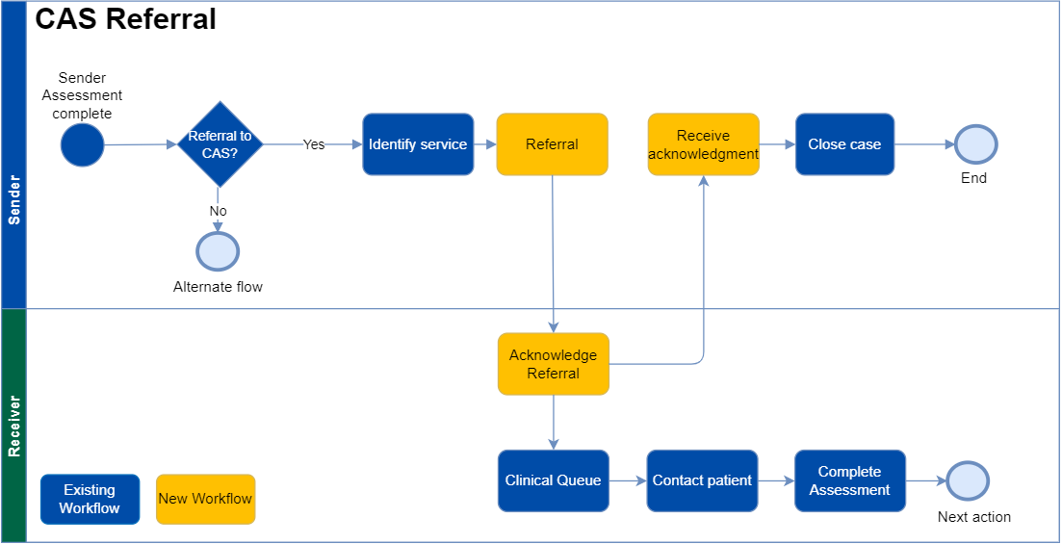
Figure 9 BaRS Referral into UEC (Application 3) Workflow

Table 22 BaRS Referrals into UEC (application 3) Clinical Use
Step | Description
1 | Prior to referral the 999 AST will undertake a triage of the patient to determine the acuity of the case. This will typically be undertaken by a call handler on the Computer Aided Dispatch system (CAD) using an approved Clinical Decision Support System (CDSS) such as NHS Pathways or AMPDS. For cases with a non-ambulance disposition (CAT5), local business rules will be applied to determine if the case meets the requirement for referral to a CAS for consultation.
2 | For cases requiring a referral to CAS, a suitable CAS is identified based on the patient’s clinical need and location. Service discovery will use local directories or UEC DOS to ascertain the ServiceID.
3 | The Service ID is used to query the BaRS endpoint catalogue to identify the receiving CAS system's endpoint details.
4 | The 999-AST will send the referral to the CAS, including the information required by a CAS Clinician to continue the patient's clinical care. This will also include the JourneyID created at the patient's first contact.
5 | The CAS system will acknowledge the referral on receipt, after which the case may be closed by the 999 AST on the CAD. It should be noted that Duty of care is passed from the 999 AST with the referral and is considered accepted by the CAS on receipt of the acknowledgement.
6 | Prior to the consultation the case will typically be posted to a queue for prioritisation, based on information in the referral. This may be based on the call back time, determined locally or nationally based on the triage outcome codes. e.g. Where cases have a Pathways disposition (Dx) these are prioritised in accordance with the criteria specified in the IUC CAS service specification [Ref 66] which sets out call-back times by Dx code.
7 | The CAS Clinician will contact the patient, or their representative, utilising information in the referral message, then undertakes a consultation which may include a triage. The consultation will be informed by the clinical information sent by the referring service. This will be recorded in the CAS system.
8 | On completion of the consultation the next action is performed. This may include provision of care advice with or without an electronic prescription (Hear and Treat), onward referral to another service provider or an ambulance request for a worsening patient.0

              - Scope of interactions

The scope of interactions for the BaRS Referral into UEC (application 3) is detailed in Table 23.
Table 23 BaRS Referrals into UEC (application 3) Interactions
Sender | Receiver
Request and Interpret Capability Statement | Provide Capability Statement on demand
Request and Interpret Message Definitions | Provide Message Definition(s) for a Service on demand (defined in NHSD-Target-Identifier)
Make Referral Request (Cat 5) | Accept Referral Request (Cat 5)  Provide representation of Referral Request
Update Referral Request to cancel (Cat 5) | Accept update to Referral Request to cancel (Cat 5)
              - Governance and assurance
                - Service Risk Level
The BaRS Referral into UEC (application 3) Service risk level has been assessed in accordance with the criteria defined in the BaRS Clinical Risk Management Plan and determined to be Medium.
                - Data Model Endorsement
For this application the BaRS team prepared a data model for endorsement [Ref 36] and collaborated with ambulance service professional bodies for expert review and feedback. Subsequently, endorsement was provided by NHSE Ambulance Improvement Programme [Ref 37].
                - Supplier Assurance
The Public Beta suppliers for the BaRS application 3 are detailed below.
Public beta | Sender | Receiver
Suppliers | MIS C3 CAD | Advanced Adastra
Supplier assurance complete | BaRS Application 3 Sender Conformance Certificate (Ref 88)  BaRS Application 3 CATR (Ref 89) | BaRS Application 3 Receiver Conformance Certificate (Ref 90)  BaRS Application 3 Receiver CATR (Ref 91)

                - Public Beta
Table 24 BaRS application 3 Public Beta providers
Use case | Sender | Receiver
999 AST to CAS Referral | North West Ambulance Service | Greater Manchester Alliance Clinical Assessment Service (GM CAS)

On 8th January 2024 the 999 AST to CAS Referral Public Beta deployment had been live for 42 days and the and had processed the following numbers of referrals.
Table 25 BaRS application 3 public beta referral figures
 | 999 AST to CAS
Referrals | 329

NHS England Live Services and the BaRS team provided additional early live support, including test issue management, with daily meetings. There were no test issues identified in the public beta phase for this application:
This meets the acceptance criteria for the Public Beta for this application as defined in the BaRS Clinical Risk Management Plan (>50 referrals with a verification period of 4-6 weeks with no significant safety issues).

            - Referral into UEC for validation (application 4)

              - Purpose

As part of the Ambulance Transformation Forum work streams, NHS England and Improvement (NHSEI) conducted pilots [Ref 67 and 68] to undertake clinical validation of some lower acuity 999 incidents ahead of face-to-face responses being sent. Clinical validation may be undertaken in a 999 AST Emergency Operation Centre (EOC) clinical hub or an external clinical assessment service, often delivered by NHS 111 Service Providers.
The NHS England Ambulance Digital Strategy [Ref 69] identified “the need for the ambulance sector to have a standardised method of electronically transferring details of a 999 call to a clinical assessment service for lower acuity and less urgent conditions calls’’. The Ambulance Improvement Programme (AIP) recognised this gap during their implementation of recommendations made in Lord Carter’s review into unwarranted variation in NHS ambulance trusts [Ref 70] and requested NHSE (previously NHSX) to commission the 999-CAS transfer project which is being delivered through the BaRS Programme to enable:
- Increased resilience across Urgent and Emergency Care (by enabling interoperability between 999 and 111/CAS services)
- Better use of scarce clinical resource (by enabling validation to be undertaken by external or consolidated Clinical Hubs or Assessment Services)
- Improved interoperability (by introducing an open standard that supports the subsequent move from proprietary to open terminologies)
- Reduction of unnecessary ambulance dispatch and conveyance
Currently there is no standard to support an ambulance validation workflow between a 999 AST and a CAS, although some suppliers/providers are using the ITK 111 Report as a workaround, at their own risk as this workflow is outside of its accredited use.
This application has been informed by the following:
- User centred design [Ref 61]
- 999-111 Alpha project [Ref 62]
- ITK Ambulance Request [Ref 63]
- ITK 111 Report [Ref 60]
- Feedback on use of ITK Ambulance Report for CAD-to-CAD transfer [Ref 64]
- Ambulance Quality Indicators AmbSys Specification [Ref 65]

              - Actors
The BaRS UEC Referral for validation (application 4) is designed to support referrals for ambulance validation from/to the following service provider types and associated systems (Table 26):
Table 26 BaRS Referrals into UEC for validation (application 4) Actors
 | Provider type | System Type | System user role
Sender | 999 Ambulance Service Trust | Computer Aided Dispatch (CAD) system hosting NHS Pathways or AMPDS clinical decision support.  E.g. Hexagon Intergraph, MIS C3, Cleric Respond2 | 999 Call handler  999 Clinician  999 Emergency Medical Dispatcher
Receiver | Clinical Assessment Service  Falls lifting Service  Community Services (including 2-hour community response) | NHS 111 system hosting Pathways e.g. Advanced Adastra, IC24 Cleo, Cleric Respond2, MIS C3  Strata Health Transition of care solution | CAS Clinician  Falls Service Operations staff  Community Service Operations staff
              - Clinical context
The clinical use of the BaRS Referral into UEC for validation (application 4) to support a referral from a 999 AST into a CAS for Validation of a lower acuity ambulance triage outcome is depicted in Figure 10and is summarised at Table 28.
The acuity of an ambulance response is determined by the mapping of the triage outcome from an Emergency Call Prioritisation Advisory Group (ECPAG) approved CDSS (NHS Pathways or AMPDS) to an Ambulance Response Programme (ARP) priority response code (Table 27).
Where the validation is undertaken in a CAS that does not use an ECPAGG approved CDSS (NHS Pathways) the CAS clinician has to make an Healthcare Professional (HCP) request using ARP HCP codes (Table 27) These requests must be reviewed by a 999 AST Clinician prior to dispatch or closure of the case. The workflow for a validation that is undertaken without using NHS Pathways is included in Appendix D.
This application has been extended to support the following use cases from version 1.2.0:
- 999 AST to Falls Lifting Service
- 999 AST to Community Services (including 2-hour Urgent Community Response (UCR))
Table 27 Ambulance Response Programme response priority codes
ARP ambulance response priority | HCP ambulance response priority | Description | Target response time
Category 1 (CAT 1) | Category 1 (HCP1) | Calls from people with life-threatening illnesses or injuries | 7 mins
Category 2 (CAT 2) | Category 2 (HCP 2) | Emergency calls | 18 mins
Category 3 (CAT 3) | Category 3 (HCP 3) | Urgent Calls | 90% in 120 mins
Category 4 (CAT 4) | Category 4 (HCP 4) | Less urgent calls | 90% 180 mins
Category 4 Transport (CAT 4T) | Category 4 (HCP 4T) | Less urgent calls requiring transport e.g. Taxi | 90% 180 mins

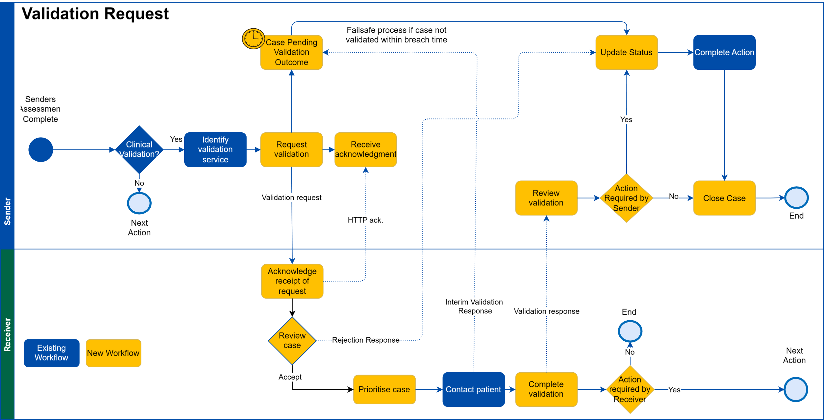
Figure 10 Referral into UEC for validation (application 4) Workflow
Table 28 BaRS Referrals into UEC for validation (application 4) Clinical Use
Step | Description
1 | Prior to referral the 999 AST will undertake a triage of the patient to determine the acuity of the case. This will typically be undertaken by a call handler on the Computer Aided Dispatch system (CAD) using an approved Clinical Decision Support System (CDSS) such as NHS Pathways or AMPDS. For cases with a low acuity ambulance triage outcome (currently CAT3 and CAT4), local business rules are applied to determine if the case meets the requirement for clinical validation of triage outcome, referral to a Falls Service or Referral to a Community Service. These may be informed by the outcome of the NHSE Ambulance Validation Project.
2 | For cases meeting the criteria, a suitable CAS, Falls or Community service, is identified based on the patient’s location. Service discovery will be locally mapped or use UEC DOS to ascertain the ServiceID. This will be used to query the BaRS endpoint catalogue.
3 | The AST will send a BaRS Validation Request to the CAS, Falls Service or Community Service which includes information required by an appropriate Healthcare Professional (HCP) to continue the patent's clinical care. This will also include the Journey ID created at the patient’s first contact.
4 | The case in the CAD is posted to a hidden/pending dispatch queue. If the case exceeds the validation breach time, a failsafe process ensures that an ambulance is dispatched according to the original triage outcome.
5 | On receipt of the BaRS Validation Request, the Receiving system sends an http response as an acknowledgement to the sending service.
6 | Cases are prioritised for validation on the Receiving system clinical queue in order of the validation breach time, included in the BaRS Validation Request.
7 | The clinician contacts the patient (or their representative) based on the contact details in the validation request.
8 | As the HCP starts the consultation , a BaRS Interim Validation Response is returned to the requesting 999 AST to inform them of the progress.  If the Receiving Service cannot complete the request, they may send a rejection using the BaRS Interim Validation Response with an appropriate reason.
9 | - The HCP then actions the request e.g. Validates the triage outcome (this may include re-triaging the patient or it may be a consultation), attempts to lift the patient or provides a 2 hour UCR and communicates the outcome to the requesting 999 AST in a BaRS Final Validation Response message.  This may include:  - An outcome that requires an upgraded ambulance response from the Sending 999 AST  - An outcome that requires a downgraded ambulance response from the Sending 999 AST  - An outcome that requires an unchanged ambulance response from the Sending 999 AST  - An outcome that can be met by the provision of care advice with or without an electronic prescription (Hear and Treat)  - An outcome that can be met by the onward referral to another service provider e.g. ED  - A Local response outcome e.g. Patient lifted, no ambulance required
9a | If the outcome communicates that an ambulance is still required, the 999 AST Emergency Medical dispatcher (EMD) uses the information in the validation response message to dispatch an ambulance within the appropriate timescales.  Where the validation in the CAS is undertaken without using Pathways, the Validation Response may be returned to the 999 EOC Clinical Hub for the 999 Clinician to review and approve the validation outcome before the case is returned to the dispatch stack.
9b | If the outcome downgrades the original triage outcome to an onwards referral or Consult and Complete/Hear and Treat, this information is returned to the CAD in the Validation Response. The CAD acts on this information and removes the case from the hidden/pending dispatch queue.  Where the validation in the CAS is undertaken without using Pathways, the Validation Response may be returned to the 999 Clinical Hub for the 999 Clinician to review and approve the validation outcome before the case is closed.
9c | If the outcome is to upgrade to a CAT1/2 an ITK Ambulance Request may be sent by the CAS to the 999 AST using existing functionality. The AST CAD treats this as a new case and calculates timings for ARP and Ambulance Quality Indicators (AQI) accordingly. In this scenario it will auto-dispatch according to local processes. The CAD sends an acknowledgement to the CAS which includes the case identifier of the new case. The CAS includes this in the validation response so that the CAD can mark the original case as a duplicate and remove from the dispatch queue.  Where the validation in the CAS is undertaken without using Pathways, the CAS Clinician MUST call the 999 AST Clinical Hub so that an ambulance (or alternative resource) can be dispatched immediately. The Validation Response is also returned to the 999 Clinical Hub for the 999 Clinician to review and approve as part of the dispatch process.

              - Scope of interactions
The scope of interactions for the BaRS UEC Referral for validation (application 4) is depicted in Table 29.
Table 29 UEC Referral for validation (application 4) Interactions (detail)
Sender | Receiver
Request and Interpret Capability Statement | Provide Capability Statement on demand
Request and Interpret Message Definitions | Provide Message Definition(s) for a Service on demand (defined in NHSD-Target-Identifier)
Make Validation Request (Cat 3/4) | Accept Validation Request (Cat 3/4)
Update Validation Request to cancel | Accept update to Validation Request to cancel
Update to modify existing Validation Request | Accept modified Validation Request, process and respond accordingly
Accept Interim Validation Response Rejection (partial – Encounter status ‘Cancelled’) | Make Interim Validation Response Rejection (partial – Encounter status ‘Cancelled’)
Accept Interim Validation Response (partial - Encounter status 'in progress' | Make Interim Validation Response (partial - Encounter status 'in progress')
Accept Validation Response (complete - Encounter status 'triaged') | Make Full Validation Response (complete - Encounter status 'triaged')
Link upgraded Validation Response (Cat 1/2) with ITK Request | Include ITK CAD Id in Full Validation Response (Cat 1/2 only)
              - Governance and Assurance
                - Service Risk Level
The BaRS Referral into UEC for validation (application 4) Service risk level has been assessed in accordance with the criteria defined in the BaRS Clinical Risk Management Plan and determined to be Medium.
This has been reviewed in light of the additional use cases and remains at Medium.
                - Data Model Endorsement
For this application the BaRS team prepared a data model for endorsement [Ref 36] and collaborated with ambulance service professional bodies for expert review and feedback. Subsequently, endorsement was provided by NHSE Ambulance Improvement Programme [Ref 37].
                - Secondary use case endorsement
BaRS Application 4 has been endorsed to support the following secondary use cases following review and approval by the relevant policy team stakeholders.
Secondary use case | Endorsement
999 AST to Falls Service | Integrated Urgent Care Team (Ref 101)
999 AST to Community Services (including 2-hour Urgent Community Response) | Integrated Urgent Care Team (Ref 101)
                - Supplier Assurance
The Public Beta suppliers for the BaRS application 4 are detailed below.
Public beta | Sender | Receiver
Suppliers | MIS C3 CAD | Advanced Adastra
Supplier assurance complete | BaRS Application 4 Conformance Certificate (Ref 92)  BaRS Application 4 CATR (Ref 93) | BaRS Application 4 Conformance Certificate (Ref 94)  BaRS Application 4 CATR (Ref 95)
                - Public Beta
Table 30 BaRS application 4 Public Beta providers
Use case | Sender | Receiver
999 AST to CAS Validation | North West Ambulance Service | Greater Manchester Alliance Clinical Assessment Service (GM CAS)

On 8th January 2024 the 999 AST to CAS referrals for validation Public Beta deployment had been live for 42 days and the and had processed the following numbers of referrals for validation
Table 31 BaRS application 4 public beta referral for validation figures
 | 999 AST to CAS
Referrals for Validation | 4618

NHS England Live Services support, and the BaRS team provided additional early live support, including test issue management [Ref 43a], with daily meetings. A summary of the issues identified in the public beta phase and the clinical risk assessment of outstanding test issues can be found in the BaRS Clinical Safety Case Report v1.5 [Ref 97].
An additional requirement for BaRS was identified:
- The ability for a CAS to return a case to the 999 AST when they cannot perform a validation e.g. failed contact
This was subsequently delivered in Release 1.1 of App4.

            - BaRS Pharmacy Referrals (application 5)
              - Purpose
The BaRS Pharmacy Referrals (application 5) is designed to support the referral of a case from a GP Practice to a Community Pharmacy (Pharmacy First) for minor illness ONLY for this release. As a pre-release application standard with a maturity of Beta to support Public Beta deployments only.
Currently there is no standard to support a referral from a GP to a community Pharmacy
This application has been informed by the following:
- Community Pharmacy advanced service specification: NHS Community Pharmacist Consultation Service [Ref 71]
- User centred design [Ref 72]
- PRSB Referral Standard data model [Ref 33]
- GP to Pharmacy Data model endorsed by NHSE Pharmacy Policy team (Ref 39)
- ITK 111 Report [Ref 60]
              - Actors
The actors in the GP to Pharmacy use case are detailed below (Table 21).
Table 32 A.1 BaRS Pharmacy Referrals (application 5) Actors
 | Provider type | System Type | System user role
Sender | GP | GP system e.g. EMIS Web (integrated with PharmRefer), TPP SystmOne  Standalone system e.g. PharmRefer  NHS Mail | GP Receptionist  Care navigator  Clinician  Healthcare Professional
Sender | Online consultation Service (OCS) from v1.1.0 | Online consultation system e.g. 111 Online, eConsult | Patient
Receiver | Community Pharmacist | Community Pharmacy IT Systems  e.g. Cegedim, PharmOutcomes (some using with PharmAlarm), Positive Solutions HX Consult, Sonar | Pharmacists  Pharmacy Assistant  Pharmacy Technician

              - Clinical context
The clinical use of the BaRS Referral from a GP into a Pharmacy is depicted in Figure 11and summarised at Table 33.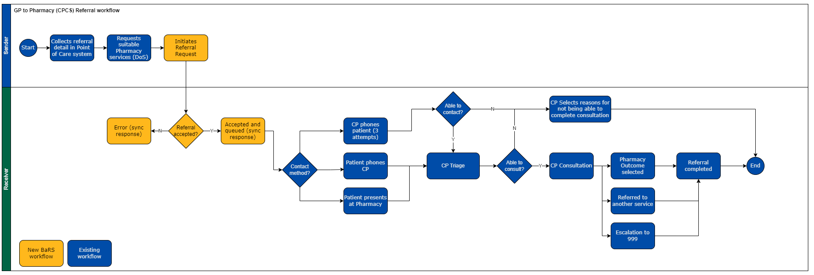
Figure 11 BaRS Pharmacy Referrals (application 5) workflow
Table 33 BaRS Pharmacy Referrals (application 5) clinical use
Step | Description
1 | Patients who contact their GP practice for advice on the treatment of minor illnesses are assessed by the practice team to determine whether they are suitable for referral to a Community Pharmacy under the Pharmacy First scheme, using streaming protocols based on a nationally defined case mix of symptoms and minor conditions [Ref 55]. The GP Practice member of staff records in the GP system or a standalone system, why the patient is being referred, for the pharmacist to review ahead of or during the patient’s consultation
2 | The patient is offered the referral and provided with details of pharmacies that provide the service, which are close to the patient’s location. The patient selects which pharmacy they wish to attend. Service discovery will use UEC DOS to ascertain the ServiceID. The Service ID is used to query the BaRS endpoint catalogue, via the BaRS API, to identify the receiving Community Pharmacy system's endpoint details and whether they support BaRS or not. If supported the workflow continues as outlined, otherwise, existing alternative methods of referral are followed e.g. NHS mail. The GP practice gives the patient the option to go to the Pharmacy or phone ahead.
3 | The GP Practice will send the referral to the selected Community Pharmacy, including the information required by the pharmacist to continue the patient's clinical care. This will also include the JourneyID created at the patient's first contact to enable the GP and CPCS encounters to be linked for reporting purposes.
4 | The Community Pharmacy system will acknowledge the referral on receipt and create a pending encounter. A human readable reference for the pending encounter is returned to the GP Practice, allowing the practice HCP to provide this to the patient to relay when they arrive at the Pharmacy. This helps support joined up care between services for the patient. Pharmacies may use an alerting mechanism that notifies them of a referral receipt (e.g. PharmAlarm).
5 | If the patient has not contacted the Pharmacy or presented within the timeframe stated in the Community Pharmacy advanced service specification: NHS Community Pharmacist Consultation Service [Ref 71] (currently 30 min), the pharmacy will attempt to call the patient using the contact details set out in the referral. If no contact has been made before the next working day, then the pharmacist can close the referral as ‘no intervention or no supply made’.
6 | The Pharmacist will undertake the consultation with the patient, either by phone and/or face to face and record the outcome in the Community Pharmacy system. The outcome of the referral received in relation to low acuity/minor illness may include:  - Self-care advice to the patient.  - Self-care advice and the sale of an over the counter (OTC) medicine.  - Referral to a separately commissioned pharmacy service delivered in the pharmacy.  - Referral to the patient’s GP or relevant out of hours service for an urgent appointment.  - Routine referral to other appropriate services (including other health professionals).
7 | Where the pharmacist needs additional advice or to escalate the patient to a higher acuity care location (e.g. a GP, UTC, OOH or ED) they use their clinical judgement to decide the urgency, route and need for referral and then choose one of the options below:  - Refer the patient for an urgent in-hours appointment with their own GP.  - Call the NHS 111 service when the patient’s own general practice is not available. The pharmacist should call NHS 111 using the healthcare professionals’ line for access to a clinician, to seek advice.  - Signpost the patient to A&E or call 999. If the patient presents with severe symptoms indicating the need for an immediate medical consultation, the pharmacist should tell the patient to attend A&E immediately or call an ambulance on behalf of the patient.  Note: Onward referrals are not in scope for this BaRS Release.

              - Scope of interactions
The scope of interactions for the BaRS Pharmacy Referrals (application 5) is detailed in Table 34.
Table 34 BaRS Pharmacy Referrals (application 5) Interactions
Sender | Receiver
Request and Interpret Capability Statement | Provide Capability Statement on demand
Request and Interpret Message Definitions | Provide Message Definition(s) for a Service on demand (defined in NHSD-Target-Identifier)
Make Referral Request | Accept Referral Request  Provide representation of Referral Request
Update Referral Request to cancel | Accept update to Referral Request to cancel

              - Governance and assurance
                - Service Risk Level
The BaRS Pharmacy Referrals (application 5) service risk level has been assessed in accordance with the criteria defined in the BaRS Clinical Risk Management Plan and determined to be Low.
                - Data Model endorsement
The BaRS referral into Pharmacy (application 5) workflow and data model was reviewed and endorsed by the NHSE Pharmacy policy team and PRSB [ Ref 39].
                - Secondary use case endorsement
BaRS Application 5 has been endorsed to support the following secondary use cases following review and approval by the relevant policy team stakeholders.
Secondary use cases (from App5 v1.1.0) | Endorsement
Online consultation Service (OCS) to Community Pharmacy | Ref 103
GP/OCS to Community Pharmacy Blood Pressure | Ref 106
GP/OCS to Community Pharmacy Oral contraception | Ref 106

                - Supplier assurance
The Public Beta suppliers for the BaRS application 5 are detailed below.
Public beta | Sender | Receiver
Suppliers | EMIS PharmRefer | Positive Solution Ltd Hx Consult
Supplier assurance complete | BaRS Application 5 Sender Conformance Certificate [Ref 107] | BaRS Application 5 Receiver Conformance Certificate [Ref 108]
                - Public Beta
Use case | Sender | Receiver
GP to Pharmacy Minor Illness | Field Street GP | Pickfords Pharmacy - Shepshed
GP to Pharmacy Minor Illness | Manor Park GP | Pickfords Pharmacy – Norwich Road
GP to Pharmacy Minor Illness | Victoria Park GP | WELL Pharmacy – Clarendon Park

On 11th June 2024 the 999 AST to CAS Referral Public Beta deployment had been live for 20 days and the and had processed the following numbers of referrals.
 | GP to Pharmacy (minor illness)
Referrals | 26

NHS England Live Services and the BaRS team provided additional early live support, including test issue management, with daily meetings. There were no outstanding test issues test issues identified in the public beta phase for this application [Ref 109].
This meets the acceptance criteria for the Public Beta for this application as defined in the BaRS Clinical Risk Management Plan (>20 referrals with a verification period of 2 weeks with no significant safety issues).

          - BaRS Pre-Release applications
            - Referrals into an Ambulance Service Trust (Application 6
              - Purpose
The BaRS Referral into an AST (application 6) is designed to support the referral of a case from a 999 AST to another 999 AST for the following use cases.
BaRS Application | Use cases supported | Version
BaRS Referral into an AST (application 6) | Out of Area Referral  Call Assist Request  Mutual Aid Request | V1.0.0_Beta2

The standard that currently supports this workflow is the ITK Ambulance Request [Ref 63} which was originally designed for referring patients from NHS 111 to 999 AST, but subsequently approved for use for Ambulance Requests between ASTs.
This application has been informed by the following:
- User centred design [Ref 74]
- ITK Ambulance Request (deprecated) [Ref 63]
- Feedback on use of ITK Ambulance Report for CAD-to-CAD transfer [Ref 64]
- Ambulance Quality Indicators AmbSys Specifications [Ref 65]
- ITK Task and Finish Group recommendations [Ref 75]
- Ambulance Response Programme Review [Ref 76]
              - Actors
 | Provider type | System Type | System user role
Sender | 999 Ambulance Service Trust | Computer Aided Dispatch(CAD) system hosting NHS Pathways or AMPDS clinical decision support.  E.g. Hexagon Intergraph, MIS C3, Cleric Respond2 | 999 Call handler  999 Clinician  999 Emergency Medical Dispatcher
Receiver | 999 Ambulance Service Trust | Computer Aided Dispatch(CAD) system hosting NHS Pathways or AMPDS clinical decision support.  E.g. Hexagon Intergraph, MIS C3, Cleric Respond2 | 999 Call handler  999 Clinician  999 Emergency Medical Dispatcher

              - Clinical context
The clinical use of the BaRS Referral into an AST (Application 6) to support a referral from a 999 AST into a CAS is depicted below.
Out of area calls
Calls may be re-routed by the BT Emergency Call Service to an AST outside of the geographic area of the incident. This case then needs referring to the AST who is responsible for the geographic area of the incident (Home AST) so they can dispatch a resource within a timescale appropriate for the priority of the case.
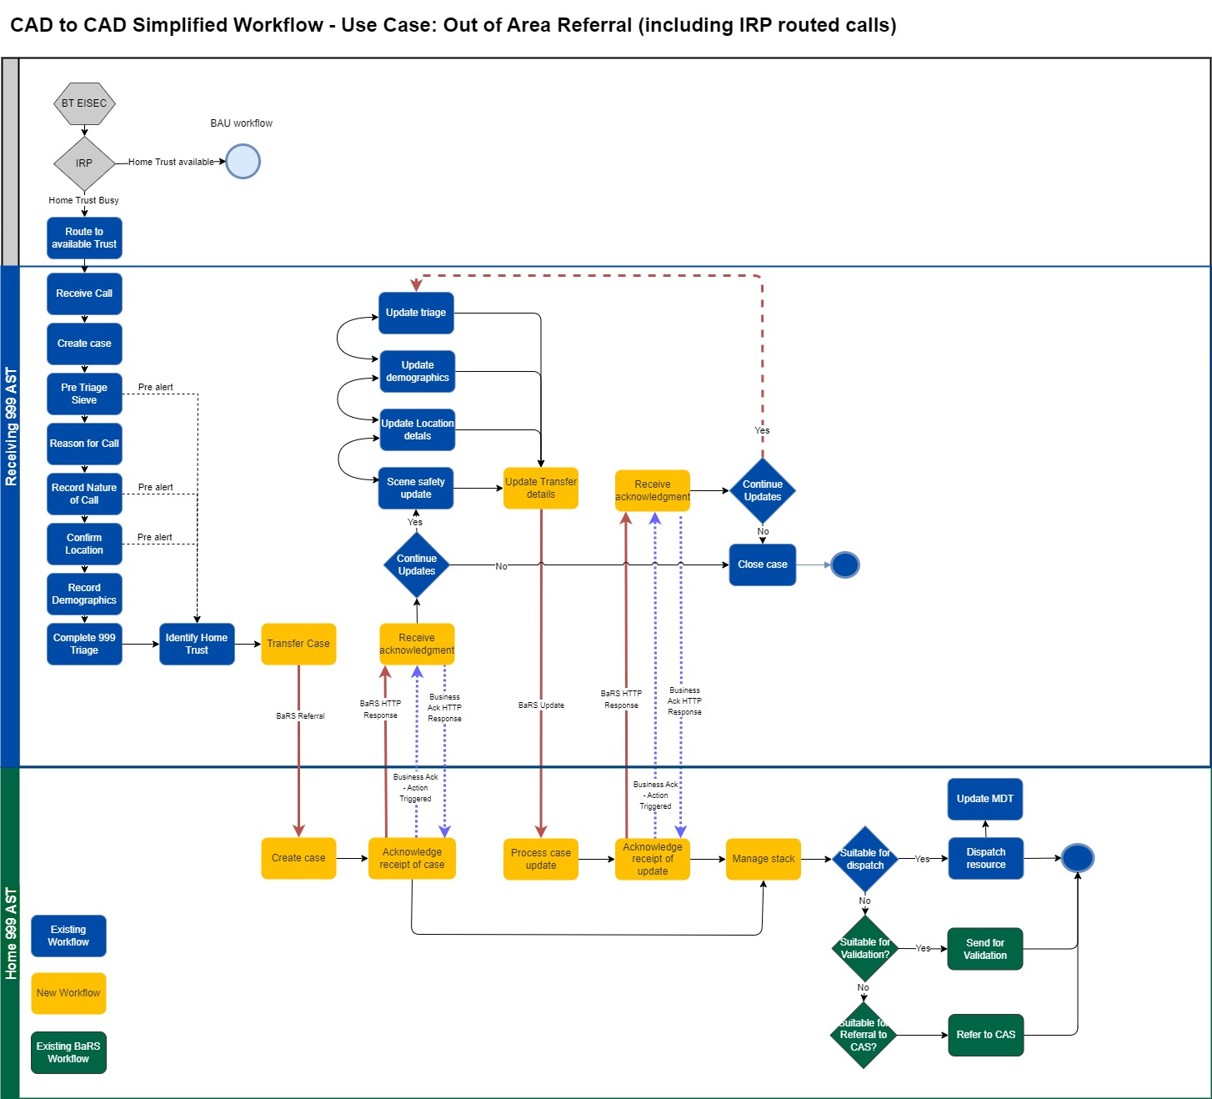
Call Assist Requests
A Home AST may request support from a Supporting AST when they cannot send a resource to an incident within their geographic boundary of responsibility
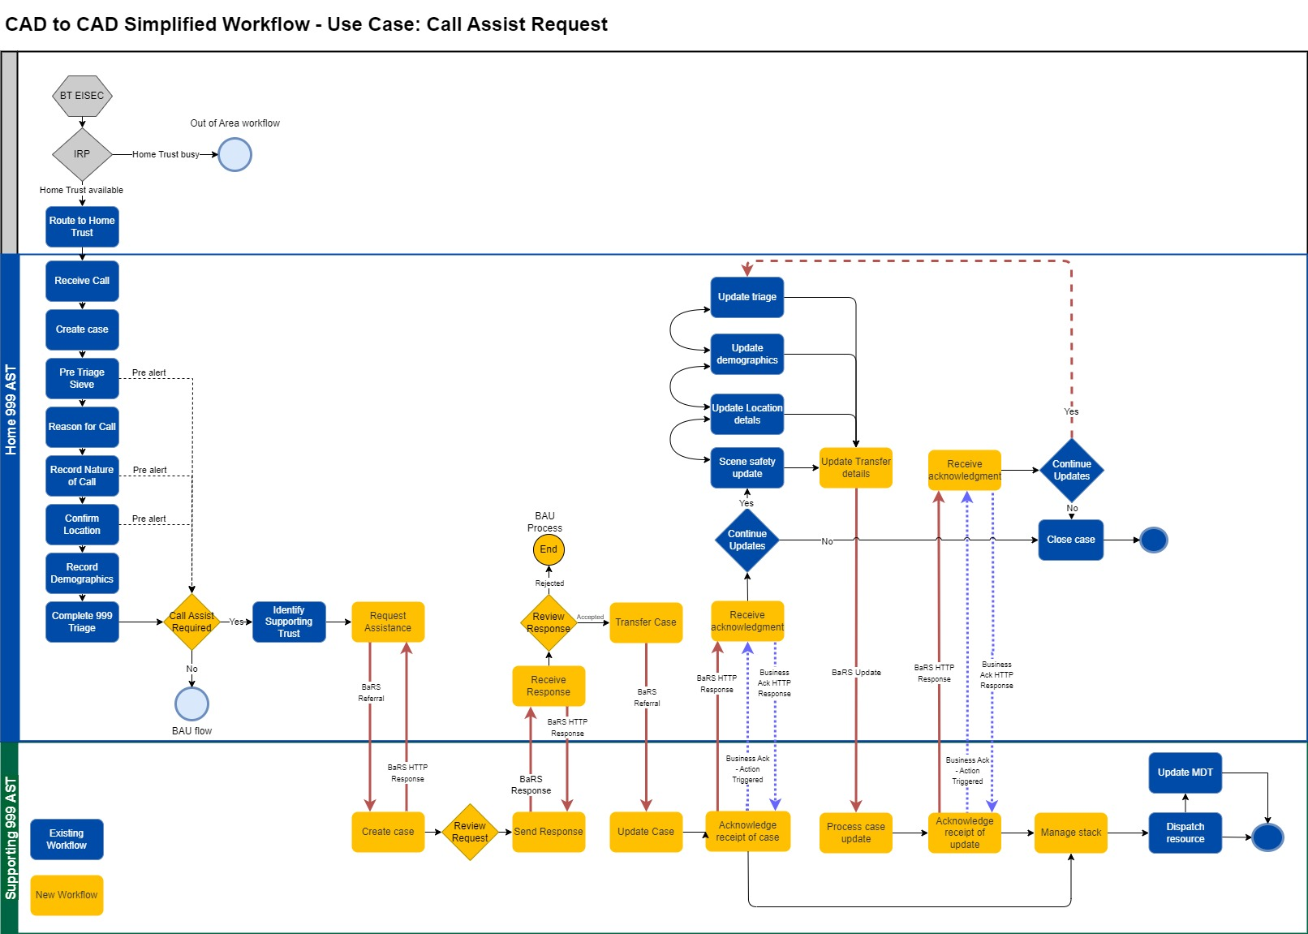
Mutual Aid Requests
A Home AST may request support from a Supporting AST when they cannot meet all the resource requirements for and incident within their geographic boundary of responsibility.
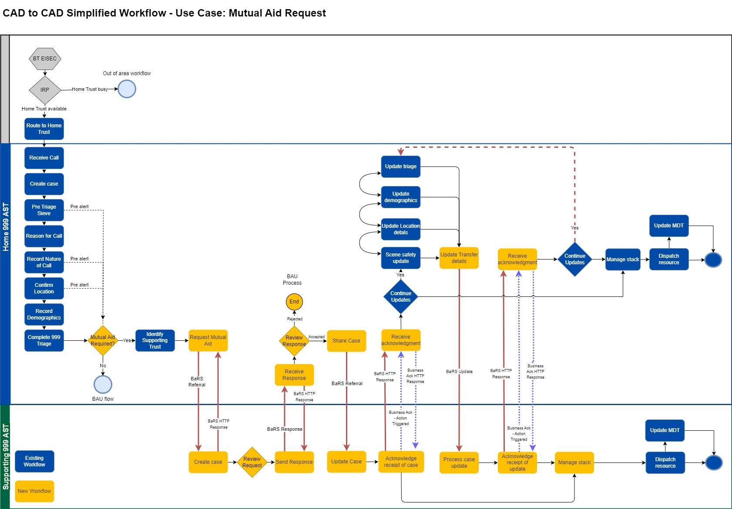
Step | Description
Receive call | When a call is re-routed by BT Emergency Services, call details are also sent electronically to the referral Sender via the Enhanced Information Service for Emergency Calls (EISEC) interface.  For the Call Assist and Mutual aid use cases, the initial call may be received via BT Emergency Services EISEC interface or directly into the CAD e.g. Healthcare Professional (HCP) direct line
Create case | On receipt of this information the referral Sender's CAD creates a case that is subsequently further populated by system end users, the associated telephony system and other interfaced systems e.g. Clinical Decision Support Systems (CDSS) such as NHS Pathways and Advanced Medical Priority Dispatch System (AMPDS)
Pre-Triage Sieve | On answering the call the referral Sender will undertake a Pre-Triage Sieve (PTS) question set to facilitate the early identification of patients with a potentially life-threatening emergency, in order that immediate dispatch of an appropriate resource can take place at the earliest possible point in the call cycle. If a life-threatening emergency is identified by the PTS the referral Sender AST may make a BaRS referral at this point in the call cycle, and all subsequent information will be communicated in BaRS Referral updates (see Sending a BaRS Referral)
Reason for call | The referral Sender will capture a Reason for Call based on what the patient or their representative tells them. This may also be known as 'What's the Problem' text or the Presenting complaint.
Nature of call | The referral Sender will capture a NOC code to facilitate the early identification of patients with a potentially life-threatening emergency. If a life-threatening emergency is identified by the NOC, the referral Sender AST may make a BaRS referral at this point in the call cycle, and all subsequent information will be communicated in BaRS Referral updates (see Sending a BaRS Referral below)
Confirm Location | The referral Sender will record the location of the incident and confirm using Gazetteer services. This is undertaken at the earliest opportunity and may be prior or subsequent to PTS and NOC
Record demographics | The referral Sender will capture the patient's baseline demographics where possible. This may be followed up by a Personal Demographics Service (PDS) search later in the call cycle
Complete Triage | The referral Sender will complete a triage of the patient to determine the acuity of the case. This will typically be undertaken by a call handler on the Computer Aided Dispatch (CAD) system, using an approved Clinical Decision Support System (CDSS) such as NHS Pathways or AMPDS. This is the point at which the Referral Sender AST will make a BaRS referral for non-life-threatening emergencies; all subsequent information captured will be communicated in BaRS Referral updates (see Sending a BaRS Referral below)
Send referral | The referral Receiver is identified based on nationally agreed polygons that set geographic boundaries of responsibility for each AST. Service discovery will use these polygons to ascertain the ServiceID of the referral Receiver.  The Service ID is used to query the BaRS Endpoint Catalogue to identify the referral Receiver's CAD system's endpoint details  The referral Sender will send the BaRS Referral to the referral Receiver, which includes information required by the referral Receiver to continue the patent's clinical care. This will also include the JourneyID created at the patient's first contact.
Create case | The referral Receiver's CAD will create a new case (Encounter) on receipt of the BaRS Referral and populate it with the patient and clinical details provided in the referral
Acknowledge receipt | The referral Receiver will send an acknowledgement back to the referral Sender, when it has successfully processed the payload. If it fails to do this, it will send a BaRS error code.
Accept/Reject request (Referral response) | For Mutual Aid and Call Assist requests ONLY the Supporting AST may Accept or Reject the request by means of a Referral Response (status update) sent back to the Home AST.
Status update (Referral response) | The referral Receiver will send a series of status updates back to the referral Sender, to support tracking the progress of the case.
Continue updates | If additional or changed information about the case is captured by the referral Sender, subsequent to sending the BaRS Referral, they may send a BaRS Referral Update to ensure that the referral Receiver has the most up to date information.  If the referral Sender no longer requires the Receiving AST to perform the validation, for example the patient calls back and says they do not require an ambulance, they may send a cancellation.  On receipt of a Referral Update, the referral Receiver will send an acknowledgement back to the Sending AST on when it has successfully processed the payload. If it fails to do this, it will send a BaRS error code
Manage stack | The referral Receiver will manage the case in accordance with the Ambulance Response Programme (ARP) Priority Level. This may include:  - Dispatching an appropriate resource within the specified time frame  - Validating the triage outcome  - Referring onward to another care setting e.g. Emergency Department  When the status of a case changes in the referral Receiver's CAD, a BaRS Status Update will be sent to the referral Sender, so they are aware of the current case status.

              - Scope of interactions
The scope of interactions for the BaRS Referral into an AST EOC (application 6) is detailed below

Sender | Receiver
Request and Interpret Capability Statement | Provide Capability Statement on demand
Request and Interpret Message Definitions | Provide Message Definition(s) for a Service on demand (defined in NHSD-Target-Identifier)
Make Referral Request | Accept Referral Request
Update Referral Request to cancel | Accept update to Validation Request to cancel
Update to modify existing Validation Request | Accept modified Referral Request, process and respond accordingly
Accept Referral Response (status update including rejection) | Make Referral Response (status update including rejection)
              - Governance and assurance
                - Service Risk Level
The BaRS Referral into an AST (Application 6) Service risk level has been assessed in accordance with the criteria defined in the BaRS Clinical Risk Management Plan and determined to be High.
                - Data Model endorsement
The BaRS Referrals into an Ambulance Service Trust (Application 6) workflow, data model and requirements were reviewed by the CAD to CAD Reference Group (operational, clinical and technical representatives from UK ASTs) and endorsed by the NHSE CAD to CAD Working Group [Ref 74a].
                - Supplier assurance
This section will be completed following the conclusion of Public Beta supplier assurance for this application.
                - Public Beta
This section will be completed following the conclusion of the Public Beta for this application.
            - Booking and Referrals into GP (application 7)
              - Purpose
The BaRS Booking and Referral into GP (application 7) is designed to support booking of an appointment into a patient’s registered General Practice. It is being delivered in a phased manner with the initial alpha standard being a Minimal Viable Product (MVP) constrained to NHS App as a sender, providing a direct replacement for IM1 Pairing Integration supporting Patient Facing Services (PFS) appointments. This will allow any New Market Entrants (NMEs) to achieve parity with incumbent GP suppliers that support IM1 PFS appointments.
It supports the following requirements:
Ref | MVP requirement
PFS1 | View my appointments at my registered GP  - Historic and Future
PFS2 | Find available (‘bookable’) appointment slots at my registered GP​
PFS3 | Book appointment at my registered GP
PFS4 | Cancel appointment at my registered GP

              - Actors
The actors in the BaRS Booking and Referral into GP use case are detailed below.
 | Provider type | System Type | System user role
Sender | N/A | Patient facing system e.g. NHS App | Patient
Receiver | General Practice | GP System e.g. EMIS, TPP, Medicus
              - Clinical context
The clinical use of the BaRS Booking and Referral into GP (Application 7) to support a booking from a Patient Facing System into the patient’s registered General Practice is depicted in below.
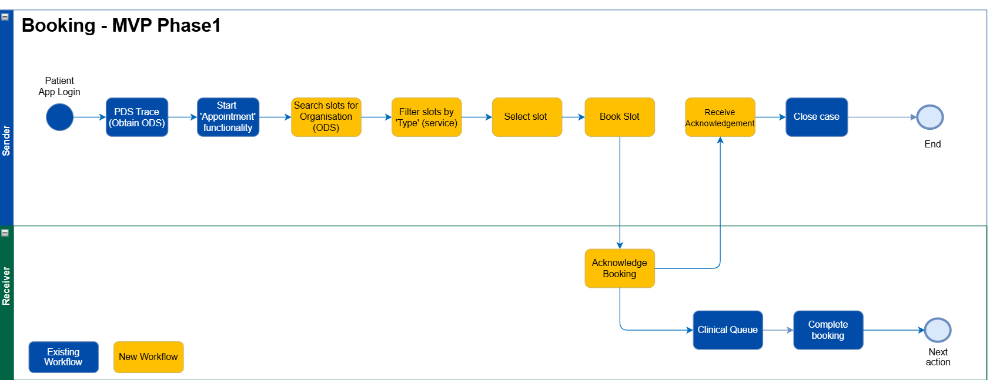
Step | Description
1 | Following the patient logging onto the PFS system, a PDS trace is undertaken to obtain the ODS code of the Patient’s Registered GP. The ODS code is used to query the BaRS endpoint catalogue to obtain the endpoint of the patient’s registered GP
2 | The patient opens the PFS appointment functionality and selects which appointment type they require. The PFS queries the patient’s registered GP system and returns open appointment slots, filters them for the appointment type requested and displays them to the patient for selection
3 | The patient selects a suitable slot and the PFS system sends a booking request.
4 | The receiving GP system books the requested slot and returns an acknowledgement which is used by the PFS system to indicate to the patient that their booking has been confirmed.

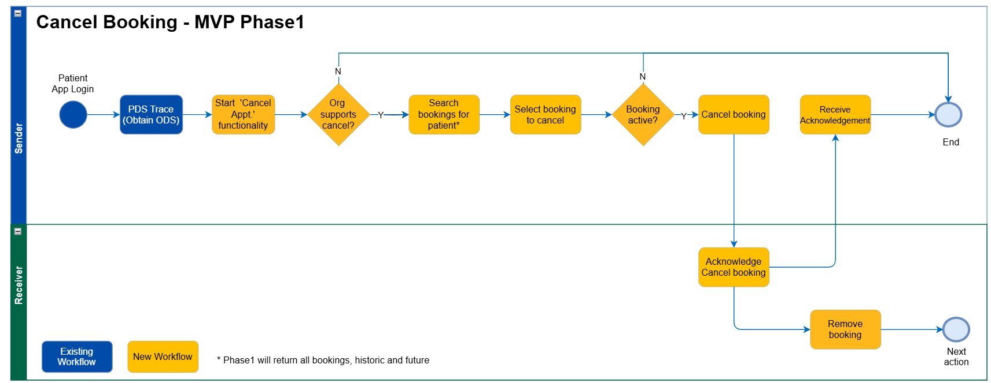

Step | Description
1 | Following the patient logging onto the PFS system, a PDS trace is undertaken to obtain the ODS code of the Patient’s Registered GP. The ODS code is used to query the BaRS endpoint catalogue to obtain the endpoint of the patient’s registered GP
2 | The patient opens the PFS cancel appointment functionality. The PFS system queries the patient’s registered GP system and returns GP appointments booked for that patient.
3 | The patient selects the appointment they wish to cancel and if the booking is active the PFS system sends a cancellation to the patient’s registered GP system
4 | The GP system acknowledges receipt of the cancellation and removes the booking from the system.
5 | On receipt of the cancellation acknowledgment, the PFS system indicates to the patient that the cancellation has been successful

              - Scope of interactions

The scope of interactions for the BaRS Booking and Referral into GP Service (application 7) is detailed in Table 23.
Table 35 BaRS Referrals into UEC (application 3) Interactions
Sender | Receiver
Request and Interpret Capability Statement | Provide Capability Statement on demand
Request and Interpret Message Definitions | Provide Message Definition(s) for a Service on demand (defined in NHSD-Target-Identifier)
Search for slots | Return slots
Make booking request | Accept Booking
Cancel booking | Accept cancel booking
              - Governance and assurance
                - Service Risk Level
The BaRS Booking and Referral into GP Service (application 7) risk level has been assessed in accordance with the criteria defined in the BaRS Clinical Risk Management Plan and determined to be Medium.
                - Data Model Endorsement
For this application the BaRS team prepared a data model for endorsement [Ref 104] and which was signed off by Digital Services for Integrated Care (DSIC) and NHS App Product and Clinical Leads (Ref 105)
                - Supplier Assurance Supplier assurance
This section will be completed following the conclusion of Public Beta supplier assurance for this application.
                - Public Beta
This section will be completed following the conclusion of the Public Beta for this application.

          - Risk Criteria
            - Hazard Consequence definitions
Table 36 Hazard Consequence Definitions
Severity Classification | Interpretation | Number of Patients Affected
Catastrophic | Death | Multiple
Catastrophic | Permanent life-changing incapacity and any condition for which the prognosis is death or permanent life-changing incapacity; severe injury or severe incapacity from which recovery is not expected in the short term | Multiple
Major | Death | Single
Major | Permanent life-changing incapacity and any condition for which the prognosis is death or permanent life-changing incapacity; severe injury or severe incapacity from which recovery is not expected in the short term | Single
Major | Severe injury or severe incapacity from which recovery is expected in the short term | Multiple
Major | Severe psychological trauma | Multiple
Considerable | Severe injury or severe incapacity from which recovery is expected in the short term | Single
Considerable | Severe psychological trauma | Single
Considerable | Minor injury or injuries from which recovery is not expected in the short term | Multiple
Considerable | Significant psychological trauma | Multiple
Significant | Minor injury or injuries from which recovery is not expected in the short term | Single
Significant | Significant psychological trauma | Single
Significant | Minor injury from which recovery is expected in the short term | Multiple
Significant | Minor psychological upset; inconvenience | Multiple
Minor | Minor injury from which recovery is expected in the short term; minor psychological upset; inconvenience; any negligible consequence | Single
            - Hazard likelihood definitions
Table 37 Hazard Likelihood Definitions
Likelihood Category | Interpretation
Very high | Certain or almost certain; highly likely to occur
High | Not certain but very possible; reasonably expected to occur in the majority of cases
Medium | Possible
Low | Could occur but in the great majority of occasions will not
Very low | Negligible or nearly negligible possibility of occurring
            - Clinical Risk Management Risk Matrix
Table 38 Clinical Risk Management Matrix
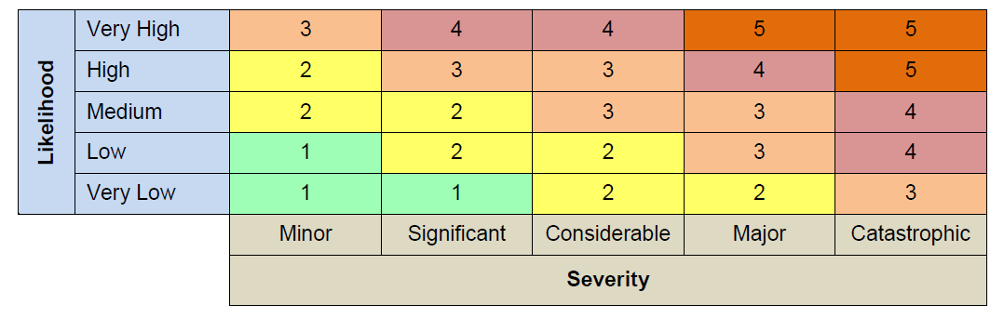
            - Risk Acceptability Criteria

Table 39 Risk Acceptability Criteria
5 | Unacceptable level of risk
4 | Mandatory elimination of hazard or addition of control measure to reduce risk to an acceptable level
3 | Undesirable level of risk. Attempts should be made to eliminate the hazard or implement control measures to reduce risk to an acceptable level. Shall only be acceptable when further risk reduction is impractical
2 | Acceptable where cost of further reduction outweighs benefits gained or where further risk reduction is impractical
1 | Acceptable, no further action required

